EMERALD ROYAL INTERNATIONAL SCHOOL

MPAPE, ABUJA

LESSON PLAN AND NOTE FOR WEEK 2 ENDING 12TH MAY, 2023

TERM : Third term.

WEEK : 2nd

SUBJECT: Social Norms

TOPIC: Myself

SUB-TOPIC: My name,age and gender

DATE: 9/5/2023.

DURATION: 40 minutes

TIME: 10:40-11:20

PERIOD: 4th

CLASS: pre-nursery

NUMBER OF PUPILS: 11

AVERAGE AGE: 2

SEX: Mixed

SPECIFIC OBJECTIVES: By the end of the lesson, the pupils should be able to:-

1. Say their names.

1. Tell their age.

3.Tell their gender.

RATIONALE: For pupils to have self awareness.

PREVIOUS KNOWLEDGE: Pupils have been practicing to say their names and their age .

INSTRUCTIONAL MATERIALS: Pupils in the classroom.

REFERENCE: Smart start Civic education for nursery Schools book 1 by T.Y. Alabi and A. M. Solu.

LESSON DEVELOPMENT

|  |  |  |  |
| --- | --- | --- | --- |
| Stages/steps | Teacher's activities | Pupils' activities | Learning points |
| Introduction | Teacher introduces the lesson by singing nursery rhymes for the pupils | Pupils sing the rhymes along with the teacher. | To get pupils attention for the lesson. |
| Presentation  Step 1 | Teacher explains to the pupils on how they can say their names. That is, the teacher touches her chest and say." My name is Mrs Gloria". Teacher calls out the pupils one after another and ask to say this after her. My name is ( the child's name) repeatedly. . | Pupils pay attention to the teacher as she explain how one can say his/ her name. Pupils repeat after the teacher to say their names repeatedly. | To improve pupils speaking ability to know how to introduce themselves. |
| Step 2 | Teacher asks the pupils to say their age.eg "I am 2 years old". | Pupils repeat after the teacher to say their age. | To enhance pupils speaking ability. |
| Step 3 | Teacher asks the pupils to say their gender. Eg "I am a girl." | Pupils repeat after the teacher to say their gender. | To improve learning. |
| Summary | Teacher summarizes the lesson by asking the pupils to say their names age and gender. | Pupils say their names, age and gender. | To ensure more understanding of the lesson. |
| Evaluation | Teacher asks the pupils the following questions.   1. What is your name? 2. How old are you? 3. Are you a boy or a girl? | Pupils answer the teacher's questions correctly. | To ascertain the level of pupils understanding of the lesson. |
| Conclusion | Teacher ends the lesson by singing nursery rhyme for the pupils. | Pupils sing along with the teacher. | To consolidate the lesson. |
| Assignment | Teacher encourages the pupils to practice their surname at home. | Pupils practice their surnames at home. | To ensure learning takes place at home. |

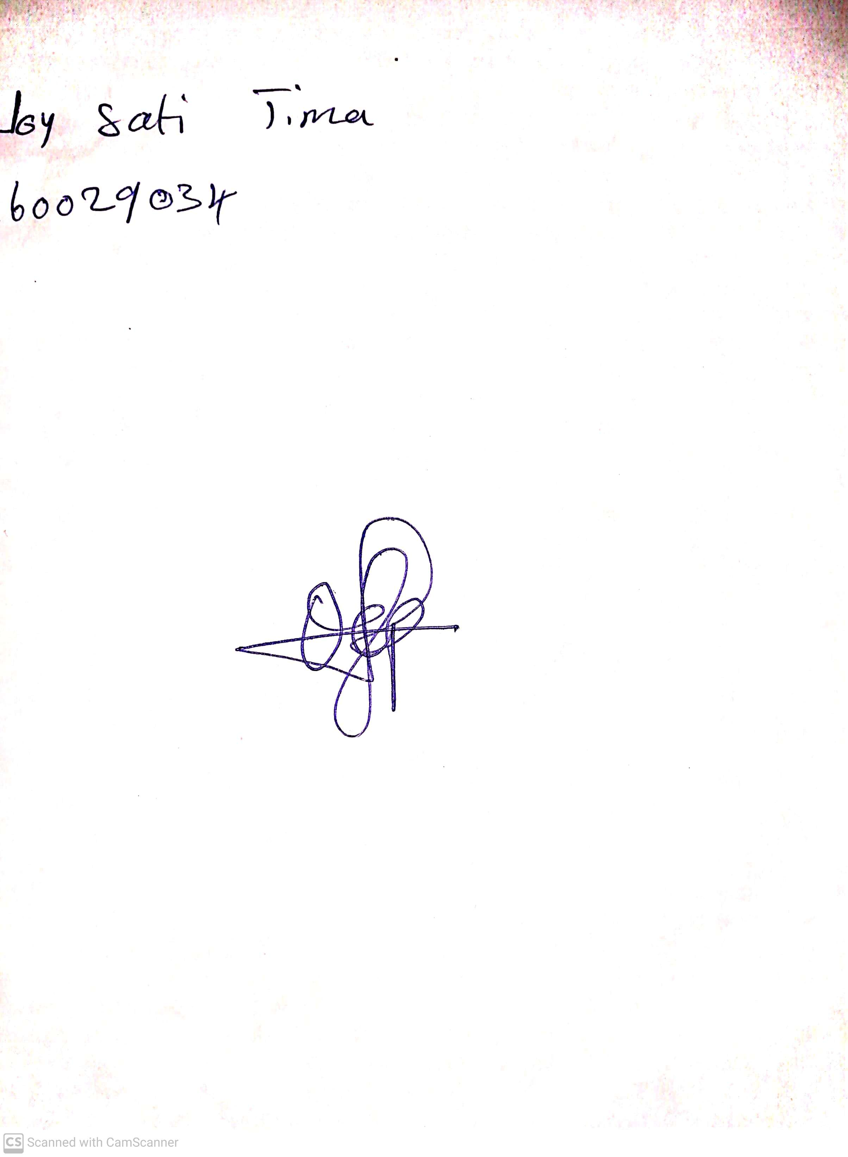

29th April, 2023

Perpetual Ojoma

Stream Head Nursery