**LESSON PLAN AND NOTE FOR WEEK 4 ENDING 02/02/2024**

**Term 2nd term**

**Week 4th week**

**Date 30th January,2024**

**Class Nursery One**

**Subject Nature Studies**

**Topic Growth in humans.**

**Sub-topic Meaning of growth and stages of growth.**

**Period 3rd period**

**Time 9:45 am**

**Duration 35 minutes**

**No in class 15**

**Average Age 3 years**

**Sex Mixed**

**Specific Objectives: By the end of the lesson, the pupils should be able to:**

**1. Define Growth in humans.**

**2. Mention the stages of growth in humans.**

**Rationale: To sure that the pupils have vital knowledge of growth in humans.**

**Previous Knowledge: The pupils have knowledge of living and non-living things.**

**Instructional Resources: Online research.**

**Reference Materials: Online research , Elementary Science by Showers kiddies nursery one.**

**LESSON PRESENTATION**

|  |  |  |  |
| --- | --- | --- | --- |
| **Steps** | **Teacher's Activities** | **Pupils' Activities** | **Learning Points** |
| **Introduction** | **The teacher introduces the topic (growth) by showing the pupils pictures of the stages of growth in humans.** | **The pupils listen attentively to the teacher.** | **To arouse the pupils' interest.** |
| **Step 1** | **The teacher starts the lesson by teaching the pupils the meaning of growth in humans as the "increase in size in humans".** | **The pupils listen attentively to the teacher and repeat continuously the meaning of growth in humans.** | **To ensure they know the meaning of growth in humans.** |
| **Step 2** | **The teacher mention the stages of growth in humans such as: newborn, infants, etc.** | **The pupils listen attentively to the teacher and repeat after the teacher the stages of growth.** | **To add to their knowledge the meaning of growth in humans.** |
| **Summary** | **The teacher summarizes the lesson by defining growth in humans.** | **The pupils know the definition of growth.** | **For better understanding of the pupils.** |
| **Evaluation** | **Question:**  **What is Growth?**  **What are the stages of growth?.** | **The pupils answer the question correctly** | **To ascertain the pupils' understanding.** |
| **Conclusion** | **The teacher applaud the pupils for their activeness and hard work** | **The pupils applaud themselves for their activeness and hard work** | **To encourage them to learn more.** |
| **Assignment** | **Question:**   1. **What is Growth?** 2. **Mention 3 stages of growth in human?** | **The pupils copy and do their homework at home.** | **To encourage learning while at home.** |

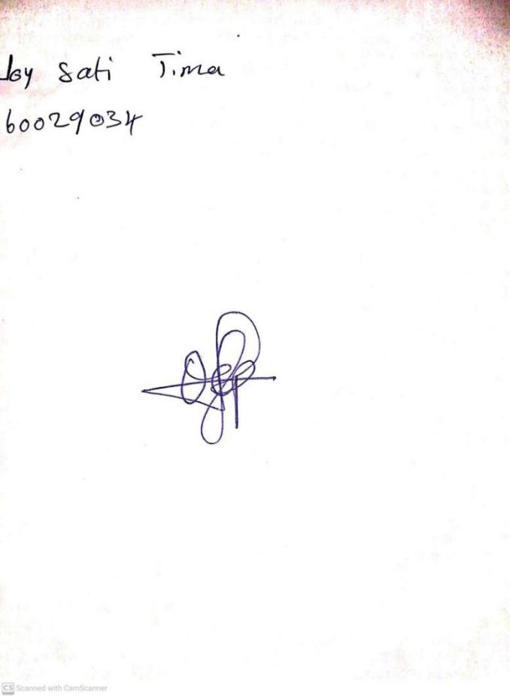

26TH January, 2024

Perpetual Ojoma Ocheja

Stream Head Nursery