EMERALD ROYAL INTERNATIONAL SCHOOL

MPAPE, ABUJA.

LESSON PLAN AND NOTE 1 FOR WEEK 5 ENDING 13TH OCTOBER,2023

TERM: First term.

WEEK: Five

SUBJECT: Literacy

TOPIC: Speech

SUB-TOPIC: Parts of the body

DATE: 10/10/2023

DURATION: 40 minutes

TIME: 08:50-09:30

PERIOD: 3rd

CLASS: Pre-nursery

NUMBER OF PUPILS: 14

AVERAGE AGE: 2 years

SEX: Mixed

SPECIFIC OBJECTIVES: By the end of the lesson, the pupils should be able to:-

I Identify the head and eye.

2. Identify the nose and mouth.

RATIONALE: For Pupils to identify their body parts.

PREVIOUS KNOWLEDGE: Pupils have been walking around with the body parts.

INSTRUCTIONAL MATERIALS: Charts video clips.

REFERENCE: Showers kiddies books Elementary science book nursery 1 by Showers kiddies books.

LESSON DEVELOPMENT

|  |  |  |  |
| --- | --- | --- | --- |
| Stages/steps | Teacher's activities | Pupils' activities | Learning points |
| Introduction | Teacher introduces the lesson by singing a nursery rhyme as:-  Head, shoulder, knees and toes  Knees and toes,.................... | Pupils listen to the teacher and practice the rhyme and sing along with the teacher.. | To arouse the interest of the pupils. |
| Presentation  Step 1 | Teacher touches her head and says  ''My head".  The teacher again touched her eyes and says  "My eyes".  Teacher tells the pupils to touch their head and eyes and say the name. | Pupils watch the teacher s she is touching her head and eyes and say their names. Pupils also repeay after the teacher by touching their head and eyes and calling their names . | For better understanding of the lesson. |
| Step 2 | Teacher again touches her nose and mouth and say their names respectively and asks the pupils to repeat after her. | Pupils also touch their nose and mouth and say their names respectively. | For better understanding of the lesson. |
| Summary | Teacher summarizes the lesson by going over the lesson again for more understanding. | Pupils listen attentively to the teacher as she is going over the lesson. | To ensure better understanding. |
| Evaluation | Teacher asks the Pupils to :-  I. Identify their head and eyes.  II. Identify their nose and mouth. | Pupils answer the teacher's questions correctly. | To ascertain the level of pupils understanding of the lesson. |
| Conclusion | Teacher concludes the lesson by singing nursery rhymes that was sang at the introduction. | Pupils sing along with the teacher. | For onwards learning. |
| Assignment | Teacher tells the pupils to colour the following parts of the body in their text books.  -- nose.  -- mouth  -- head. | Pupils do the assignment at home. | To encourage Learning at home. |

EMERALD ROYAL INTERNATIONAL SCHOOL

MPAPE, ABUJA.

LESSON PLAN AND NOTE 2 FOR WEEK 5 ENDING 13TH OCTOBER,2023

TERM: First term.

WEEK: Five

SUBJECT: Literacy

TOPIC: Speech

SUB-TOPIC: Identification and functions of the body parts.

DATE: 12/10/2023

DURATION: 40 minutes

TIME: 08:50-09:30

PERIOD: 3rd

CLASS: Pre-nursery

NUMBER OF PUPILS: 14

AVERAGE AGE: 2 years

SEX: Mixed

SPECIFIC OBJECTIVES: By the end of the lesson, the pupils should be able to:-

I Mention the uses of hands.

2. Itemize the uses of mouth.

RATIONALE: For Pupils to identify their body parts and the uses of the body parts.

PREVIOUS KNOWLEDGE: Pupils have been taught the parts of the body.

INSTRUCTIONAL MATERIALS: Charts video clips.

REFERENCE: Showers kiddies books Elementary science book nursery 1 by Showers kiddies books.

LESSON DEVELOPMENT

|  |  |  |  |
| --- | --- | --- | --- |
| Stages/steps | Teacher's activities | Pupils' activities | Learning points |
| Introduction | Teacher introduces the lesson by asking the pupils to touch their hands, mouth,ear and eyes. | Pupils touch the parts of the body the teacher mentioned. | To arouse the interest of the pupils. |
| Presentation  Step 1 | Teacher explains to the pupils what we use our hands to do as:-  I clap with my hands.  I write with my hands. | Pupils listen as the teacher is explaining the uses of hands. | For better understanding of the uses of hands. |
| Step 2 | Teacher leads the pupils to mention the uses of mouth. | Pupils mention the uses of mouth as:-  I eat with my mouth.  I talk with my mouth. | For better understanding of the uses of mouth. |
| Summary | Teacher summarizes the lesson by going over the lesson again for more understanding of the lesson. | Pupils listen attentively to the teacher as she is going over the lesson. | To ensure better understanding. |
| Evaluation | Teacher asks the Pupils to :-  I. Mention the uses of the hands.  II. State the uses of mouth. | Pupils answer the teacher's questions correctly. | To ascertain the level of pupils understanding of the lesson. |
| Conclusion | Teacher concludes the lesson by singing nursery rhymes for the pupils. | Pupils sing along with the teacher. | For onwards learning. |
| Assignment | Teacher tells the pupils to match the objects that can be touched by hands to the hand in their text books. | Pupils do the assignment at home. | To encourage Learning at home. |

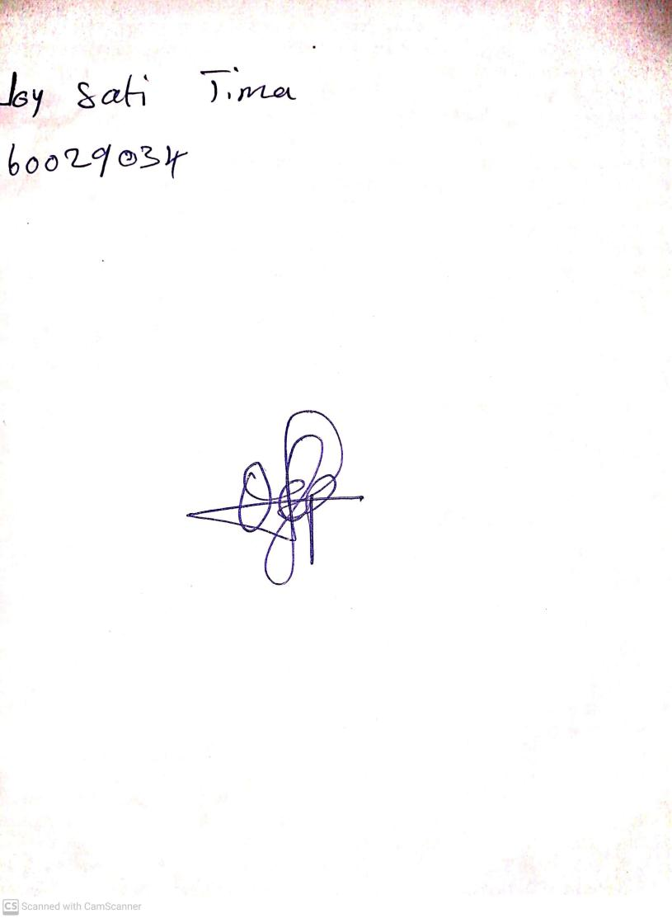

29TH September, 2023

Perpetual Ojoma Ocheja

Stream Head Nursery

EMERALD ROYAL INTERNATIONAL SCHOOL

MPAPE, ABUJA.

LESSON PLAN AND NOTE 3 FOR WEEK 5 ENDING 13TH OCTOBER,2023

TERM: First term.

WEEK: Five

SUBJECT: Literacy

TOPIC: Speech

SUB-TOPIC: Functions of the parts of the body.e.g ear and teeth.

DATE: 13/10/2023

DURATION: 40 minutes

TIME: 08:50-09:30

PERIOD: 3rd

CLASS: Pre-nursery

NUMBER OF PUPILS: 14

AVERAGE AGE: 2 years

SEX: Mixed

SPECIFIC OBJECTIVES: By the end of the lesson, the pupils should be able to:-

I Mention the use of ear

2. State the uses of teeth.

RATIONALE: For Pupils to identify their body parts and the uses of the body parts.

PREVIOUS KNOWLEDGE: Pupils have been taught the parts of the body.

INSTRUCTIONAL MATERIALS: Charts video clips.

REFERENCE: Showers kiddies books Elementary science book nursery 1 by Showers kiddies books.

LESSON DEVELOPMENT

|  |  |  |  |
| --- | --- | --- | --- |
| Stages/steps | Teacher's activities | Pupils' activities | Learning points |
| Introduction | Teacher introduces the lesson by singing parts of the body song for the pupils. | Pupils sing the song along with the teacher. | To arouse the interest of the pupils. |
| Presentation  Step 1 | Teacher guides the pupils to touch their ear and say what they use the ear to do. | Pupils touch their ear and say :-  "This is my ear'.  They also say what they use the ear to do as:-  " I hear with my ears." | For better understanding of the use of ear. |
| Step 2 | Teacher leads the pupils to touch their teeth and say what they use their teeth to do. | Pupils touch their teeth and say;  "These are my teeth."  Pupils also say what they uses the teeth to do as:-  I cut food with my teeth.  2. I chew food with my teeth | For better understanding of the uses of teeth. |
| Summary | Teacher summarizes the lesson by going over the lesson again for more understanding of the lesson as:-  Uses of ear.  I hear with my ear.  Uses of teeth  I cut food with my teeth.  I chew food with my teeth. | Pupils listen attentively to the teacher as she is going over the lesson again. | To ensure better understanding. |
| Evaluation | Teacher asks the Pupils to :-  I. Say what they use their ear to do.  II. State the uses of teeth. | Pupils answer the teacher's questions correctly. | To ascertain the level of pupils understanding of the lesson. |
| Conclusion | Teacher concludes the lesson by singing nursery rhymes for the pupils. | Pupils sing along with the teacher. | For onwards learning. |
| Assignment | Teacher asks the pupils to answer the these questions at home.  I see with my--------------(eyes,legs)  I hear with my------------(nose,ear)  I cut food with my--------(tongue, teeth) | Pupils do the assignment at home. | To encourage Learning at home. |