**LESSON PLAN AND NOTE FOR WEEK 6 ENDING 9/6/2023**

**Term 3rd term**

**Week 6th week**

**Date 9th June, 2023**

**Class Nursery One**

**Subject Social Norms**

**Topic Safety at School.**

**Sub-topic Define Safety at School**

**Period 4th period**

**Time 10:40 am**

**Duration 35 minutes**

**No in class 18**

**Average Age 3 years**

**Sex Mixed**

**Specific Objectives: By the end of the lesson, the pupils should be able to:**

1. **Define Safety at School.**
2. **Identify sharp objects in the school to avoid to be safe.**

**Rationale: To ensure the pupils have knowledge of staying free from dangers in the school.**

**Previous Knowledge: The pupils can identify sharp objects that shouldn’t be played with..**

**Instructional Resources: Online research.**

**Reference Material: Smart Smart Civic Education by A.M Solu & T.Y Alabi, nursery 2**

**LESSON PRESENTATION**

|  |  |  |  |
| --- | --- | --- | --- |
| **Steps** | **Teacher’s Activities** | **Pupils’ Activities** | **Learning Points** |
| **Introduction** | **The teacher introduces the lesson by teaching the pupils the importance of staying safe always.** | **The pupils pays attention to the teacher.** | **To arouse the pupils’ interest.** |
| **Step 1** | **The teacher leads the pupils to define Safety at School as “staying free from dangers’ in the school..** | **The pupils pay attention and repeats the definition of Safety at School with the teacher.** | **For proper understanding.** |
| **Step 2** | **The teacher guides the pupils to recognize things to do in other to stay safe in school e.g**  **Avoid rough play.**  **Avoid running anyhow.**  **Avoiding playing with sharp objects.** | **The pupils identify the safety rules in school that should be followed.** | **For better understanding.** |
| **Summary** | **The teacher summarizes the lesson by mentioning the ways of avoiding dangers at school which include**  **Not playing rough play.**  **Not playing with Electric plugs**  **Not playing with sharp objects etc.** | **The pupils listen and understands the lesson.** | **For onward study.** |
| **Evaluation** | **Question:**  **Define Safety at school?**  **Mention two ways of staying safe in the school?.** | **The pupils answer the question correctly.** | **To ascertain the pupils’ understanding.** |
| **Conclusion** | **The teacher summarizes the lesson to the pupils.** | **The pupils gives answers to the teacher.** | **To consolidate the lesson.** |
| **Assignment** | **Question:**  **Mention safety objects in the school?.** | **The pupils copy and do their homework .** | **To encourage learning while at home.** |

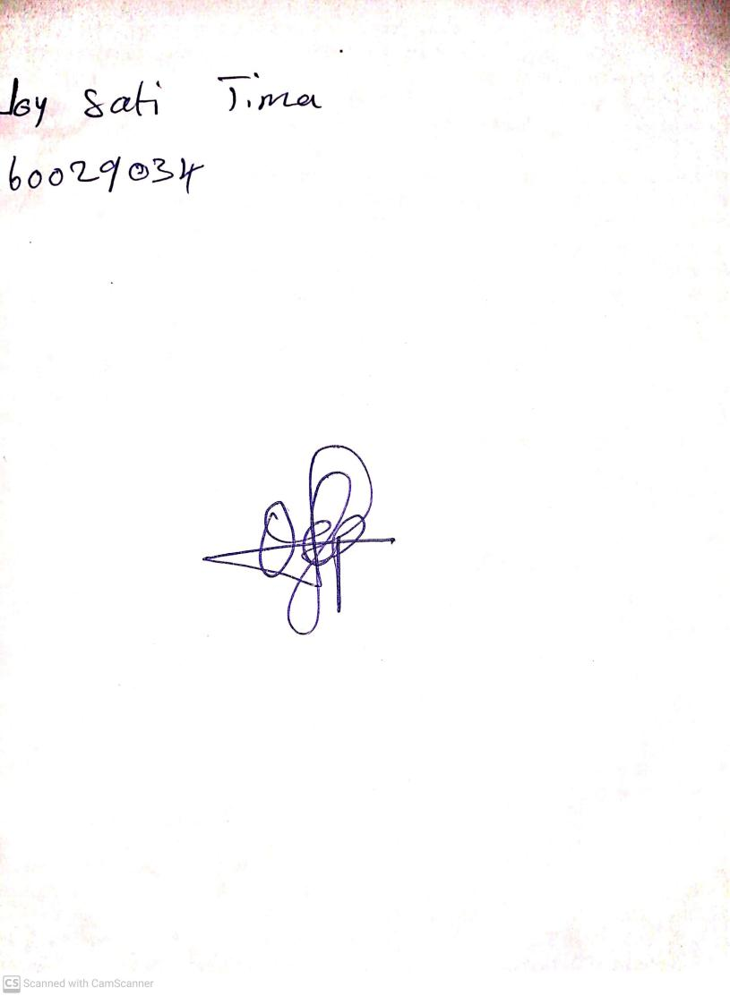

10th May, 2023

Perpetual Ojoma

Stream Head Nursery