**LESSON PLAN/NOTE FOR WEEK 3 ENDING 19/05/2023**

**Term**: 3rd

**Week**: 3

**Date**: 15/05/2023

**Class**: ss 2

**Subject**: Civic Education

**Topic**: Human Rights

**Sub-Topic:** Differences between categories of human rights.

**Period**: 6th

**Time**: 11:50-12:30

**Duration**: 40 minutes

**Number in class**: 5 students

**Average Age**: 14 years

**Sex**: mixed

**Specific objectives:** By the end of the lesson, the students should be able to:

1. State the categories of human rights.
2. Differentiate between the categories of human rights

**Rationale**: for the students to be able to differentiate between the categories of human rights.

**Previous knowledge**: the students can differentiate between the categories of human rights as political and economic rights.

**Instructional material:** A chart showing the different categories of human rights.

**Reference material**: Gbenga Babalola (2017) Essential civic education for senior secondary schools.

**LESSON DEVELOPMENT**

|  |  |  |  |
| --- | --- | --- | --- |
| **Stages/steps** | **Teacher’s Activities** | **Students’ Activities** | **Learning points** |
| **Introduction** | Review the previous lesson | Participate actively in the class discussion | To arouse the students interest to learn. |
| **Step 1** | States the categories of human rights as: civic, political, economic and environmental rights. | Listen carefully to the teacher | For better understanding of the lesson. |
| **Step 11** | Guides the students to differentiate between the first, second and third rights. | Respond to the class activity. | To encourage critical thinking. |
| **Board summary** | Summarizes the lesson as:  **Categories of human rights**   1. Civic and political rights 2. Economic and social rights 3. Environmental rights.   **Differences between first, second and third rights.**   |  |  |  | | --- | --- | --- | |  | First rights | Second and third rights | | 1 | Most rights in categories associate with public government- societal interest the most. | Most rights in this category associate with private personal interest the most. | | 2 | They enhance smooth conducts of elections. | They enhance smooth conducts of trades | | 3 | They are more of attention gaining. | They are more of profit. | | 4 | They are invisible natural rights. | They are invisible artificial rights. | | 5 | They are not given by anyone and cannot be taken away by anyone. | They are sometimes given by someone, either government or private individual and sometimes can be taken away by government or an employer. | | Copy and submit the note book for marking. | For future reference. |
| **Evaluation** | Evaluates the students as:   1. State 3 categories of human rights 2. Differentiate between the categories of human rights. | Respond to the questions | Ascertaining the attainment of the stated objectives. |
| **Conclusion** | Rounds up the lesson by marking and correcting work. | Check and do their correction | Consolidation of the lesson |
| **Assignment** | Gives home work as:   1. Explain environmental rights of the citizens | Respond by doing the home work at home. | To ensure continuity of learning. |

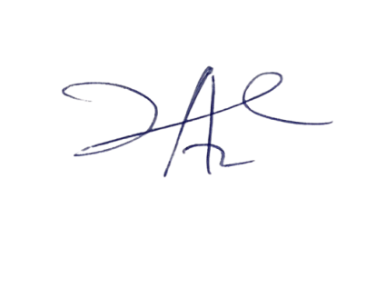

11/5/2023

Principal Head Instuctor