**Lesson Plan/Notes for week One Ending 13/1/2023.**

**Term:** 2nd

**Week:** one

**Class:** SS 1

**Date:** 9/1/2023.

**Subject:** Economics

**Topic:** firms and industry.

**Sub- topic:** Meaning and types of business enterprise.

**Period:** first

**Time:** 8:10-8:50

**Duration:** 40 Minutes.

**Number in class:** 7 Students.

**Average Age:** 14 Years.

**Sex:** mixed

**Specific objectives:** By the end of the lesson, the students should be able to:

1 Define firm and industry

11 mention the types of business enterprises.

**Rationale:** To be able to differentiate between firm and industry.

**Previous knowledge:** The students have been seeing blocks industry and other industries around.

**Instructional Material:** A chart showing business and shops as well as firm and industry.

**Reference material:** Gbenga Babalola (2017) Metropolitan Economics for senior Secondary schools.

**LESSON DEVELOPMENT**

|  |  |  |  |
| --- | --- | --- | --- |
| **Stages/steps** | **Teacher's Activities** | **Students' Activities** | **Learning points** |
| **Introduction** | Review the previous lesson. | Participate actively in the class discussion. | To arouse the students’ interest to learn. |
| **Step 1** | Defines firm and industry as: . firm is the basic unit of decision making in a decentralized economy. While industry is the collection of firms producing the same goods and services. | Listen carefully to the teacher. | For better understanding of the lesson |
| **Step 11** | Guides the students to mention the types of business enterprises. | Mention the types of business enterprises as: (1) Sole proprietorship (2) partnership (3) private limited company etc. | To encourage critical thinking. |
| **Summary** | Summarises the lesson as:  **Firm and Industry**  Firm is the basic unit of decision taking in a decentralized economy. It is an organization or a company that specialises in the production of goods and services. A firm is an entity which specializes in the production and distribution of goods under one administration or management. Example of a firm are Unilever Nigeria PLC, Tanko Nigeria limited, Texaco Nigeria limited, zenith bank,Ashaka cement supplying building materials,eg cement.  On the other hand, an industry is the collection of firms producing the same or identical goods or services. It is a sector of the economy in which firms use similar Factor inputs to make a group of related products. Example is the banking system, petroleum industry eg Oando, Total Mobil, Texaco etc. All these firms are under different management but all provide similar products.  **Types of Business Enterprises.**  (1) sole proprietorship  (2) partnership.  (3) private limited company.  Public limited company  (4) Co-operative societies. | Copy and submit the Note book for marking. | For future reference. |
| **Evaluation** | Evaluates the students as:  (1) Define firm and industry  (2) mention two types of business enterprise. | Respond to the questions | Ascertaining the attainment of the stated objectives. |
| **Conclusion** | Rounds up the lesson by marking and correcting students work. | Check and do their correction | Consolidation of the lesson |
| **Assignment** | Gives home work as:  (1) Differentiate between firm and industry.  (2) what is plant and factory. | Respond by doing the home work at home. | To ensure continuity of learning. |

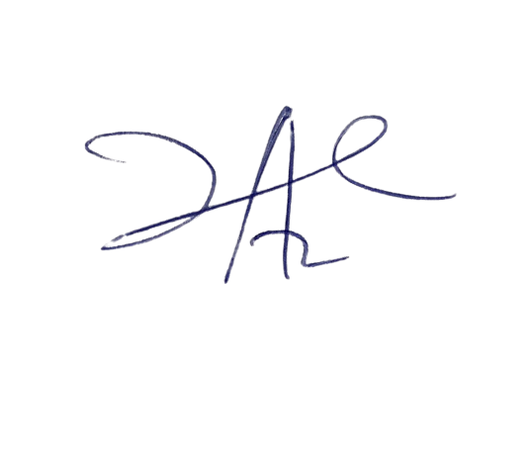

**6/3/2023**

**Principal Head Instructor**