**LESSON PLAN/NOTE FOR WEEK 1 ENDING 05/05/2023**

**Term**: 3rd

**Week**: 1

**Date**: 01/05/2023

**Class**: ss 1

**Subject**: Civic Education

**Topic**: cultism

**Sub-Topic:** meaning of cultism and secret cult.

**Period**: 3rd

**Time**: 9:30-10:10

**Duration**: 40 minutes

**Number in class:** 8 students

**Average Age:** 14 years

**Sex**: mixed

**Specific objectives**: By the end of the lesson, the students should be able to:

1. Define cultism
2. Explain secret cult.

Rationale: for the students to be able to explain cultism and secret cult

**Previous knowledge**: the students have seen cult group display in Nigeria movies or on television.

**Instructional material:** A chart showing the symbols of cult group in Nigeria.

**Reference material:** Gbenga Babalola (2017) Essential civic education for senior secondary schools.

**LESSON DEVELOPMENT**

|  |  |  |  |
| --- | --- | --- | --- |
| **Stages/steps** | **Teacher’s Activities** | **Students Activities** | **Learning points** |
| **Introduction** | Review the previous lesson | Participate actively in the class discussion | To arouse the students interest to learn. |
| **Step 1** | Defines cultism as: cultism is a small group of people who have extreme religious beliefs and who are not part of any establish religion. | Listen carefully to the teacher. | For better understanding of the lesson. |
| **Step 11** | Guides the students to explain secret cult. | Respond to the class discussion | To encourage critical thinking. |
| **Board summary** | Summarizes the lesson as:  **Cultism**  Cultism according to the oxford advanced learner’s dictionary defines cultism as a small group of people who have extreme religious beliefs and who are not part of any established religion.  **Secret cult**  Secret cult is an enclosed organised association or group of people devoted to the same cause. It is an enclosed group of adherents having an exclusive sacred ideology and a series of rites centering around their sacred symbols. Secret cult is a terminology coined by a former military Head of state, Ibrahim Babangida between 1983-1984. before then, such groups used to be referred to as fraternities. Members of the cult group commit themselves to oath and allegiance, which serves as their strong bond. Members of these groups are always violent when defending their cause. Secret cult are found among the various ethnic groups. They have been in existence since the precolonial period in Nigeria. | Copy and submit the note book for marking. | For future reference |
| **Evaluation** | Evaluates the students as:   1. Define cultism 2. Explain the meaning of secret cult. | Respond to the questions | Ascertaining the attainment of the stated objectives. |
| **Conclusion** | Rounds up the lesson by marking and correcting students work | Check and do their corrections | Consolidation of the lesson. |
| **Assignment** | Gives home work as:   1. Explain what you understand by cultism. | Respond by doing the home work at home. | To ensure continuity of learning. |

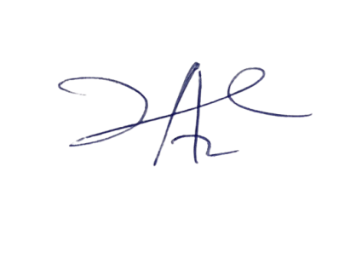

10/5/2023

Principal Head Instuctor