LESSON PLAN AND NOTE FOR WEEK 7 ENDING 16/06/2023

TERM: 3rd

WEEK: 7th

DATE: 12/06/2023

CLASS: Nursery 2

SUBJECT: Social norms

TOPIC: Living with people with HIV/ AIDS.

SUB—TOPIC: Meaning of HIV/AIDS.

PERIOD: 2nd period after long break

TIME: 11:20—12: 00pm

DURATION: 40 minutes

NUMBER IN CLASS: 14

AVERAGE AGE: 5 years

SEX: Mixed

LEARNING OBJECTIVES: By the end of the lesson, the Pupils should be able to:

1. Explain the meaning of HIV

2. Define AIDS.

3. State the ways HIV/AIDS can be contacted.

RATIONALE: For pupils to know the meaning of HIV/AIDS virus

PREVIOUS KNOWLEDGE: Pupils have learnt about orphaned and vulnerable children.

INSTRUCTIONAL MATERIALS: Razor blade, needle and syringes.

REFERENCE MATERIALS: Google. com

LESSON DEVELOPMENT

|  |  |  |  |
| --- | --- | --- | --- |
| Steps | Teacher's activities | Pupils' activities | Learning point |
| Introduction | Teacher reviews the previous lesson. | Pupils pay attention to the teacher. | To prepare pupils minds for the lesson ahead. |
| Presentation step 1 | Teacher explains the meaning of HIV to pupils and then asks them to repeat after her. | Pupils pay attention to the teacher and repeat after her. | For proper understanding. |
| Step 2 | Teacher defines the word AIDS to pupils and also asks them to repeat after her. | Pupils listen to the teacher and repeat after her. | For better understanding. |
| Step 3 | Teacher States the various ways in which one can contact HIV/AIDS to pupils and also asks them to repeat after her. | Pupils listen attentively to the teacher and also repeat after her. | To enhance Pupils listening and speaking ability. |
| Board summary | Teacher summarizes the lesson by writing the whole note of lesson on the board for pupils to copy into their books. That is;  LIVING WITH PEOPLE WITH HIV AIDS.  Meaning of HIV  HIV means( human immune deficiency virus) is a virus that attacks the body's immune system. If HIV is not treated, it can lead to AIDS (acquired immunodeficiency syndrome).  There is currently no effective cure. Once people get HIV they have it for life.  AIDS is the late stage of HIV infection that occurs when the body's immune system is badly damaged because of the virus.  Ways it can be contacted  1. Sharing needles  2. Sharing syringes  3. Sharing razor blade  4. Through blood transfusion.  5. Through breast milk etc. | Pupils copy the note into their books. | For onward study. |
| Evaluation | Teacher evaluates the lesson by asking pupils the following questions:  1. What is the full meaning of HIV?  2. If HIV is not treated, it can lead to ____  3. What is the full meaning of AIDS?  4. Mention the ways by which HIV/ AIDS can contacted. | Pupils answer the questions asked by the teacher. | To assess pupils level of understanding. |
| Conclusion | Teacher concludes the lesson by marking pupils books. | Pupils submit their books for marking.. | For endorsement. |
| Assignment | Answer the following question:  Mention ten (10) ways of preventing HIV/ AIDS. | Pupils do their assignment at home. | To encourage learning at home. |

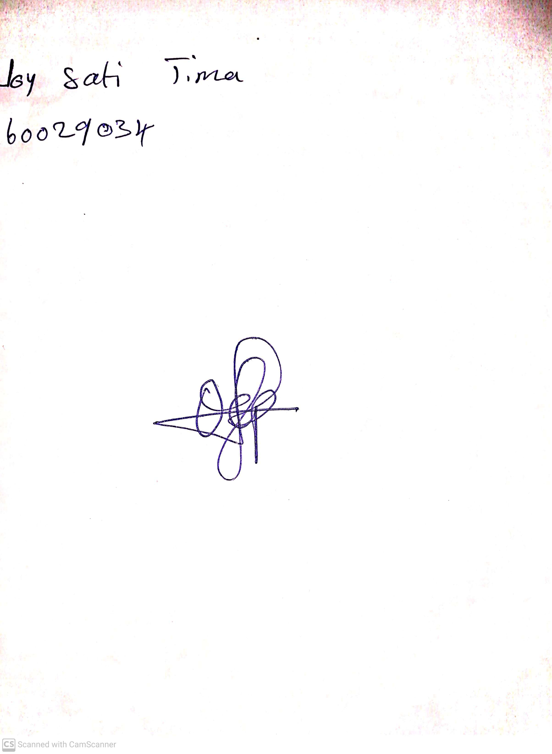

10th May, 2023

Perpetual Ojoma

Stream Head Nursery