**EMERALD ROYAL INTERNATIONAL SCHOOL**

**MPAPE, ABUJA.**

**LESSON PLAN AND NOTE FOR WEEK 5 ENDING 13TH OCTOBER,2023**

TERM : First term.

WEEK : 5

SUBJECT: Social Norms

TOPIC: Members of the family.

SUB-TOPIC: Children as members of the family.

DATE: 11/8/2023

DURATION: 40 minutes

TIME: 10:40-11:20

PERIOD: 5th

CLASS: pre-nursery

NUMBER OF PUPILS:

AVERAGE AGE: 2

SEX: Mixed

SPECIFIC OBJECTIVES: By the end of the lesson, the pupils should be able to:-

1. Identify children as members of the family .

2. Have an idea on the responsibilities of children at home.

RATIONALE: For pupils to know the members of the family.

PREVIOUS KNOWLEDGE: Pupils have identify daddy and mummy in the picture in the previous lesson.

INSTRUCTIONAL MATERIALS: chart and picture book.

REFERENCE: Smart start Civic education for nursery Schools book 1 by T.Y. Alabi and A. M. Solu.

LESSON DEVELOPMENT

|  |  |  |  |
| --- | --- | --- | --- |
| Stages/steps | Teacher's activities | Pupils' activities | Learning points |
| Introduction | Teacher introduces the lesson by going over the previous lesson. | Pupils pay attention to the teacher | To arouse the interest of the pupils. |
| Presentation  Step 1 | Teacher shows the pupils a family picture emphasizing on the children in the picture. | Pupils sit on their chairs and see the picture of the children. Pupils also take turns to point at children in the family picture. | To improve better understanding. |
| Step 2 | Teacher also explains to the pupils in simple term using the picture to show the responsibilities of children at home. | Pupils pay attention to the teacher and carefully look at the picture of children performing their duties at home. Examples:-  ---- washing dishes.  ---- sweeping.  --- going for an errand. | For better understanding of the lesson. |
| Summary | Teacher summarizes the lesson by emphasizing on the responsibilities of children in the family for more understanding such as:-  --- children helps their parents in sweeping.  --- children washes dishes at home.  --- children runs errand for their parents. | Pupils pay attention to the teacher's explanation. | To ensure better understanding of the lesson. |
| Evaluation | Teacher asks the pupils to:-  1.Identify children in the picture.  2. Mention the duties of children in the family. | Pupils answer the teacher's question correctly. | To assess pupils level of understanding of the lesson. |
| Conclusion | Teacher ends the lesson by singing a nursery rhyme for the pupils. | Pupils sing the rhyme along with the teacher. | To consolidate the lesson. |

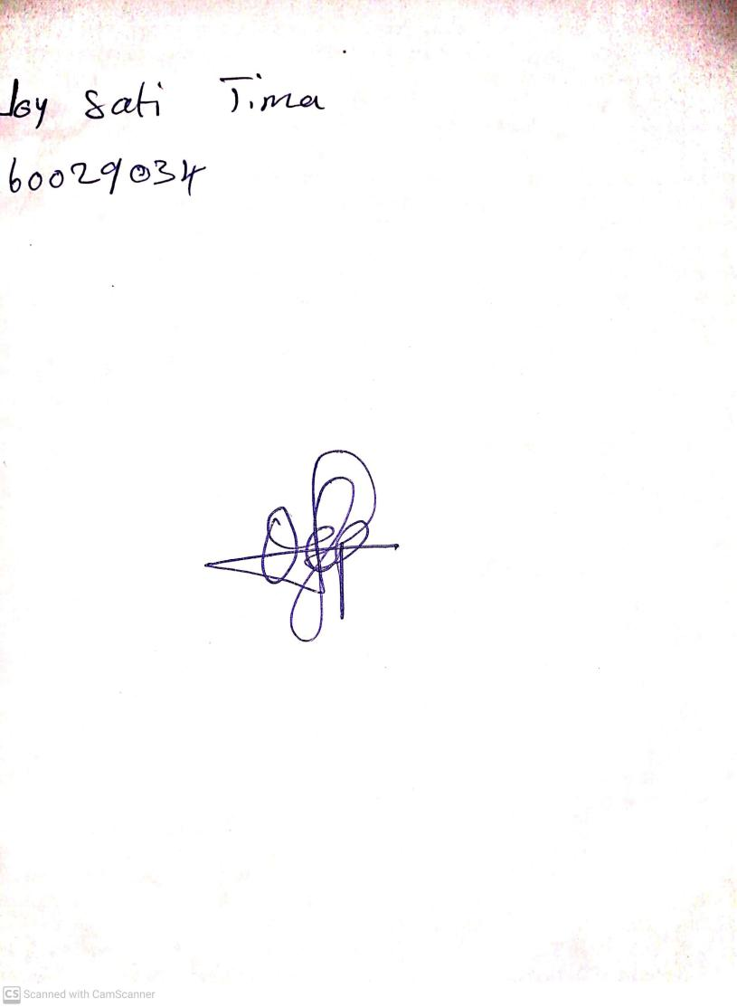

25th August, 2023

Perpetual Ojoma Ocheja

Stream Head Nursery