LESSON NOTE/ PLAN FOR WEEK 8 ENDING 03/03/2023

TERM: 2nd

WEEK: 8th

DATE : 03/03/2023

CLASS: Nursery 2

SUBJECT: Letter work

TOPIC: Consonant Digraphs 1

SUB—TOPIC: Consonant digraphs ‘sh’ and ‘ch’

PERIOD: 3rd

TIME: 09:30–10:10am

DURATION: 40 minutes

NUMBER IN CLASS: 14

AVERAGE AGE: 5 years

SEX: Mixed

LEARNING OBJECTIVES: By the end of the lesson, the Pupils should be able to:

1. Generate words with consonant digraphs ‘sh’

2. Make words with consonant digraphs ‘ch’

RATIONALE: For Pupils to km know more of consonant digraphs words.

PREVIOUS KNOWLEDGE: Pupils have learnt consonant digraphs ‘ck’and ‘ph’

INSTRUCTIONAL MATERIALS: A chart of words with consonant digraphs ‘sh’and ‘ch’

REFERENCE MATERIALS: Google. com

LESSON DEVELOPMENT

|  |  |  |  |
| --- | --- | --- | --- |
| Steps | Teacher's activities | Pupils' activities | Learning point |
| Introduction | Teacher introduces the lesson by asking pupils to mention words with consonant digraphs ck and ph . | Pupils listen to the teacher and answer the question. | To prepare pupils minds for the lesson ahead. |
| Presentation step 1 | Teacher generates words with consonant digraphs ‘sh’ and ask Pupils to repeat after her. | Pupils listen to the teacher and repeat after her. | For proper understanding. |
| Step 2 | Teacher makes words with consonant digraphs ‘ch’and also ask Pupils to repeat after her. | Pupils pay attention to the teacher and repeat after her. | For better understanding. |
| Board summary | Teacher writes the whole note on the board for pupils to copy. That is;  CONSONANT DIGRAPHS ‘SH’ARE:  (1) Shoe (2) Shut (3)shirt (4) brush (5)wash (6) shadow (7) shed (8) shock(9) she (10) shack (11) shop (12) shelf (13) shell (14) push (15)mash (16) crash etc.  CONSONANT DIGRAPHS ‘CH’ARE:  (1) church (2) school (3) chain (4) chair (5) chart (6) chase (7) chess (8) chest (9) chance (10)check(11) match (12) catch (13) patch (14) teach (15)lunch (16)punch etc. | Pupils copy the note into their exercise books. | For onward study. |
| Evaluation | Teacher asks pupils to read the comments digraphs on the board one after another. | Pupils go to the board one after another and read. | To enhance Pupils participation in the class. |
| Conclusion | Teacher concludes the lesson by marking pupils books. | Pupils submit their books for marking. | For endorsement. |
| Assignment | Make 5 words each with the following digraphs  1. nd  2. ng  3. ft  4. st  5. lf | Pupils do their assignment at home. | To encourage learning at home. |

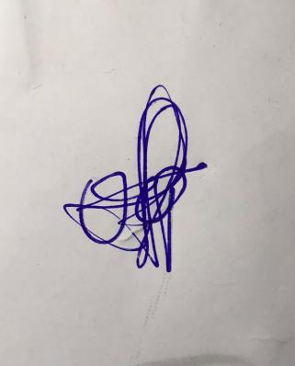

**29th March, 2023**

**Perpetual Ojoma Ocheja**

**Stream Head Nursery**