**EMERALD ROYAL INTERNATIONAL SCHOOL**

**MPAPE, ABUJA.**

**LESSON PLAN AND NOTE FOR WEEK 6 PERIOD 1 ENDING 31/05/2024**

**TERM: 3RD**

**WEEK: 6TH**

**DATE: 27/05/2024**

**CLASS: NURSERY 2**

**SUBJECT: NUMBER WORK**

**TOPIC: NUMBER 46-50 .**

**SUB-TOPIC: COUNTING OF AND WRITING NUMBER 46-50**

**PERIOD: 1ST.**

**TIME: O8:50-09:30.**

**DURATION: 40 MINUTES.**

**NUMBER IN CLASS: 13**

**AVERAGE AGE: 5 YEARS.**

**SEX: MIXED.**

**SPECIFIC OBJECTIVES: BY THE END OF THE LESSON,THE PUPILS SHOULD BE**

**ABLE TO:**

1. **COUNT NUMBER 46-50.**
2. **WRITE NUMBER 46-50.**

**RATIONALE: FOR PUPILS TO BE ABLE TO COUNT AND WRITE NUMBER**

**46–50**

**PREVIOU KNOWLEDGE: PUPILS HAVE LEARNT COUNTING OF NUMBERS 1-45 IN**

**PREVIOUS LESSON.**

**INSTRUCTIONAL MATERIALS: NUMBER CHART FROM 1-50**

**REFERENCE MATERIALS: THE NEW MASTERING MATHEMATICS FOR NURSERY SCHOOLSBOOK 3 BY HENRY.Z.IDOGUN.**

**LESSON DEVELOPMENT**

|  |  |  |  |
| --- | --- | --- | --- |
| **STAGES/STEPS** | **TEACHER’S ACTIVITIES** | **PUPILS’ ACTIVITIES** | **LEARNING POINTS** |
| **INTRODUCTION** | **Teacher introduces the lesson by singing a number rhyme for the pupils.** | **Pupils sing the rhyme along with the teacher.** | **To arouse pupils interest in the lesson.** |
| **PRESENTATION**  **STEP 1** | **Teacher writes numbers 46-50 on the board, counts and then asks pupils to repeat after her. I.e,**  **46 47 48 49 50.** | **Pupils count numbers 46-50 after the teacher.** | **For proper understanding of the lesson .** |
| **STEP 2** | **Teacher prepares pupils books for them to count and copy the numbers on the board into their exercise books.** | **Pupils count and copy the numbers into their exercise books. I.e,**  **46 47 48 49 50.** | **For better understanding of the lesson.** |
| **BOARD SUMMARY** | **Teacher summarizes the lesson by going through the lesson on the board over and over again.** | **Pupils pay attention to the teacher.** | **To create platform for slow learners.** |
| **EVALUATION** | **Teacher asks Pupils to identify and count numbers 46-50 on the board one after the other.** | **Pupils count numbers 46 - 50 on the board one after another.** | **To assess pupils understanding of the lesson.** |
| **CONCLUSION** | **Teacher marks pupils books.** | **Pupils submit their books for marking.** | **For endorsement.** |
| **ASSIGNMENT** | **Identify, count and write numbers 1 -50** | **Pupils do their assignment at home.** | **To encourage learning at home.** |

**LESSON PLAN AND NOTE FOR WEEK 6 PERIOD 2 ENDING 31/05/2024**

**TERM: 3RD**

**WEEK: 6 TH**

**DATE: 28/05/2024**

**CLASS: NURSERY 2**

**SUBJECT: NUMBERWORK**

**TOPIC: NUMBERS 46-50 .**

**SUB-TOPIC: IDENTIFY,COUNT AND WRITE NUMBER 1–50**

**PERIOD: 2nd**

**TIME: O8:50-09:30.**

**DURATION: 40 MINUTES.**

**NUMBER IN CLASS: 13**

**AVERAGE AGE: 5 YEARS.**

**SEX: MIXED.**

**SPECIFIC OBJECTIVES: BY THE END OF THE LESSON,THE PUPILS SHOULD BE**

**ABLE TO:**

**1. IDENTIFY AND COUNT NUMBERS 1-50**

**2. WRITE NUMBERS 1-50**

**RATIONALE: FOR PUPILS TO KNOW COUNTING AND WRITING OF**

**NUMBERS.**

**PREVIOU KNOWLEDGE: PUPILS HAVE LEARNT COUNTING AND WRITING OF**

**NUMBERS 46-50 IN PREVIOUS LESSON.**

**INSTRUCTIONAL MATERIALS: NUMBER CHART .**

**REFERENCE MATERIALS: THE NEW MASTERING MATHEMATICS FOR NURSERY SCHOOLSBOOK 3 BY HENRY.Z.IDOGUN.**

**LESSON DEVELOPMENT**

|  |  |  |  |
| --- | --- | --- | --- |
| **STAGES/STEPS** | **TEACHER’S ACTIVITIES** | **PUPILS’ ACTIVITIES** | **LEARNING POINTS** |
| **INTRODUCTION** | **Teacher introduces the lesson by asking pupils to count number 1-50.** | **Pupil count number 1-50** | **To arouse pupils interest for the lesson ahead.** |
| **PRESENTATION**  **STEP 1** | **Teacher presents the lesson by counting numbers 1-50 from the chart and then asks pupils to repeat after her.** | **Pupils count the numbers after the teacher.** | **For proper understanding of the lesson .** |
| **STEP 2** | **Teacher writes numbers 1-50 on the board and then asks pupils to identify and count.** | **Pupils identify the numbers 1-50 on the board and count.** | **For better understanding of the lesson.** |
| **BOARD SUMMARY** | **Teacher summarizes the lesson by writing the whole note of lesson on the board for pupils to copy into their books.that is,**  **COUNTING OF NUMBERS 1-50.**  **1 2 3 4 5 6 7 8 9 10 11 12 13 14 15 16 17 18 19 20 21 22 23 24 25 26 27 28 29 30 31 32 33 34 35 36 37 38 39 40 41 42 43 44 45 46 47 48 49 50.** | **Pupils copy the note into their exercise books.** | **For onwardstudy.** |
| **EVALUATION** | **Teacher asks Pupils to all stand and count numbers 1-50 on the board** | **Pupils count numbers 1-50 on the board all together.** | **To assess pupils understanding of the lesson.** |
| **CONCLUSION** | **Teacher marks pupils books.** | **Pupils submit their books for marking.** | **For endorsement.** |
| **ASSIGNMENT** | **Count and write number 1-50** | **Pupils do their assignment at home.** | **To encourage learning at home.** |

**LESSON PLAN AND NOTE FOR WEEK 6 PERIOD 3 ENDING 31/05/2024**

**TERM: 3RD**

**WEEK: 6th**

**DATE: 31/05/2024**

**CLASS: NURSERY 2**

**SUBJECT: NUMBER WORK**

**TOPIC: NUMBER 46-50 .**

**SUB-TOPIC: COUNTING BACKWARD FROM 50–46**

**PERIOD: 3RD.**

**TIME: O8:50-09:30.**

**DURATION: 40 MINUTES.**

**NUMBER IN CLASS: 13**

**AVERAGE AGE: 5 YEARS.**

**SEX: MIXED.**

**SPECIFIC OBJECTIVES: BY THE END OF THE LESSON,THE PUPILS SHOULD BE**

**ABLE TO:**

**1. COUNT NUMBER 50-46**

**2. WRITE NUMBER 50-46**

**RATIONALE: FOR PUPILS TO BE ABLE TO RECALL NUMBERS 46-50.**

**PREVIOU KNOWLEDGE: PUPILS HAVE LEARNT COUNTING OF NUMBERS IN**

**PREVIOUS TERM.**

**INSTRUCTIONAL MATERIALS: NUMBER CHART FROM 1-50.**

**REFERENCE MATERIALS: THE NEW MASTERING MATHEMATICS FOR NURSERY SCHOOLSBOOK 3 BY HENRY.Z.IDOGUN.**

**LESSON DEVELOPMENT**

|  |  |  |  |
| --- | --- | --- | --- |
| **STAGES/STEPS** | **TEACHER’S ACTIVITIES** | **PUPILS’ ACTIVITIES** | **LEARNING POINTS** |
| **INTRODUCTION** | **Teacher introduces the lesson by reviewing the previous lesson.** | **Pupil listen to the teacher.** | **To arouse pupils interest for the lesson ahead.** |
| **PRESENTATION**  **STEP 1** | **Teacher writes numbers 50-46 on the board, counts and then asks pupils to repeat after her. I.e, 50 49 48 47 46.** | **Pupils count numbers 50-46 after the teacher.** | **For proper understanding of the lesson .** |
| **STEP 2** | **Teacher prepares pupils books for them to count and copy the numbers on the board into their exercise books.** | **Pupils count and copy the numbers into their exercise books. I.e,**  **50 49 48 47 46.** | **For better understanding of the lesson.** |
| **BOARD SUMMARY** | **Teacher summarizes the lesson by going through the lesson on the board over and over again.** | **Pupils pay attention to the teacher.** | **For more understanding of the lesson.** |
| **EVALUATION** | **Teacher asks Pupils to count numbers 50-46 on the board one after the other.** | **Pupils count numbers 50-46 on the board one after another.** | **To assess pupils understanding of the lesson.** |
| **CONCLUSION** | **Teacher marks pupils books.** | **Pupils submit their books for marking.** | **For endorsement.** |
| **ASSIGNMENT** | **Identify, count and write numbers 1- 50.** | **Pupils do their assignment at home.** | **To encourage learning at home.** |

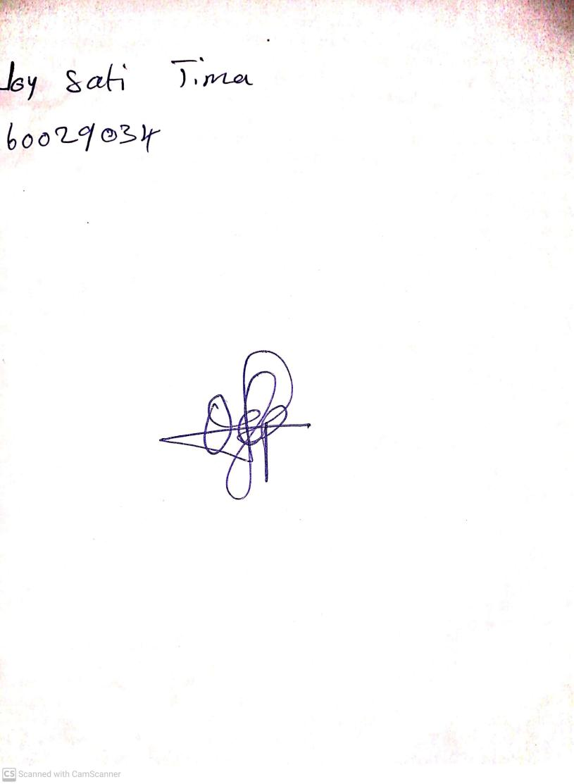

**24th May, 2024**

**Perpetual Ojoma Ocheja**

**Stream Head Nursery**