**EMERALD ROYAL INTERNATIONAL SCHOOL, MPAPE ABUJA**

**LESSON PLAN AND NOTE FOR WEEK 8 ENDING FRIDAY, 3RD NOVEMBER, 2023**

**TERM:** FIRST TERM

**WEEK:** WEEK 8

**SUBJECT:** SOCIAL STUDIES

**TOPIC:** CULTURE AND SOCIAL VALUES

**SUB-TOPIC:** BAD MORALS IN OUR SOCIETY

**DATE:** TUESDAY, 31ST OCTOBER ANDWEDNESDAY, 1ST NOVEMBER, 2023

**TIME:** 11:50 – 12:30PM AND 01:20 – 02:00PM

**DURATION:** 40 MINUTES

**PERIOD:** 6TH AND 8TH

**CLASS:** NURSERY 3

**NUMBER IN CLASS:** ELEVEN

**AVERAGE AGE:** FIVE

**SEX:** MIXED

**LEARNING OBJECTIVES:** By the end of the lesson, the pupils should be able to:

1. List the examples of bad moral values in the society.
2. Explain the examples of good morals values in the society.

**RATIONALE:** for pupils to learn identify the examples of bad moral values in the society.

**PREVIOUS KNOWLEGDE:** pupils learnt the examples of good moral values in the society.

**INSTRUCTIONAL MATERIALS:**

1. Charts.
2. Textbook

**REFERENCE MATERIALS:**

1. Social Studies for primary schools book 1 by Olufemi J. Olugasa, Olusola H. Bamidele, Felix K. Alonge, Julius O. Onwuka

**LESSON DEVELOPMENT**

|  |  |  |  |
| --- | --- | --- | --- |
| **STAGES/STEPS** | **TEACHER’S ACTIVITIES** | **PUPILS’ ACTIVITIES** | **LEARNING POINTS** |
| **INTRODUCTION** | Review previous knowledge | Respond to the teacher | To arouse the pupils’ interest. |
| **PRESENTATION**  **STEP 1** | List the examples of bad moral values.  **Examples of bad moral values**   1. Stealing 2. Fighting 3. Lying 4. Bullying 5. Back-biting | Listen attentively and learn. | Examples of bad moral values. |
| **STEP 2** | Teaches and explain the examples of bad moral values.  **Examples of good moral values**  **Stealing**  Stealing is a bad value that makes one to take what belong to another person without permission.  **Fighting**  Fighting is a bad value cause it is the use of force by a person to solve a problem.  **Lying**  This is saying or writing what is not true about a person or group of persons  **Bullying**  This is the use of one’s power to frighten or injure a weaker person.  **Back-biting**  This is saying something that is bad about someone who is not present.. | Listen attentively and learn. | Examples of bad moral values. |
| **SUMMARY** | Summarises the lesson by emphasising on the main concept and writes note on the board | Listen and copy their notes | For onward study |
| **EVALUATION** | Asks pupils to.   1. List and explain the examples of bad moral values. | Respond to the teacher’s question. | To test the pupils understanding on the lesson. |
| **CONCLUSION** | Summarizes, corrects and mark pupils’ notebooks | Submit their notebooks for marking. | Clarifying the concept. |
| **HOME WORK** | 1. List five (5) examples of bad moral values and explain any three. | Cope and return with task. | Extending lesson home. |

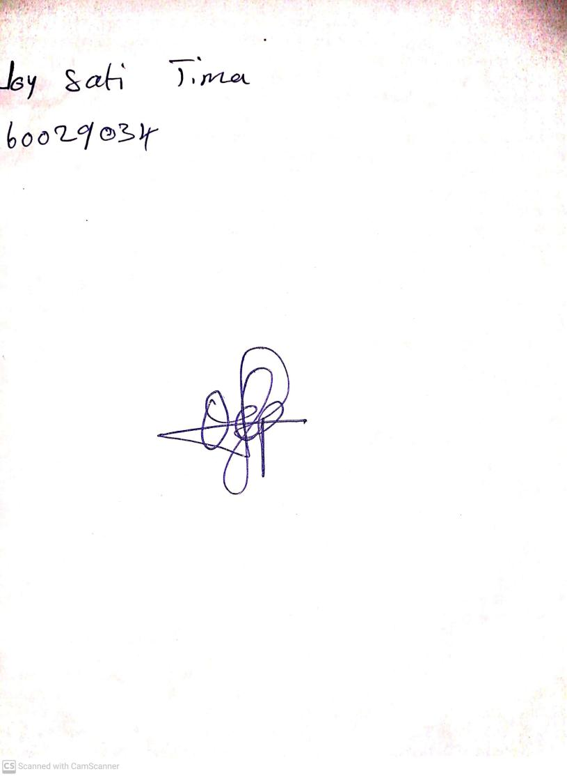

13TH October, 2023

Perpetual Ojoma Ocheja

Stream Head Nursery

NB: kindly do the necessary corrections

1. The evaluation doesn't tally with your learning objectives. (2 learning objectives and 1 evaluation).