**EMERALD ROYAL INT’L SCHOOL**

**LESSON PLAN/NOTE FOR WEEK 3 ENDING: 19TH MAY, 2023**

|  |  |
| --- | --- |
| **Term** | 3rd |
| **Week** | 3 |
| **Date** | 15/05/2023 |
| **Class** | SSS 2 |
| **Subject** | Physics |
| **Topic** | Electric field 1 |
| **Sub-topic** | Electric circuit |
| **Period** | 1 and 2 |
| **Time** | 10:30-11:50 |
| **Duration** | 80minutes |
| **Number in class** | 2 |
| **Average age** | 14years |
| **Sex** | Mixed |
| **Specific objectives** | By the end of the lesson, the students should be able to:   1. Explain electric power 2. Explain and state some examples of electrical energy conversion. 3. Explain the importance of fuses in an electric circuit. |
| **Rationale** | To enable the students understand the concepts of electric power. |
| **Previous knowledge** | Students should have been taught on electric potential difference and work done. |
| **Instructional aid** | One guide sheet for each student, a cell, an ammeter, a voltmeter, a science notebook and a science textbook. |
| **Reference** | * M.W. Anyakoha. New school physics for secondary schools. Africana first publishers PLC. page 74-88 * P.N. Okeke. Macmillan Senior Secondary Physics. Pearson. Page 44-57 |

**LESSON DEVELOPMENT**

|  |  |  |  |
| --- | --- | --- | --- |
| **STEPS** | **TEACHER’S ACTIVITIES** | **STUDENTS’ ACTIVITIES** | **LEARNING POINTS** |
| **Introduction** | The teacher introduces the lesson by explaining that electrical power arises from the flow of charges, known as current, due to the electrical energy arising from a potential difference. | The students differentiates between power and work done | To give the students a rudimentary understanding of electric power. |
| **Step I** | *Electric Power*  Electric power is the rate is which electrical energy is transferred by an electric circuit. The S.I unit of power is the watt. Electrical power is given mathematically as;  **P = $\frac{Work done (Joules)}{time taken (seconds)}$**  **P = IV---------- (1)**  **P = I2R ----------(2)**  **P = ---------(3)**  Where; **I** is electric current (A)  **V** is potential difference (volts)  **R** is resistance (ohm) | Begin to develop an idea of what electric power means.. | To ensure proper understanding of the lesson. |
| **Step II** | *Electric power conversion*  Electrical energy can be converted into other forms of energy such as;   1. Heat energy; e.g in electric irons, electric kettles, immersion heaters. Etc. 2. Mechanical energy, e,g in the movements of the blades of electric fans and in washing machines.conversion of electric energy to mechanical energy is made possible through the action of electric motors. 3. Light energy, e,g in the glow of filament lamps or bulbs. 4. Sound energy, e.g in telephone ear-piece, in music record players. | The students listen attentively the teacher’s explanation. | To ensure that all the students are carried along. |
| **Step III** | *Importance of fuses*  A fuse is simply a short length of wire of low melting point connected to an electric circuit. Its purpose is to automatically open the circuit whenever excess current might destroy the wiring or the appliance connected to it. | The students listen attentively to the teacher’s explanation. | Consolidate acquired knowledge on electric power. |
| **Summary** | Electric power is defined as the rate of doing work. It is given mathematically stated as;  **P = IV = I2R = V2/R**  The unit of power is the watt. | The students listen attentively to the teacher’s explanation. | For reference purpose. |
| **Evaluation** | The teacher evaluates the students by giving the students the following classwork.  An electric lamp is marked 240 volts. 60 watts. What is its resistance when it is operated at the correct voltage. | The students answer the question in their science notebook. | To ascertain the students level of understanding of the lesson. |
| **Conclusion** | The teacher makes correction of the classwork. | The students copy the correction in their exercise books. | For reference purpose |
| **Assignment (Homework)** | The teacher gives the students the following assignment.  Calculate the total energy developed by the system.  12v  40~  40~  1.2A | The students copy the questions into their exercise books. | To encourage critical thinking of students at home. |

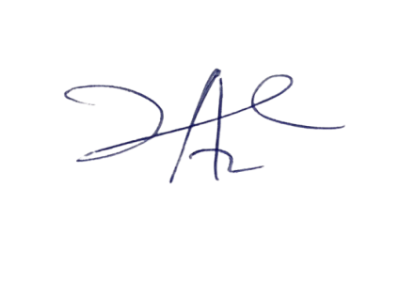

20/7/2023

Principal Head Instuctor