**EMERALD ROYAL INTERNATIONAL SCHOOL**

**MPAPE, ABUJA.**

**LESSON PLAN AND NOTE FOR WEEK 8 ENDING 01/11/2024**

**TERM: 1st**

**WEEK: 8th**

**DATE: 28/10/2024**

**CLASS: Nursery 2**

**SUBJECT: Nature studies**

**TOPIC: Body care on sickness**

**SUB—TOPIC: Meaning and types of sickness**

**PERIOD: 4th**

**TIME: 10:40—11:20am**

**DURATION: 40 minutes**

**NUMBER IN CLASS: 14**

**AVERAGE AGE: 5 years**

**SEX: Mixed**

**LEARNING OBJECTIVES: By the end of the lesson, the pupils should be able to:**

**1. Explain the meaning of sickness.**

**2. Mention the examples of sickness.**

**3. State the things to do when you are sick.**

**RATIONALE: For pupils to know the meaning of sickness and kind of sickness.**

**PREVIOUS KNOWLEDGE: Pupils have been falling sick**

**INSTRUCTIONAL MATERIALS: picture of a sick person at the hospital in Pupils text books.**

**REFERENCE MATERIALS: Basic science and technology for Nursery schools book 3 by OPEMIPO DADA.**

**LESSON DEVELOPMENT**

|  |  |  |  |
| --- | --- | --- | --- |
| **Steps** | **Teacher's activities** | **Pupils' activities** | **Learning point** |
| **Introduction** | **Teacher introduces the lesson by reviewing the previous lesson.** | **Pupils pay attention to the teacher.** | **To prepare pupils minds for the lesson ahead.** |
| **Presentation step 1** | **Teacher explains the meaning of sickness to pupils and then asks them to repeat after her.** | **Pupils listen to the teacher and repeat after her.** | **To improve pupils listening and speaking ability.** |
| **Step 2** | **Teacher mentions the examples of sickness to pupils and also asks them to repeat after her.** | **Pupils pay attention to the teacher and repeat her.** | **To enhance pupils participation in the class.** |
| **Step 3** | **Teacher state the things to do when one is sick to pupils and also asks them to repeat after her.** | **Pupils listen very attentively to the teacher and repeat after her.** | **To improve pupils speaking ability.** |
| **Board summary** | **Teacher writes the whole note of lesson on the board for pupils to copy into their books. That is;**  **Body care on sickness:**  **A sick person is a person who is not healthy.**  **Sickness is the condition of being sick or unwell.**  **Examples of sickness are:**   1. **Malaria** 2. **Stomach upset** 3. **Headaches** 4. **Diarrhoea** 5. **Conjunctivitis** 6. **Fever** 7. **Catarrh** 8. **Measles** 9. **Kwashiorkor** 10. **Cough etc.**   **What to do when you are sick:**   1. **Tell your parents or teachers when you feel sick.** 2. **Ask for your mum or dad to take you to a hospital.** 3. **Take your drugs.** 4. **Rest at home.** 5. **Eat lots of fruits and vegetables.** 6. **Eat some food to keep you strong.** 7. **Drink lots of water.** | **Pupils copy the note into their exercise books.** | **For onward study.** |
| **Evaluation** | **Teacher evaluates the lesson by asking pupils the following questions;**   1. **What is sickness?** 2. **Mention the examples of sickness.** | **Pupils answer the questions asked by the teacher.** | **To assess pupils level of understanding.** |
| **Conclusion** | **Teacher concludes the lesson by marking pupils books.** | **Pupils submit their books for marking.** | **For endorsement.** |
| **Assignment** | **Answer the following questions:**   1. **What is food?** 2. **Mention 5 types of food** 3. **List 5 reason why we eat food.** | **Pupils do their assignment at home.** | **To encourage learning at home.** |

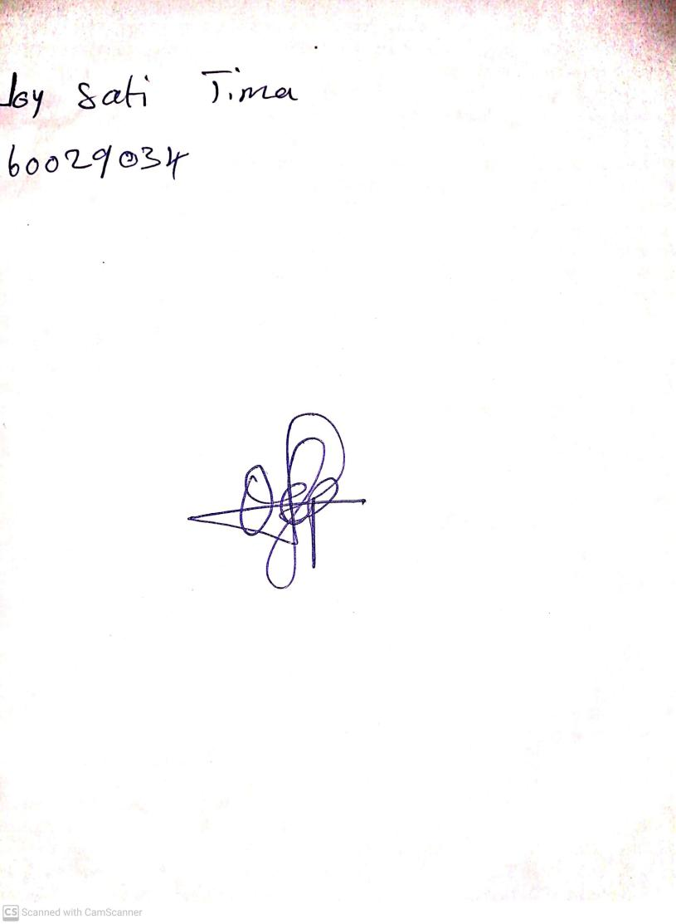

**25th October, 2024**

**Perpetual Ojoma Ocheja**

**Stream Head Nursery**