**LESSON PLAN AND NOTE FOR WEEK 6 ENDING 16/02/2024**

**Term 2nd term**

**Week 6th week.**

**Date 14th February,2024**

**Class Nursery one**

**Subject Social Norms**

**Topic Roles of the members of the family**

**Sub-topic Roles of Daddy, Mummy and Children**

**Period 2nd period**

**Time 9:05 am**

**Duration 35 minutes**

**No in class 15**

**Average Age 3 years**

**Sex Mixed**

**Specific Objectives: By the end of the lesson the pupils should be able to:**

1. **Know the roles of Daddy and Mummy.**
2. **Know the roles of Children.**

**Rationale: To ensure the pupils mention the roles of Daddy and Mummy.**

**Previous Knowledge: The pupils can mention the qualities of a good family.**

**Instructional Resources: Board,marker ,online research.**

**Reference Materials: Smart smart Civic Education by A.M Solu, T.Y Alabi, Nursery 2**

**LESSON PRESENTATION**

|  |  |  |  |
| --- | --- | --- | --- |
| **Steps** | **Teacher’s Activities** | **Pupils’ Activities** | **Learning Points** |
| **Introduction** | **The teacher introduces the topic (Roles of Daddy, Mummy and Children) to the pupils.** | **The pupils listens attentively to the teacher.** | **To arouse the pupils’ interest towards the lesson.** |
| **Step 1** | **The teacher mention the roles of daddy and mummy to the pupils which include:**  **DADDY**  **Daddy buys food for us**  **Daddy buys clothe for us**  **Daddy build big house for us**  **MUMMY**  **Mummy cooks food for us**  **Mummy takes care of us**  **Mummy cleans the house for us** | **The pupils repeats continuously the roles of daddy and mummy.** | **For proper understanding.** |
| **Step 2** | **The teacher mention the roles of children to the pupils which include:**  **CHILDREN**  **Children helps mummy and daddy to do work**  **Children respects mummy and daddy**  **Children obeys mummy and daddy.** | **The pupils repeats continuously the roles of children.** | **For better understanding** |
| **Summary** | **The teacher summarizes the lesson by asking the pupils how many of them will build big house,will buy plenty cloth,will feed mummy and daddy when they grow up?** | **The pupils echo their answers saying ME .** | **For onward study.** |
| **Evaluation** | **Question:**   1. **Mention 2 roles of daddy?** 2. **Mention 2 roles of mummy?** 3. **Mention 2 roles of children?** | **The pupils answer the questions accordingly.** | **To ascertain the pupils’ understanding.** |
| **Conclusion** | **The teacher summarizes,reacts,and corrects the pupils.** | **The teacher gives answers to the teacher’s question.** | **To consolidate the lesson.** |
| **Assignment** | **Question:**   1. **Mention 2 roles of daddy?** 2. **Mention 2 roles of mummy?** 3. **Mention 2 roles of children?** | **The pupils copy and do their homework at home.** | **To encourage learning while at home.** |

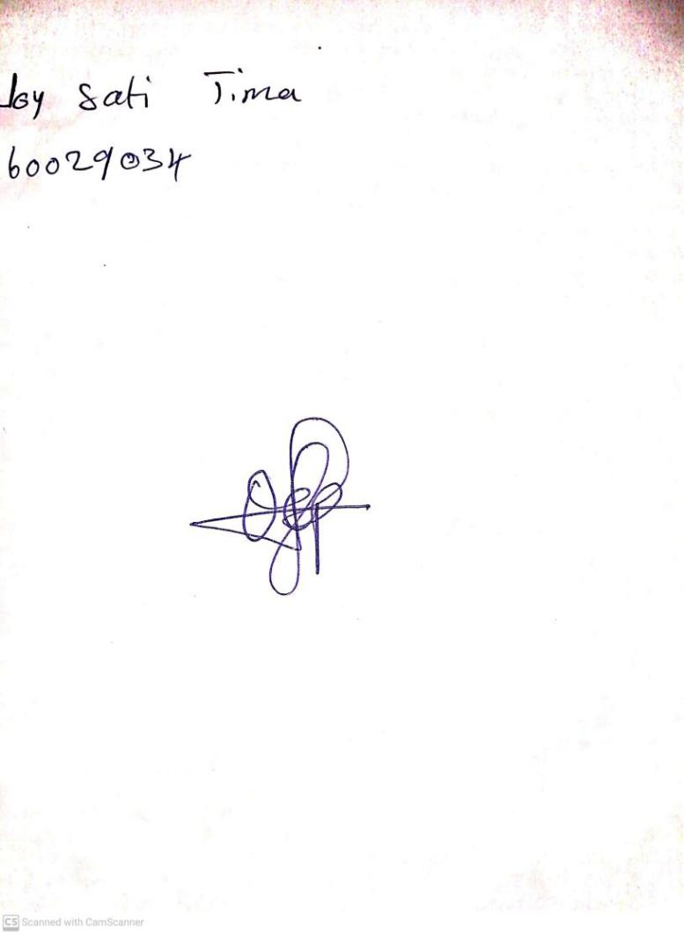

9TH February, 2024

Perpetual Ojoma Ocheja

Stream Head Nursery