**EMERALD ROYAL INTERNATIONAL SCHOOL**

**MPAPE, ABUJA.**

**LESSON PLAN AND NOTE FOR WEEK 7 ENDING 27TH OCTOBER,2023**

TERM : First term.

WEEK : 7

SUBJECT: Social Norms

TOPIC: Greetings.

SUB-TOPIC: Saying " good afternoon".

DATE: 25/8/2023

DURATION: 40 minutes

TIME: 10:40-11:20

PERIOD: 5th

CLASS: pre-nursery

NUMBER OF PUPILS:

AVERAGE AGE: 2

SEX: Mixed

SPECIFIC OBJECTIVES: By the end of the lesson, the pupils should be able to:-

1. Say good afternoon.

2. Understand when to greet "good afternoon."

RATIONALE: For pupils to know good etiquettes and be respectful.

PREVIOUS KNOWLEDGE: Pupils are familiar with the word " good morning".

INSTRUCTIONAL MATERIALS: picture book.

REFERENCE: Smart start Civic education for nursery Schools book 1 by T.Y. Alabi and A. M. Solu.

LESSON DEVELOPMENT

|  |  |  |  |
| --- | --- | --- | --- |
| Stages/steps | Teacher's activities | Pupils' activities | Learning points |
| Introduction | Teacher introduces the lesson by singing nursery rhymes for the pupils. | Pupils sing the rhymes along with the teacher. | To arouse the interest of the pupils. |
| Presentation  Step 1 | Teacher tells the pupils to repeat after the teacher to say "good afternoon". | Pupils say the " good afternoon" after the teacher repeatedly. | To improve better understanding. |
| Step 2 | Teacher explains to the pupils in simple term when to greet good afternoon" when they return back home from school, they should greet good afternoon to their parents". Teacher also encourages the pupils to always greet good afternoon when someone enters the classroom in the afternoon. | Pupils pay attention to the teacher's explanation. Pupils also promise to always greet their parents, elders and teachers . | For better understanding of the lesson. |
| Summary | Teacher summarizes the lesson by showing pupils picture of children greeting their parents. | Pupils pay attention to the teacher's explanation. | To ensure better understanding of the lesson. |
| Evaluation | Teacher asks the pupils :-  What do we greet in the afternoon?  When do we greet good afternoon? | Pupils respond to the teacher's questions correctly. | To assess pupils level of understanding of the lesson. |
| Conclusion | Teacher ends the lesson by correcting the pupils who were not able to answer the questions. | Pupils take the corrections given to them by the teacher. | For onwards learning. |

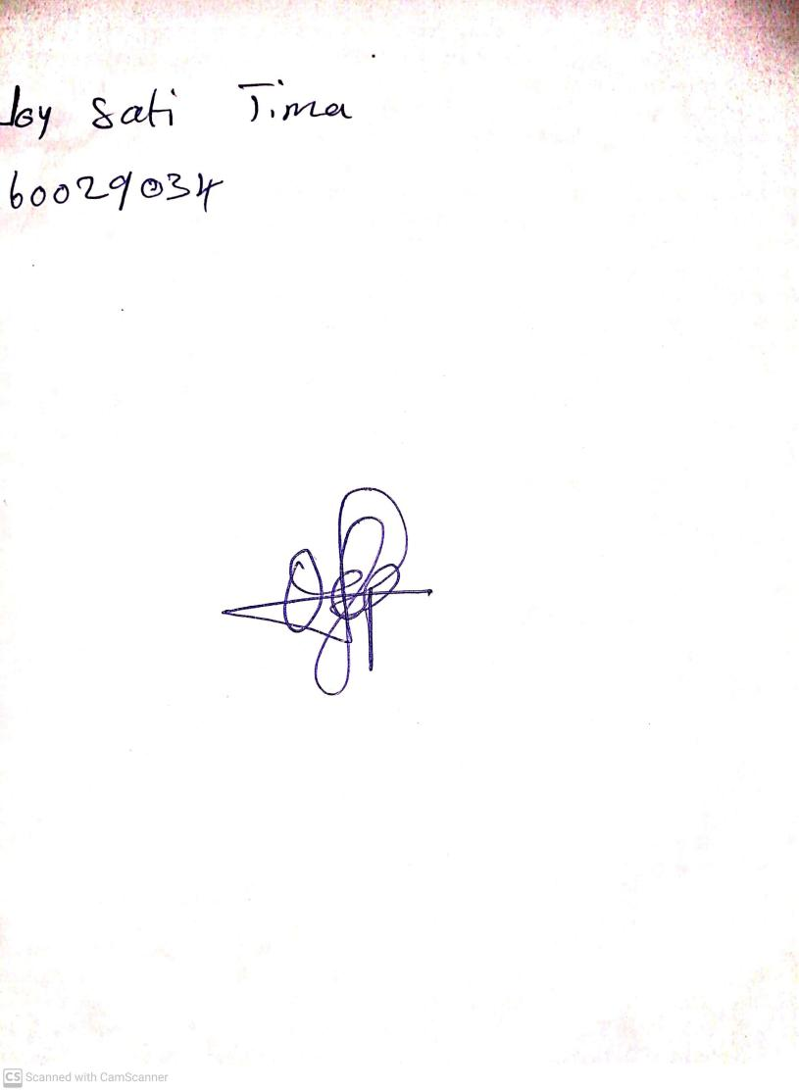

25th August, 2023

Perpetual Ojoma Ocheja

Stream Head Nursery