**LESSON PLAN AND NOTE 1 FOR WEEK 6 ENDING 31/5/2024**

**Term 3rd term**

**Week 6th week**

**Date 27/5/2024**

**Class Nursery one**

**Subject Letter work**

**Topic Vowel Sounds.**

**Sub-topic Meaning of Vowel sounds.**

**Period 2nd period**

**Time 9:05 am**

**Duration 35 minutes**

**No in class 14**

**Average Age 3 years**

**Sex Mixed**

**Specific Objectives: By the end of the lesson the pupils should be able to;**

1. **Define vowel sounds.**
2. **List the examples of vowel sounds.**

**Rationale: To make sure the pupils define & mention vowel sounds**

**Previous knowledge: The pupils can write two letter words.**

**Instructional Resources: Chart, board, marker, exercise books, pencils.**

**Reference Materials: Online Research,chart,board.**

**LESSON PRESENTATION**

|  |  |  |  |
| --- | --- | --- | --- |
| **Steps** | **Teacher’s Activities** | **Pupils’ Activities** | **Learning points** |
| **Introduction** | **The teacher introduces the topic (Vowel sounds) to the pupils.** | **The pupils listen attentively to the teacher.** | **To arouse the interest of the pupils.** |
| **Step 1** | **The teacher starts by explaining vowel sounds as “any sound that a letter makes that is not a consonant sound”.** | **The pupils repeat after the teacher meaning of vowel sounds.** | **For proper understanding.** |
| **Step 2** | **The teacher mentions the vowel sounds**  **a e**  **i o u** | **The pupils repeats after the teacher the vowel sounds.** | **For better understanding.** |
| **Summary** | **The teacher summarizes the lesson by sounding the vowel sound**  **a e i**  **o u** | **The pupils can sound the vowel sounds.** | **For onward study.** |
| **Evaluation** | **Question:**   1. **How many vowel sounds do we have?.** 2. **Mention the vowel sound ?** | **The pupils answer the question correctly.** | **To ascertain the pupils’ understanding.** |
| **Conclusion** | **The teacher summarizes, reacts & corrects the pupils.** | **The pupils answer to the teacher’s questions.** | **To consolidate the lesson.** |
| **Assignment** | **Question:**  **How many vowel sounds do we have?.**  **Mention the vowel sound ?** | **The pupils copy and do their homework at home.** | **To encourage learning while at home.** |

**LESSON PLAN AND NOTE 2 FOR WEEK 6 ENDING 31/5/2024**

**Term 3rd term**

**Week 6th week**

**Date 29/5/2024**

**Class Nursery one**

**Subject Letter work**

**Topic Vowel sounds**

**Sub-topic Identification of vowel sounds.**

**Period 2nd period**

**Time 9:32 am**

**Duration 35 minutes**

**No in class 14**

**Average Age 3 years**

**Sex Mixed**

**Specific Objectives: By the end of the lesson the pupils should be able to;**

1. **Identify vowel sounds**
2. **Mention words that starts with /a/, /e/, /I/.**

**Rationale: To make the pupils identify &mention words with /a/, /e/,/I/.**

**Previous knowledge: The pupils can define and list examples of vowel sounds**

**Instructional Resources: Crayon, board, marker, exercise books, pencils.**

**Reference Materials: Online Research,marker,board.**

**LESSON PRESENTATION**

|  |  |  |  |
| --- | --- | --- | --- |
| **Steps** | **Teacher’s Activities** | **Pupils’ Activities** | **Learning points** |
| **Introduction** | **The teacher introduces the topic (Vowel sounds) to the pupils.** | **The pupils listen attentively to the teacher.** | **To arouse the interest of the pupils.** |
| **Step 1** | **The teacher leads the pupils to identify vowel sounds** | **The pupils identify the vowel sounds.** | **For proper understanding.** |
| **Step 2** | **The teacher mention words that start with vowel /a/ /e/ /I/**  **/a/--- ‘ant’, ‘arm’.**  **/e/---’egg’.**  **/i/---’ink’.** | **The pupils listen to the teacher.** | **For better understanding.** |
| **Summary** | **The teacher summarizes the lesson by identifying words that start with vowel /a/, /e/, /I/.** | **The pupils have knowledge of identifying vowels /a/, /e/, /I/.** | **For onward study.** |
| **Evaluation** | **Question:**  **Identify the vowel sound /i/?**  **Mention words that start with vowel /a/.** | **The pupils answer the question correctly.** | **To ascertain the pupils’ understanding.** |
| **Conclusion** | **The teacher summarizes, reacts & corrects the pupils.** | **The pupils answer to the teacher’s questions.** | **To consolidate the lesson.** |
| **Assignment** | **Question:**  **Identify the vowel sound /i/?**  **Mention words that start with vowel /a/.**  **Mention words that start with vowel /o/?** | **The pupils copy and do their homework at home.** | **To encourage learning while at home.** |

**LESSON PLAN AND NOTE 3 FOR WEEK 6 ENDING 31/5/2024**

**Term 3rd term**

**Week 6th week**

**Date 31/5/2024**

**Class Nursery one**

**Subject Letter work**

**Topic Vowel sounds**

**Sub-topic Words that start with vowel /o/,/u/**

**Period 2nd period**

**Time 9:43am**

**Duration 35 minutes**

**No in class 14**

**Average Age 3 years**

**Sex Mixed**

**Specific Objectives: By the end of the lesson the pupils should be able to;**

1. **Words that starts with vowel /o/,/u/.**
2. **Write the five vowel sounds.**

**Rationale: To make the pupils write vowels sounds.**

**Previous knowledge: The pupils have identify & name words that start with /a/,/e/,/I/**

**Instructional Resources: Cardboard , exercise books, pencils.**

**Reference Materials: Online Research,Cardboard.**

**LESSON PRESENTATION**

|  |  |  |  |
| --- | --- | --- | --- |
| **Steps** | **Teacher’s Activities** | **Pupils’ Activities** | **Learning points** |
| **Introduction** | **The teacher introduces the topic (Vowel sounds) to the pupils.** | **The pupils listen attentively to the teacher.** | **To arouse the interest of the pupils.** |
| **Step 1** | **The teacher mention words that start with vowel /o/,/u/**  **/o/--- ‘oil’, ‘oat’**  **/u/--- ‘us’, ‘up’.** | **The pupils actively listens to the teacher.** | **For proper understanding.** |
| **Step 2** | **The teacher guides the pupils to write the five vowel sounds**   |  |  | | --- | --- | | **a** | **e** | |  |  | | **i** | **o** | |  |  | | **u** | **u** | |  |  | | **The pupils write the five vowel sounds.** | **For better understanding.** |
| **Summary** | **The teacher summarizes the lesson by sounding five vowel sounds.** | **The pupils understand the lesson.** | **For onward study.** |
| **Evaluation** | **Question:**  **Mention words that start with the five vowel sounds below**  **/a/ -----**  **/e/ -----**  **/i/ ------**  **/o/ -----**  **/u/ -----**  **Write the vowel sounds you know?** | **The pupils answer the question correctly.** | **To ascertain the interest of the pupils.** |
| **Conclusion** | **The teacher summarizes, reacts & corrects the pupils.** | **The pupils gives answers to the teacher.** | **To consolidate the lesson.** |
| **Assignment** | **Mention words that start with the five vowel sounds below**  **/a/ -----**  **/e/ -----**  **/i/ ------**  **/o/ -----**  **/u/ -----**  **Write the five vowel sound in the box below**   |  |  | | --- | --- | | **a** | **e** | |  |  | | **i** | **o** | |  |  | | **u** | **u** | |  |  | | **The pupils copy and do their homework at home.** | **To encourage learning while at home.** |

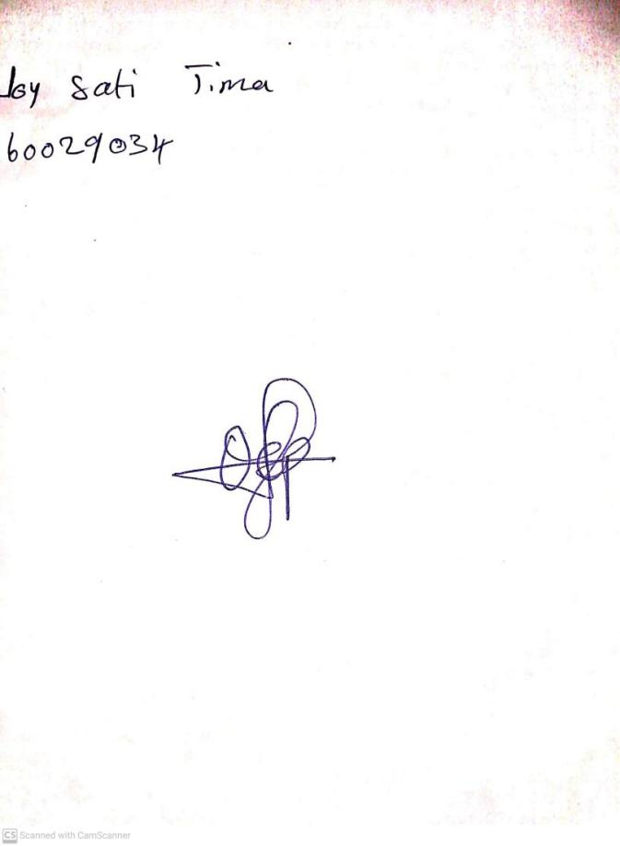

24TH May, 2024

Perpetual Ojoma Ocheja

Stream Head Nursery