**EMERALD ROYAL INTERNATIONAL SCHOOL**

**MPAPE, ABUJA.**

**LESSON PLAN AND NOTE FOR WEEK 5 ENDING 24 MAY,2024.**

TERM : Third term.

WEEK : 5th

SUBJECT: Social Norms

TOPIC: My classroom

SUB-TOPIC: Things in the Classroom

DATE: 22/5/2024

DURATION: 40 minutes

TIME: 10:40-11:20

PERIOD: 5th

CLASS: pre-nursery

NUMBER OF PUPILS: 19

AVERAGE AGE: 2

SEX: Mixed

SPECIFIC OBJECTIVES: By the end of the lesson, the pupils should be able to:-

1. Say the class they are in.

2. Identify things in the classroom.

1. State the uses of things found in the classroom .

RATIONALE: For pupils to be conversant with their classroom.

PREVIOUS KNOWLEDGE: Pupils have the in a classroom for quite some time and have been seeing different things in the class.

INSTRUCTIONAL MATERIALS: The classroom.

REFERENCE: Smart start Civic education for nursery Schools book 1 by T.Y. Alabi and A. M. Solu.

LESSON DEVELOPMENT

|  |  |  |  |
| --- | --- | --- | --- |
| Stages/steps | Teacher's activities | Pupils' activities | Learning points |
| Introduction | Teacher introduces the lesson by asking the pupils to look around the class and tell her what they see. | Pupils look around and tell the teacher that they see:- chair, board, television and table. | To arouse the interest of the pupils for the new lesson. |
| Presentation  Step 1 | Teacher teaches the pupils to say the class they are in. That's.  "I am in Pre-nursery".  Teacher asks the pupils to repeat after the teacher. | Pupils practice to say the class they are in repeatedly. | For proper understanding of the lesson. |
| Step 2 | Teacher leads the pupils to identify things found in the classroom. | Pupils identify things found in the classroom as:-   1. Chair. 2. Television. 3. Table 4. Books 5. Wall clock. | To ensure active participation. |
| Step 3 | Teacher also explains the uses of things found in the classroom as:-  Chair:- we sit on the chair.  Table:- we eat and write on the table.  Pencil:- we write with our pencil. | Pupils pay attention to the teacher and repeat after her. | To ensure better understanding of the lesson. |
| Summary | Teacher summarizes the lesson by going over the lesson again for more clarification. | Pupils pay attention to the teacher and repeat after the her. | To ensure proper understanding of the lesson. |
| Evaluation | Teacher asks the pupils :-   1. What class are you? 2. What are you sitting on? 3. Identify the objects in the classroom. | Pupils answer the questions correctly. | To assess the level of pupils understanding of the lesson. |
| Conclusion | Teacher ends the lesson by singing rhymes for the pupils. | Pupils sing along with the teacher. | To consolidate the lesson. |
| Assignment | Teacher encourages the pupils to practice the class they are in. | Pupils do the assignment at home . | To encourage learning at home. |

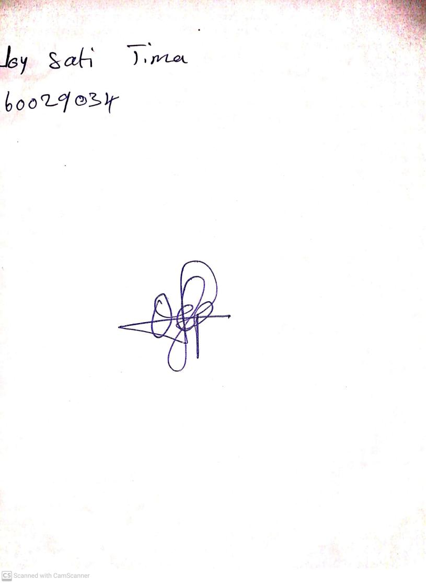

**17th May, 2024**

**Perpetual Ojoma Ocheja**

**Stream Head Nursery**