**EMERALD ROYAL INT’L SCHOOL**

**LESSON PLAN/NOTE FOR WEEK 2 ENDING: 12TH MAY, 2023**

|  |  |
| --- | --- |
| **Term** | 3rd |
| **Week** | 2 |
| **Class** | SS1 |
| **Date** | 09/05/2023 |
| **Subject** | Data Processing |
| **Topic** | Formatting the Worksheet |
| **Sub-Topic** | Aligning cells |
| **Period** | 8th |
| **Time** | 1:20 – 2:00 |
| **Duration** | 40minutes |
| **Number in class** | 7 |
| **Average age** | 14years |
| **Sex** | Mixed |
| **Specific Objectives** | By the end of the lesson, students should be able to:   1. Align texts 2. Align cells |
| **Rationale** | To teach students how to align cells |
| **Previous knowledge** | Students have been taught how to write complex formulas in their previous class |
| **Instructional material** | Computer set with Microsoft Excel software |
| **Reference** | Data Processing for Senior Secondary Education (SS1 – 3) by Hiit Plc |

|  |  |  |  |
| --- | --- | --- | --- |
| **STEPS** | **TEACHER’S ACTIVITIES** | **STUDENTS’ ACTIVITIES** | **LEARNING POINTS** |
| Introduction | The teacher introduces the lesson by asking the students to expalin the processes involved in writing complex. | Students answer the teacher’s question orally. | To arouse the students interest for the lesson. |
| Step I | *Teacher explains how text are aligned as thus:*  **Text alignment**  By default, any text entered into your worksheet will be aligned to the bottom-left of a cell, while any numbers will be aligned to the bottom-right. Changing the alignment of your cell content allows you to choose how the content is displayed in any cell, which can make your cell content easier to read.  The different text align options are:   * Left align - aligns content to the left border of the cell. * Centre align - aligns content an equal distance from the left and right borders of the cell. * Right align - aligns content to the right border of the cell. * Top align - aligns content to the top border of the cell. * Middle align - aligns content an equal distance from the top and bottom border of the cell. * Bottom align - aligns content to the bottom border of the cell. | Students listen as the teacher explains | To ensure proper understanding of the lesson |
| Step II | *The teacher describe the process of aligning cells as thus:*  **Cell Alignment**  If you want to change the way data appears in a cell, you can rotate the font angle, or change the text alignment.  *How to change the orientation of text in a cell:*   1. Select a cell, row, column, or a range 2. Select Home > Orientation  IMG_256, and then select an option. 3. You can rotate your text up, down, clockwise, or counterclockwise, or align text vertically:   *How to rotate text to a precise angle:*   1. Select a cell, row, column, or a range. 2. Select Home > Orientation  IMG_256  > Format Cell Alignment. 3. Under Orientation on the right side, in the Degrees box, use the up or down arrow to set the exact number of degrees that you want to rotate the selected cell text.   Positive numbers rotate the text upward. Negative numbers rotate the text downward. | Students participate in the practicals. | To create a platform where all students are carried along. |
| Summary | The teacher summarizes the lesson thus:  With MS Excel, cell alignment is how your text or numbers are positioned in the cell. You can align vertically, meaning towards the top, the middle or the bottom. And you can also align horizontally, meaning to the left, the centre or the right. Excel has its own defaults for alignment too. | Students pay attention and copy the note into their exercise books. | For reference purpose |
| Evaluation | The teacher asks the students to explain the process involved in aligning cells in Ms Excel. | Students answer the question orally | To ascertain the students level of understanding of the lesson |
| Conclusion | The teacher corrects the students where necessary. | Students take note of the correction(s) made | To ensure proper understanding of the lesson |
| Assignment | *The teacher gives the following assignment.*  How are texts aligned in Ms Excel? | Students copy the assignment in their exercise books | To encourage studying at a home. |

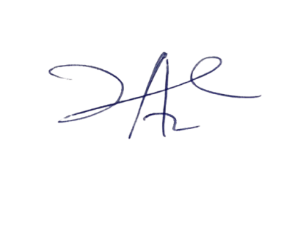

24/5/2023

Principal Head Instuctor