EMERALD ROYAL INTERNATIONAL SCHOOL

MPAPE, ABUJA.

LESSON PLAN AND NOTE FOR WEEK 3 ENDING 10TH MAY, 2024.

TERM: Third term.

WEEK: 3rd

SUBJECT: Nature studies.

TOPIC: Floating objects

SUB-TOPIC: Meaning of floating objects and examples of floating objects.

DATE: 9/5/2024

DURATION: 40 minutes

TIME: 08:50-09:30

PERIOD: 3rd

CLASS: Pre-nursery

NUMBER OF PUPILS: 19

AVERAGE AGE: 2 years

SEX: Mixed

SPECIFIC OBJECTIVES: By the end of the lesson, the pupils should be able to:-

I Meaning of floating objects.

2. Mention the examples of floating objects.

RATIONALE: For Pupils to know the objects that stays on top of water

PREVIOUS KNOWLEDGE: Pupils have been taught the meaning of water

INSTRUCTIONAL MATERIALS: pencil, pieces of paper and water.

REFERENCE: Showers kiddies books Elementary science book nursery 1 by Showers kiddies books.

LESSON DEVELOPMENT

|  |  |  |  |
| --- | --- | --- | --- |
| Stages/steps | Teacher's activities | Pupils' activities | Learning points |
| Introduction | Teacher introduces the lesson by going over the previous lesson which was on sources of water. After that, the teacher introduces the lesson as " Floating objects". | Pupils listen to the teacher as she is reviewing the previous lesson and introducing the new lesson. | To arouse the interest of the pupils. |
| Presentation  Step 1 | Teacher defines floating objects to the pupils as:-  "Floating objects are those things that stays on top of water."  Teacher asks the pupils to repeat after her. | Pupils listen to the teacher and repeat after the teacher. | For better understanding of the lesson. |
| Step 2 | Teacher leads the pupils to mention the things that can stay on top of water. | Pupils mention the things that can stay on top of water. Examples:-   1. pencil. 2. Pieces of paper. 3. Feathers. 4. Plastic cups. 5. Plastic plates.etc. | For active class room participation. |
| Summary | Teacher summarizes the lesson by going over the lesson again for more understanding. | Pupils listen attentively to the teacher as she is going over the lesson. | To ensure better understanding. |
| Evaluation | Teacher asks the Pupils to:-   1. define floating objects. 2. mention the floating objects. | Pupils answer the teacher's questions correctly. | To ascertain the level of pupils understanding of the lesson. |
| Conclusion | Teacher concludes the lesson by demonstrating why objects floats by pouring water inside a bucket and putting pieces of paper inside the water to show to the pupils that when an object is light it stays on top of the water. | Pupils watch the teacher and also participate in the demonstration of the floating objects. | To improve the pupils pyschcomotor skills. |
| Assignment | Teacher encourages the pupils to repeat the demonstration at home. | Pupils do the assignment at home. | To encourage Learning at home. |

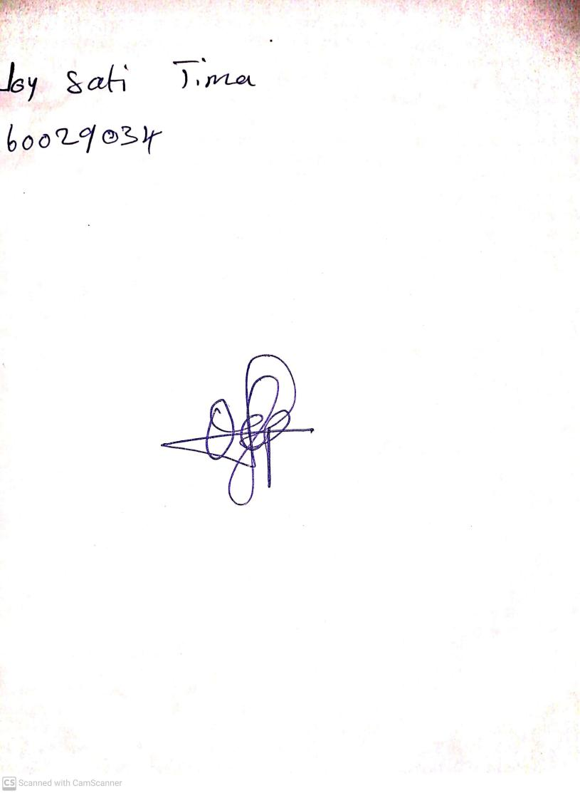

**3RD May, 2024**

**Perpetual Ojoma Ocheja**

**Stream Head Nursery**