**EMERALD ROYAL INTERNATIONAL SCHOOL**

**MPAPE, ABUJA.**

**LESSON PLAN AND NOTE FOR WEEK 7 ENDING 27/10/2023**

TERM: FIRST

WEEK: 7TH

DATE: 23/10/2023

CLASS: NURSERY 2

SUBJECT: SOCIAL NORMS

TOPIC: SAVINGS .

SUB-TOPIC: MEANING OF SAVING AND THINGS WE CAN SAVE.

PERIOD: 2ND PERIOD AFTER LONG BREAK

TIME: 11: 20- 12: 00PM

DURATION: 40 MINUTES.

NUMBER IN CLASS: 14

AVERAGE AGE: 5 YEARS.

SEX: MIXED.

SPECIFIC OBJECTIVES: BY THE END OF THE LESSON,THE PUPILS SHOULD BE ABLE TO:

1. EXPLAIN THE MEANING OF SAVINGS
2. MENTION THE THINGS WE CAN SAVE
3. STATE THE PLACES WE CAN SAVE.

RATIONALE: FOR PUPILS TO KNOW HOW TO SAVE THINGS.

PREVIOU KNOWLEDGE: PUPILS HAVE LEARNT ABOUT HOW TO BE RESPONSIBLE IN PREVIOUS LESSON.

INSTRUCTIONAL MATERIALS: MONEY, JEWELRIES, AND BOOKS.

REFERENCE MATERIALS: GOOGLE.COM

**LESSON DEVELOPMENT**

|  |  |  |  |
| --- | --- | --- | --- |
| STAGES/STEPS | TEACHER’S ACTIVITIES | PUPILS’ ACTIVITIES | LEARNING POINTS |
| INTRODUCTION | Teacher introduces the lesson by reviewing the previous lesson. | Pupils pay attention to the teacher. | To arouse pupils interest for the lesson ahead. |
| PRESENTATION  STEP 1 | Teacher explains the meaning of saving to pupils and then asks them to repeat after her. | Pupils listen attentively to the teacher and repeat after her. | For proper understanding . |
| STEP 2 | Teacher mentions the things we can save to pupils and also asks them to repeat after her. | Pupils pay attention to the teacher and repeat after her. | For better understanding of the lesson. |
| STEP 3 | Teacher states the places we can save to pupils and also asks them to repeat after her. | Pupils listen very attentively to the teacher and repeat after her. | To enhance pupils speaking ability. |
| BOARD SUMMARY | Teacher summarizes the lesson by writing the whole note of lesson on the board for pupils to copy into their books. That is;  SAVINGS:  Savings is the act of keeping our valuable items for future use.  THINGS WE CAN SAVE:   1. Money 2. Jewelries 3. Books 4. Certificate 5. Cloths etc.   PLACES WE CAN SAVE:   1. Bank 2. Box 3. Shelves 4. Cupboard 5. Store 6. Cabinet cabinet. | Pupils copy the note into their exercise books. | For onward study. |
| EVALUATION | Teacher evaluates the lesson by asking the following questions;   1. What is savings?. 2. Mention the things we can save. 3. State the places we can save. | Pupils answer the questions asked by the teacher. | To assess pupils level of understanding. |
| CONCLUSION | Teacher concludes the lesson by marking pupils books. | Pupils submit their books for marking. | For endorsement. |
| ASSIGNMENT | 1. What are harmful traditional practices? 2. List 5 examples of harmful traditional practices. | Pupils do their assignment at home. | To encourage learning at home. |

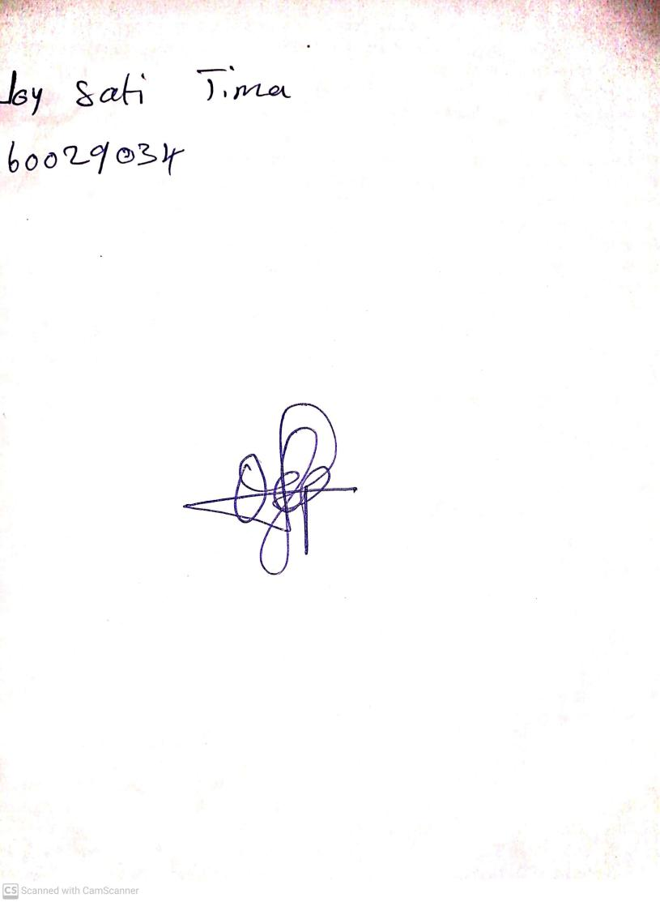

18th September, 2023

Perpetual Ojoma Ocheja

Stream Head Nursery