EMERALD ROYAL INTERNATIONAL SCHOOL

MPAPE, ABUJA.

LESSON PLAN AND NOTE FOR WEEK 1 ENDING 5TH MAY,2023

TERM: Third term.

WEEK: First

SUBJECT: Nature studies.

TOPIC: Water

SUB-TOPIC: Meaning of water and qualities of a good water.

DATE: 4/5/2023

DURATION: 40 minutes

TIME: 08:50-09:30

PERIOD: 3rd

CLASS: Pre-nursery

NUMBER OF PUPILS: 11

AVERAGE AGE: 2 years

SEX: Mixed

SPECIFIC OBJECTIVES: By the end of the lesson, the pupils should be able to:-

I State the meaning of water

2. State the qualities of a good water.

RATIONALE: For Pupils to know the qualities of good water

PREVIOUS KNOWLEDGE: Pupils have been drinking good water.

INSTRUCTIONAL MATERIALS: Table, chair, Pupils in the class .

REFERENCE: Showers kiddies books Elementary science book nursery 1 by Showers kiddies books.

LESSON DEVELOPMENT

|  |  |  |  |
| --- | --- | --- | --- |
| Stages/steps | Teacher's activities | Pupils' activities | Learning points |
| Introduction | Teacher introduces the lesson by singing a nursery rhyme as:-  Water Water water  Water is life.  Anytime am thirsty.  I drink clean water. | Pupils listen to the teacher and practice the rhyme and sing along with the teacher.. | To arouse the interest of the pupils. |
| Presentation  Step 1 | Teacher defines water as:-  " Water is a liquid that is colourless,odourless and tasteless.  Teacher asks the pupils to repeat after her. | Pupils listen to the teacher and repeat after the teacher. | For better understanding of the lesson. |
| Step 2 | Teacher list the qualities of a good water for the pupils as:-   1. A good water is colourless. 2. It is odourless. 3. It is tasteless. 4. It is liquid.   Teacher asks the pupils to repeat after the teacher. | Pupils repeat after the teacher to list the qualities of a good water. | For better understanding of the lesson. |
| Summary | Teacher summarizes the lesson by going over the lesson again for more understanding. | Pupils listen attentively to the teacher as she is going over the lesson. | To ensure better understanding. |
| Evaluation | Teacher asks the Pupils to :-   1. Define water. 2. State the qualities of a good water. | Pupils answer the teacher's questions correctly. | To ascertain the level of pupils understanding of the lesson. |
| Conclusion | Teacher concludes the lesson by singing nursery rhymes for the pupils | Pupils sing along with the teacher. | To improve the pupils speaking ability. |
| Assignment | Teacher encourages the pupils to always look into the water before drinking to make sure that the water is clean. | Pupils do the assignment at home. | To encourage Learning at home. |

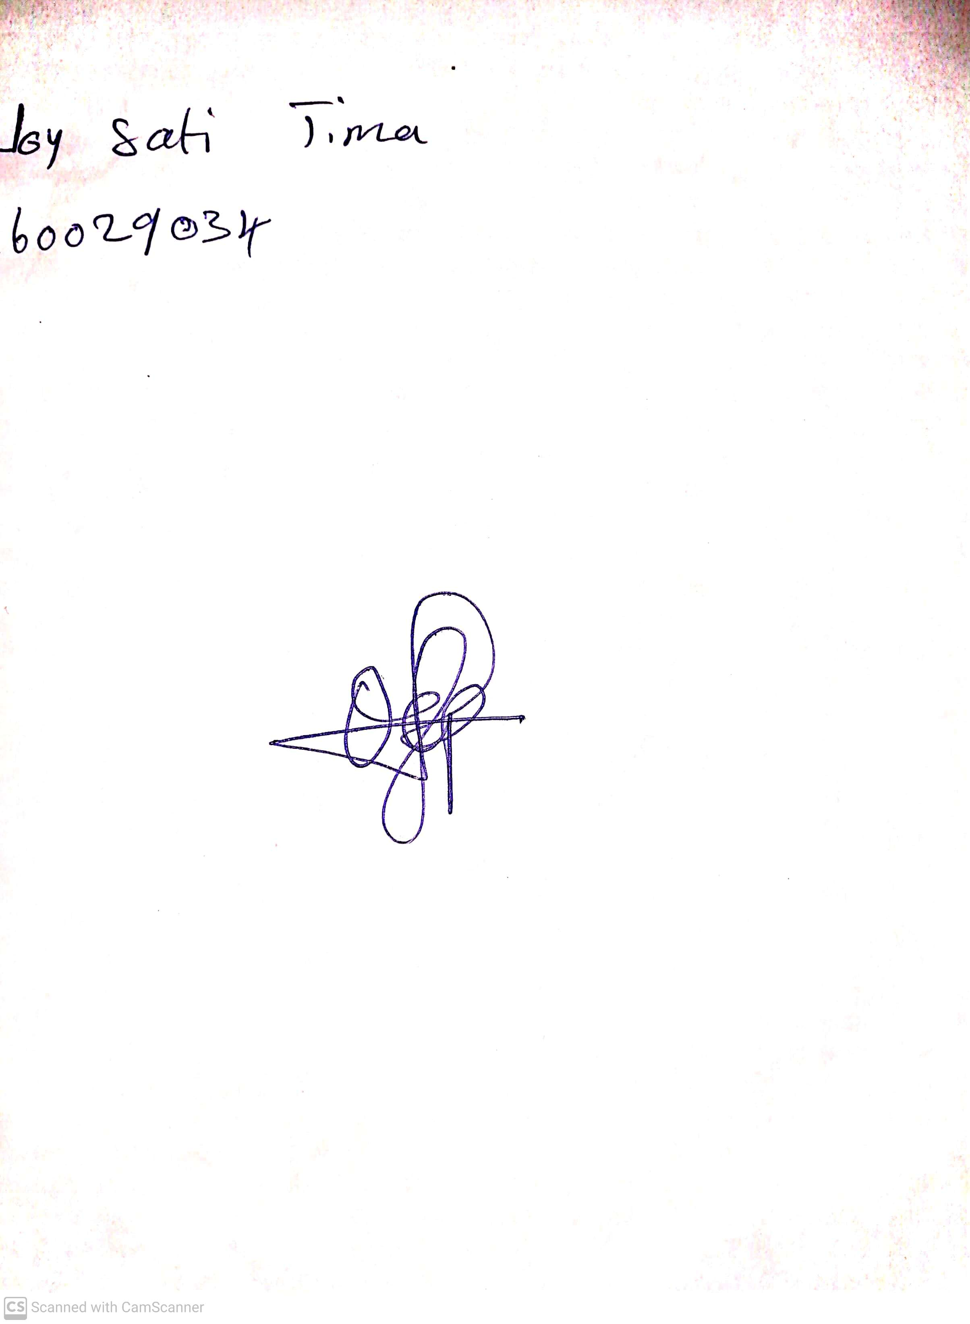

29th April, 2023

Perpetual Ojoma

Stream Head Nursery