**EMERALD ROYAL INTERNATIONAL SCHOOL MPAPE, ABUJA**

**LESSON PLAN AND NOTE FOR WEEK 8 PERIOD 1 ENDING 01/03/2024**

**TERM: 2nd**

**WEEK: 8th**

**DATE: 26/02/2024**

**CLASS: Nursery 2**

**SUBJECT: Number work**

**TOPIC: Fraction**

**SUB—TOPIC: Meaning of Fraction and part of Fraction.**

**PERIOD: 3rd**

**TIME: 08:50—09:30am**

**DURATION: 40 minutes**

**NUMBER IN CLASS: 13**

**AVERAGE AGE: 5 years**

**SEX: Mixed**

**LEARNING OBJECTIVES: By the end of the lesson, the Pupils should be able to:**

**1. Define Fraction**

**2. Explain the parts of fraction and examples.**

**RATIONALE: For pupils to know the meaning and part of fraction.**

**PREVIOUS KNOWLEDGE: Pupils learnt multiplication table 3 in their previous Lesson.**

**INSTRUCTIONAL MATERIALS: An orange fruit, a slice of bread, and a cup of water.**

**REFERENCE MATERIALS: My choice of mathematics stage 3.**

**LESSON DEVELOPMENT**

|  |  |  |  |
| --- | --- | --- | --- |
| **Steps** | **Teacher's activities** | **Pupils' activities** | **Learning point** |
| **Introduction** | **Teacher introduces the lesson by dividing an orange fruit into two equal parts and then asks Pupils, class what did I just do?** | **Pupils pay attention and answer the question ask by the teacher.** | **To prepare pupils minds for the lesson ahead.** |
| **Presentation step 1** | **Teacher defines fraction to pupils and then asks them to repeat after him or her.** | **Pupils listen to the teacher and repeat after him or her.** | **To improve Pupils listening and speaking ability.** |
| **Step 2** | **Teacher explains the parts of fraction with some examples on the board.** | **Pupils pay attention to the teacher as he or she explain.** | **For better understanding.** |
| **Board summary** | **Teacher writes the whole note of lesson on the board for pupils to copy into their books. That is;**  **FRACTION: HALF(½)**  **A fraction is a part of a whole number, and a way to split up a number into equal parts.**  **A fraction has two parts.**  **The number on the top of the line is called the numerator.**  **The number below the line is called the denominator.**  **Examples**  **1 Numerator**  **____**  **2 Denominator**  **A half is one part of two equal pieces . it is written ½.**  **This means one out of two equal parts.**  **Examples**    **½**  **½**  **A quarter is one part of four equal pieces. It is written ¼.**  **This means one part out of four equal parts.**  **Examples** | **Pupils copy the note into their exercise books.** | **For onward study.** |
| **Evaluation** | **Teacher evaluates the lesson by asking the following questions.**  **1. What is a fraction?**  **2. In fraction, the number on top of a line is called_____**  **3. The number below the line is called_____**  **4. One part of two equal pieces is called half while one part of four equal pieces is called_______** | **Pupils answer the questions ask by the teacher.** | **To assess Pupils level of understanding.** |
| **Conclusion** | **Teacher concludes the lesson by marking pupils books.** | **Pupils submit their books for marking.** | **To make corrections where necessary.** |
| **Assignment** | **Answer all the following questions**  **1. Colour the shapes to show fractions.**  **2. Count and write the parts of each shape below.**    **3. Draw a line to match each of the shaded circles to its fraction and to its word form** | **Pupils do their assignment at home.** | **To encourage learning at home.** |

**LESSON NOTE/PLAN FOR WEEK 8 PERIOD 2 ENDIND 01/03/2024**

**TERM: 2nd**

**WEEK: 8th**

**DATE: 30/02/2024**

**CLASS: Nursery 2**

**SUBJECT: Number work**

**TOPIC: Fraction: Half(½)**

**SUB—TOPIC: Addition of fractions with the same denominator.**

**PERIOD: 2nd**

**TIME: 08:50—09:30am**

**DURATION: 40 minutes**

**NUMBER IN CLASS: 13**

**AVERAGE AGE: 5 years**

**SEX: Mixed**

**LEARNING OBJECTIVES: By the end of the lesson, the Pupils should be able to:**

**1. Explain the meaning of addition of fractions with the same**

**denominator.**

**2. Solve questions on addition of fractions.**

**RATIONALE: For Pupils to be able to add numbers like fractions.**

**PREVIOUS KNOWLEDGE: Pupils have learnt the meaning and Parts of fraction in previous lesson.**

**INSTRUCTIONAL MATERIALS: A chart of shapes with different fractions.**

**REFERENCE MATERIALS: My choice of Mathematics stage 3.**

**LESSON DEVELOPMENT**

|  |  |  |  |
| --- | --- | --- | --- |
| **Steps** | **Teacher's activities** | **Pupils' activities** | **Learning point** |
| **Introduction** | **Teacher introduces the lesson by asking pupils to Define Fraction.** | **Pupils Define Fraction.** | **To prepare pupils minds for the lesson ahead.** |
| **Presentation step 1** | **Teacher explains the meaning of addition of fractions with the same denominator to pupils and asks them to repeat after him or her.** | **Pupils listen to the teacher and repeat after him or her.** | **To improve Pupils speaking ability.** |
| **Step 2** | **Teacher solves some fraction with the same denominator on the board** | **Pupils pay attention to the teacher.** | **To enhance Pupils attention span.** |
| **Board summary** | **Teacher writes the whole note of lesson on the board for pupils to copy. That is;**  **ADDITION OF FRACTIONS WITH THE SAME DENOMINATOR**  **Fractions with the same denominator are also called like fractions**  **Example ¼ and ¾.**  **When adding fractions with the same denominator, add only the numerators.**  **In ¾,3 is the numerator while 4 is the denominator.**  **Examples**  **Add the following like fractions:** | **Pupils copy the note into their books.** | **For onward study.** |
| **Evaluation** | **Teacher evaluates the lesson by asking pupils the following questions;**  **1). Fractions with the same denominators are also called______.**  **2). When adding fractions with the same denominator, we should add only the ______.** | **Pupils answer the questions ask by the teacher.** | **To assess Pupils level of understanding.** |
| **Conclusion** | **Teacher concludes the lesson by marking pupils notes.** | **Pupils submit their books for marking.** | **For endorsement.** |
| **Assignment** | **Answer all the following questions.** | **Pupils do their assignment at home.** | **To encourage learning at home.** |

**LESSON PLAN /NOTE FOR WEEK 8 PERIOD 3 ENDING 01/03/2024**

**TERM: 2nd**

**WEEK: 8th**

**DATE: 01/03/2024**

**CLASS: Nursery 2**

**SUBJECT: Number work**

**TOPIC: Fraction: half(½)**

**SUB—TOPIC: Subtraction of fraction with the same denominator.**

**PERIOD: 3rd**

**TIME: 08:10 — 08:50am**

**DURATION: 40 minutes**

**NUMBER IN CLASS: 13**

**AVERAGE AGE: 5 years**

**SEX: Mixed**

**LEARNING OBJECTIVES: By the end of the lesson, the Pupils should be able to:**

**1. Explain of subtraction of fraction with the same denominator.**

**2. Solve questions on subtraction of fraction with the same denominator.**

**RATIONALE: For Pupils to be able to subtract numbers like fractions**

**PREVIOUS KNOWLEDGE: Pupils have learnt addition of fractions with the same denominator.**

**INSTRUCTIONAL MATERIALS: Bottle tops for Counting.**

**REFERENCE MATERIALS: My choice of Mathematics stage 3.**

**LESSON DEVELOPMENT**

|  |  |  |  |
| --- | --- | --- | --- |
| **Steps** | **Teacher's activities** | **Pupils' activities** | **Learning point** |
| **Introduction** | **Teacher introduces the lesson by singing nursery rhymes.** | **Pupils sing the rhymes along with the teacher.** | **To arouse pupils interest for the lesson ahead.** |
| **Presentation step 1** | **Teacher Explains the meaning of subtraction of fractions with the same denominator to pupils and then asks them to repeat after him or her.** | **Pupils listen and repeat after the teacher.** | **For proper understanding.** |
| **Step 2** | **Teacher writes some examples of subtraction of fractions with the same denominator on the board and solve.** | **Pupils pay attention to the teacher.** | **For better understanding.** |
| **Board summary** | **Teacher writes the whole note of lesson on the board for pupils to copy into their books. That is;**  **SUBTRACTION OF FRACTIONS WITH THE SAME DENOMINATOR**  **When subtracting fractions with the same denominator, subtract only the numerators.**  **Examples** | **Pupils copy the note into their exercise books.** | **For onward study.** |
| **Evaluation** | **Teacher evaluates the lesson by writing some questions on the board for pupils to solve one after another. As;** | **Pupils go to the board one after the other to solve the questions on the board.** | **To assess Pupils level of understanding.** |
| **Conclusion** | **Teacher concludes the lesson by marking pupils books.** | **Pupils submit their books for marking.** | **For endorsement.** |
| **Assignment** | **Answer all the following questions.** | **Pupils do their assignment at home.** | **To encourage learning at home.** |

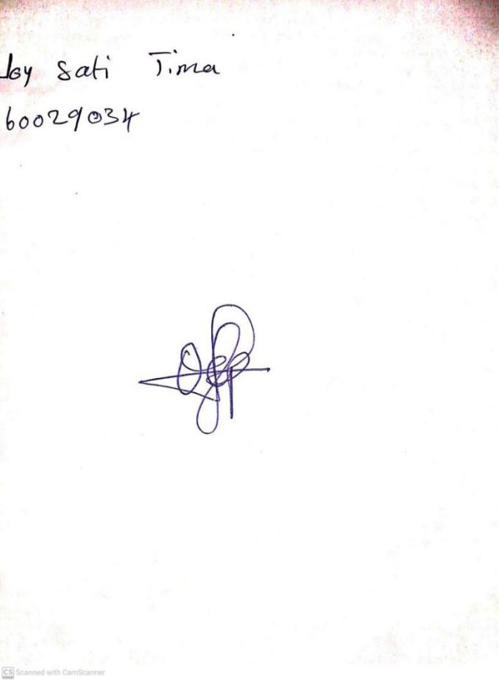

**23RD FEBRUARY, 2024**

**Perpetual Ojoma Ocheja**

**Stream Head Nursery**