**LESSON PLAN AND NOTE FOR WEEK 11 ENDING 22/11/2024**

**Term 1st term**

**Week 11th week.**

**Date 20th November,2024**

**Class Nursery one**

**Subject Social Norms**

**Topic Members of the family.**

**Sub-topic Identification of the members of the family.**

**Period 4th period**

**Time 10:40 am**

**Duration 35 minutes**

**No in class 15**

**Average Age 3 years**

**Sex Mixed**

**Specific Objectives: By the end of the lesson the pupils should be able to:**

1. **Identify the members of the family.**
2. **Colour the members of the family.**

**Rationale: To ensure the pupils identify & colour members of the family.**

**Previous Knowledge: The pupils can define and lists the members of the family.**

**Instructional Resources: Board,marker , crayons, online research.**

**Reference Materials: Smart smart Civic Education by A.M Solu, T.Y Alabi, Nursery 2**

**LESSON PRESENTATION**

|  |  |  |  |
| --- | --- | --- | --- |
| **Steps** | **Teacher’s Activities** | **Pupils’ Activities** | **Learning Points** |
| **Introduction** | **The teacher introduces the lesson (Members of the family) to the pupils by defining it.** | **The pupils participates and listen actively with the teacher in learning.** | **To arouse the pupils’ interest towards the lesson.** |
| **Step 1** | **The teacher leads the pupils to identify the members of the family**  **image of a baby A Baby**  **image of a fatherA Father**  **image of a motherA Mother**  **image of a brother A Brother**  **image of a sister A Sister** | **The pupils actively repeats after their teacher the name of their school.** | **For proper understanding.** |
| **Step 2** | **The teacher guides the pupils in colouring the members of the family**  **plain father**  **plain mother**  **plain brother and sister** | **The pupils with fun colour the members of the family.** | **For better understanding.** |
| **Summary** | **The teacher summarizes the lesson by mentioning the member of the family.** | **The pupils actively participates with their teacher in listing the members of the family.** | **For onward study.** |
| **Evaluation** | **The teacher asks the pupils to:**   1. **Identify the following members of the family?**   **image of a baby __________**  **image of a father__________**  **image of a mother____________**   1. **Colour the following members of the family below?**   **plain brother and sister** | **The pupils answer the questions accordingly.** | **To ascertain the pupils’ understanding.** |
| **Conclusion** | **The teacher summarizes,reacts,and corrects the pupils.** | **The teacher gives answers to the teacher’s question.** | **To consolidate the lesson.** |
| **Assignment** | 1. **Identify the members of the family below?**   **image of a baby ___________**  **image of a father _________**  **image of a mother __________**  **image of a brother __________**  **image of a sister __________**   1. **Colour the following members of the family below?**   **plain father**  **plain mother**  **plain brother and sister** | **The pupils copy and do their home-work at home.** | **To encourage learning while at home.** |

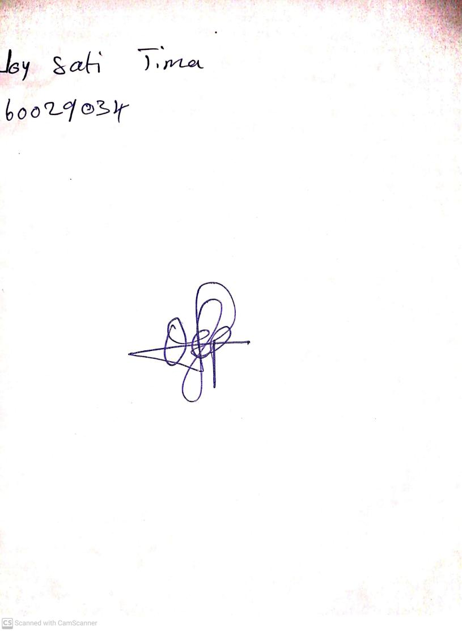

22nd November, 2024

Perpetual Ojoma Ocheja

Stream Head Nursery