**Lesson Plan/Note for Week 4 Ending 3/2/2023.**

**Term:** 2nd

**Week**: 4

**Date:** 30/1/2023.

**Class:** SS 1

**Subject**: Economics.

**Topic:** Firm and Industry.

**Sub-Topic:** Quoted and unquoted company and shares.

**Period:** 3rd

**Time:** 9:30- 10:10.

**Duration:** 40 Minutes.

**Number in class:** 7 Students.

**Average Age:** 14 Years.

**Sex:** Mixed.

**Specific objectives:** By the end of the lesson, the students should be able to:

(1) Define Quoted and unquoted company.

(11) Explain shares.

(111) State the types of shares.

**Rationale:** To be able to differentiate between Quoted and unquoted company and shares.

**Previous knowledge:** The students are aware of other sources of business finance.

**Instructional Material**: A chart showing Nigeria stock exchange market.

**Reference material:** Gbenga Babalola (2017) Metropolitan Economics for senior Secondary schools.

**LESSON DEVELOPMENT**

|  |  |  |  |
| --- | --- | --- | --- |
| **Stages/steps** | **Teacher's Activities** | **Students' Activities** | **Learning points.** |
| **Introduction** | Review the previous lesson. | Participate actively in the class discussion. | To arouse the students’ interest to learn. |
| **Step 1** | Defines Quoted and unquoted company as: Quoted company is a public company who list their securities in stock exchange or markets to raise funds through the sale of securities in the primary or secondary market. While the unquoted company is a public company whose shares are not freely traded on the stock exchange or in over-the counter market. | Listen carefully to the teacher and ask questions when necessary. | For better understanding of the lesson. |
| **Step 11** | Guides the students to explain shares | Explain shares as: Shares are the interest of a shareholder in a definite portion of the capital. | To encourage critical thinking. |
| **Step 111** | Asks the students to state the types of shares. | State the types of shares as: (1) preference share.  (2) ordinary or equity share. | To enhance their logical reasoning. |
| **Board Summary** | Summarises the lesson as:  **Quoted and unquoted company**  Quoted company i.e a publicly traded/ held company is a company who list their securities in stock exchange or markets to raise funds through the sale of securities in the primary or secondary market. This process generally starts with an initial company public offering (IPO) and later may happen with further issue of shares. An unquoted company is a public company whose shares are not freely traded on the stock exchange or in over-the counter (OTC) market. Otherwise popularly also known as unlisted public company.  **Shares**  Shares are the interest of a a shareholder in a definite portion of the capital. It expresses a proprietary relationship between the company the shareholder. A shareholder is the proportionate owner of the company but he does not own the company's assets, which belong to the company as a separate legal entity.  **Types of shares**  There are two types of shares. These are: (1) preference shares and (2) equity or ordinary shares. | Copy and submit the note book for marking | For future reference. |
| **Evaluation** | Evaluates the students as:  (1) Define quoted and unquoted company.  (2) what is shares?  (3) State two types of shares. | Respond to the questions | Ascertaining the attainment of the stated objectives. |
| **Conclusion** | Rounds up the lesson by marking and correcting students work. | Check and do their correction | Consolidation of the lesson. |
| **Assignment** | Gives home work as:  (1) Explain Equity and preference shares.  (2) state 4 features of preference shares.  (3) Mention and Explain 5 types of preference Shares. | Respond by doing the home work at home. | To ensure continuity of learning. |

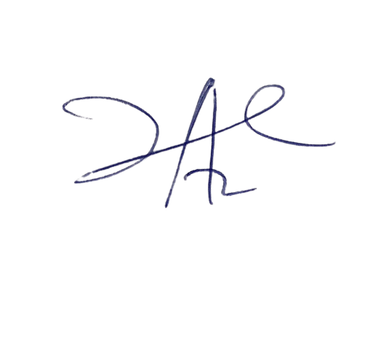

6/3/2023

Principal Head Instructor