**LESSON PLAN AND NOTE 1 FOR WEEK 5 ENDING 24/5/2024**

**Term 3rd term**

**Week 5TH week**

**Date 20/5/2024**

**Class Nursery one**

**Subject Number work**

**Topic Odd numbers**

**Sub-topic Meaning of Odd numbers.**

**Period 2nd period**

**Time 9:05 am**

**Duration 35 minutes**

**No in class 14**

**Average Age 3 years**

**Sex Mixed**

**Specific Objectives: By the end of the lesson the pupils should be able to;**

1. **Explain odd numbers.**
2. **List the examples of odd numbers**

**Rationale: To make sure the pupils explain odd numbers.**

**Previous knowledge: The pupils can recite the twelve months of the year.**

**Instructional Resources: Chart, board, marker, exercise books, pencils.**

**Reference Materials: Online Research,chart,board.**

**LESSON PRESENTATION**

|  |  |  |  |
| --- | --- | --- | --- |
| **Steps** | **Teacher’s Activities** | **Pupils’ Activities** | **Learning Points** |
| **Introduction** | **The teacher introduces the topic [Odd numbers] to the pupils.** | **The pupils listens to the teacher.** | **To arouse the pupils’ interest towards the lesson.** |
| **Presentation**  **Step 1** | **The teacher defines odd numbers as “numbers that cannot be divided by two (2)”.** | **The pupils individually repeats after the teacher.** | **For proper understanding.** |
| **Step 2** | **The teacher lists the examples of odd numbers on the board e.g**  **1 3 5 7**  **9 11 13 17.** | **The pupils repeats after the teacher.** | **For better understanding.** |
| **Summary** | **The teacher summarizes the lesson by defining odd numbers to the pupils.** | **The pupils understands the lesson.** | **For onward study.** |
| **Conclusion** | **The teacher summarizes, reacts, and corrects the pupils.** | **The pupils gives answers to the teacher’s question.** | **To consolidate the lesson.** |
| **Evaluation** | **Question:**  **What are odd numbers?**  **List (3) odd numbers you know?.** | **The pupils answer the question accordingly** | **To ascertain the pupils’ understanding.** |
| **Assignment** | **Question:**  **What are odd numbers?**  **Write only odd numbers from 1-10.** | **The pupils copy and do their homework at home.** | **To encourage learning while at home.** |

**LESSON PLAN AND NOTE 2 FOR WEEK 5 ENDING 24/5/2024**

**Term 3rd term**

**Week 5th week**

**Date 22/5/2024**

**Class Nursery one**

**Subject Number work**

**Topic Odd numbers**

**Sub-topic Identification of odd numbers.**

**Period 2nd period**

**Time 9:35 am**

**Duration 35 minutes**

**No in class 14**

**Average Age 3 years**

**Sex Mixed**

**Specific Objectives: By the end of the lesson the pupils should be able to;**

1. **Identify odd numbers**
2. **Match odd numbers.**

**Rationale: To make sure the pupils identify and match odd numbers Previous knowledge: The pupils can define and list odd numbers.**

**Instructional Resources: Chart, board, marker, exercise books, pencils.**

**Reference Materials: Online Research,chart,board.**

**LESSON PRESENTATION**

|  |  |  |  |
| --- | --- | --- | --- |
| **Steps** | **Teacher’s Activities** | **Pupils’ Activities** | **Learning Points** |
| **Introduction** | **The teacher introduces the topic [Odd numbers] to the pupils.** | **The pupils repeats after the teacher.** | **To arouse the pupils’ interest towards the lesson.** |
| **Presentation**  **Step 1** | **The teacher leads the pupils to identify odd numbers.** | **The pupils individually identify odd numbers.** | **For proper understanding.** |
| **Step 2** | **The teacher leads the pupils to match odd numbers**  **1 11**  **9 7**  **5 3**  **3 5**  **7 9**  **11 1** | **The pupils match odd numbers.**  **1 11**  **9 7**  **5 3**  **3 5**  **7 9**  **11 1** | **For better understanding.** |
| **Summary** | **The teacher summarizes the lesson by identifying random odd numbers for the pupils.**  **35 27 19 51.** | **The pupils can identify odd numbers.** | **For onward study.** |
| **Conclusion** | **The teacher summarizes, reacts, and corrects the pupils.** | **The pupils gives answers to the teacher’s question.** | **To consolidate the lesson.** |
| **Evaluation** | **Question:**  **Identify the odd numbers below**  **3,9,5,7,1.**  **List the odd number in numbers 1-10.** | **The pupils answer the question accordingly** | **To ascertain the pupils’ understanding.** |
| **Assignment** | **Question:**  **Identify the odd numbers below**  **3,9,5,7,1.**  **Match the following odd numbers below?**  **17 11**  **99 77**  **55 37**  **37 55**  **77 99**  **11 17** | **The pupils copy and do their homework at home.** | **To encourage learning while at home.** |

**LESSON PLAN AND NOTE 3 FOR WEEK 5 ENDING 24/5/2024**

**Term 3rd term**

**Week 5th week**

**Date 24/5/2024**

**Class Nursery one**

**Subject Number work**

**Topic Odd numbers**

**Sub-topic Fill in the missing odd numbers**

**Period 2nd period**

**Time 9:50 am**

**Duration 35 minutes**

**No in class 14**

**Average Age 3 years**

**Sex Mixed**

**Specific Objectives: By the end of the lesson the pupils should be able to;**

1. **Fill in the missing numbers accordingly.**
2. **Underline odd numbers.**

**Rationale: To make sure the pupils fill in & underline odd numbers**

**previous knowledge: The pupils can identify and match odd numbers**

**Instructional Resources: Crayons, exercise books, pencils.**

**Reference Materials: Online Research,chart,board.**

**LESSON PRESENTATION**

|  |  |  |  |
| --- | --- | --- | --- |
| **Steps** | **Teacher’s Activities** | **Pupils’ Activities** | **Learning Points** |
| **Introduction** | **The teacher introduces the topic [Odd numbers] to the pupils.** | **The pupils listens to the teacher.** | **To arouse the pupils’ interest towards the lesson.** |
| **Presentation**  **Step 1** | **The teacher writes missing odd numbers on the board for the pupils to identify & fill in the missing numbers e.g**  **------ 2 -----4 ----6----8**  **------ 10 .** | **The pupils fill in the missing odd numbers from the board**  **1 2 3 4 5 6**  **7 8 9 10 .** | **For proper understanding.** |
| **Step 2** | **The teacher writes down random numbers for the pupils to underline the odd numbers inside their notebooks.**  **15 16 17 18**  **19 20 21 22**  **23 24 25 26** | **The pupils underline the odd numbers inside their notebook**  **15 16 17 18**  **19 20 21 22**  **23 24 25 26** | **For better understanding.** |
| **Summary** | **The teacher summarizes the lesson by defining odd numbers to the pupils.** | **The pupils understands odd numbers.** | **For onward study.** |
| **Conclusion** | **The teacher summarizes, reacts, and corrects the pupils.** | **The pupils gives answers to the teacher’s question.** | **To consolidate the lesson.** |
| **Evaluation** | **Question:**  **Fill in the missing odd numbers below**  **2 -----4 ----6----**  **Underline the odd numbers below?**  **15 16 17 18**  **19 20 21 22**  **23 24 25 26** | **The pupils answer the question accordingly** | **To ascertain the pupils’ understanding.** |
| **Assignment** | **Question:**  **Fill in the missing odd numbers below?**  **------ 30 -----32 ----34----36------.**  **Underline the odd numbers below?**  **15 16 17 18**  **19 20 21 22**  **23 24 25 26** | **The pupils copy and do their homework at home.** | **To encourage learning while at home.** |

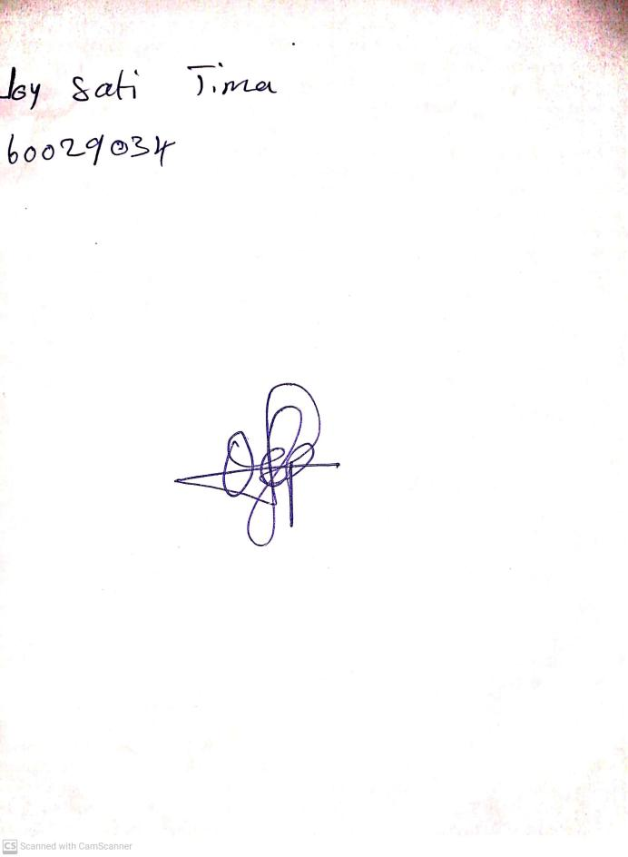

17th May, 2024

Perpetual Ojoma Ocheja

Stream Head Nursery