**EMERALD ROYAL INTERNATIONAL SCHOOL MPAPE, ABUJA**

**NURSERY 2 (TWO) SCHEME OF WORK**

**1ST TERM**

**HEALTH HABITS**

|  |  |  |
| --- | --- | --- |
| **WEEKS** | **TOPICS** | **CONTENT/ACTIVITIES** |
| **1** | **Exercise** | **Meaning, exercises e.g jogging, twisting, stretching of arms and legs etc.** |
| **2** | **Disposal of refuse** | **Meaning , proper disposal of refuse e.g the use of dust bin.** |
| **3** | **Disposal of waste** | **Meaning of waste,two types of waste-solid and liquid waste.** |
| **4** | **Disposal of waste** | **Methods of disposing animal waste- burying inside the ground to prevent bad odour or epidemic. Use of animal waste-dungs.** |
| **5** | **Waste disposal materials: compositing** | **Meaning of compost, example of compost materials.** |
| **6** | **Sources of water.** | **List and describe the various sources of water used by man.** |
| **7** | **Food and nutrition: good and bad drinking water.** | **Difference between good and bad drinking water and their effect to our health.** |
| **8** | **Waste disposal materials: recycling.** | **Meaning of recycling. E.g books, metals, poly products, cans.** |
| **9** | **Cleanliness: school uniform.** | **Meaning of cleanliness, steps in cleaning school uniform-washing, rinsing, drying and ironing.** |
| **10** | **Sleep-bed-time** | **Meaning of sleep and its usefulness. Need to do before going to bed.** |
| **11** | **Revision** |  |
| **12-13** | **Examination** |  |

**EMERALD ROYAL INTERNATIONAL SCHOOL MPAPE, ABUJA**

**NURSERY 2 (TWO) SCHEME OF WORK**

**2ND TERM**

**HEALTH HABITS**

|  |  |  |
| --- | --- | --- |
| **WEEKS** | **TOPICS** | **CONTENT/ACTIVITIES** |
| **1** | **Revision** | **Revision of 1st term’s work** |
| **2** | **Toilet : types** | **Meaning of toilet. Types of toilet facilities e.g potty, pit latrine etc.** |
| **3** | **Toilets: cleaning materials.** | **Materials for cleaning the toilet e.g water, towel, soap etc.** |
| **4** | **Toilets: Good habits.** | **Cleaning of seat bowl with tissue before sitting on it etc.** |
| **5** | **Toilets: Bad habits** | **- using toilet without flushing, eating in the toilet etc.** |
| **6** | **Food and nutrition preparation and preservation of food.** | **Copying with good spacing.** |
| **7** | **Eating habit: Good** | **Simple good eating habits.**  **- use clean plates, cutlery, place water by food side, take a little at a time, washing hands before and after meal, etc.** |
| **8** | **Eating habit: Bad** | **Discuss bad eating habit.**  **-talking, fighting while eating, cleaning hands with dress after meal, etc.** |
| **9** | **Care of teeth** | **Pupils should identify teeth in the mouth.**  **Use of teeth- tearing, cutting, biting, chewing food etc.**  **Teeth song.** |
| **10** | **Some insects that cause sicknesses and diseases.** | **Mosquito-malaria, tse-tse fly-sleeping sickness.** |
| **11** | **Revision** |  |
| **12-13** | **Examination** |  |

**EMERALD ROYAL INTERNATIONAL SCHOOL MPAPE, ABUJA**

**NURSERY 2 (TWO) SCHEME OF WORK**

**3RD TERM**

**HEALTH HABITS**

|  |  |  |
| --- | --- | --- |
| **WEEKS** | **TOPICS** | **CONTENT/ACTIVITIES** |
| **1** | **Revision** | **Revision of 2nd terms work** |
| **2** | **Sanitation** | **Meaning of sanitation, purpose of sanitation in our environment.** |
| **3** | **Sanitation** | **Places sanitation can take place e.g house, market, offices, street etc.** |
| **4** | **Hot weather** | **Discuss hot weather.**  **Care- wearing light clothes, eating warm food, sleeping in cool and airy room, etc.** |
| **5** | **Cold weather** | **Discuss cold weather**  **-wearing thick clothes or sweater/cardigan, eating hot food, tea etc.** |
| **6** | **Safety health: putting things in the eye, mouth, ear and nose.** | **Putting sticks , leaves, stones, pins, sharp objects, chemical and drugs in the mouth, ears,and eyes.** |
| **7** | **Hand washing** | **Simple meaning of hand washing.** |
| **8** | **Diseases: types of diseases.** | **Communicable and non-communicable diseases.** |
| **9** | **Diseases: water related** | **Meaning of diseases, e.g- skin rashes, dysentery, guinea worm, diarrhoea, malaria, vomiting.** |
| **10** | **Diseases: excreta related.** | **- cholera, dysentery,diarrhoea.**  **- transmitting agents-water, air, man, fruit.** |
| **11** | **Safety health: Accidents in the home.** | **Mention and explain some preventive measures as against accidents in the home.** |
| **12** | **Revision** |  |
| **13** | **Examination** |  |

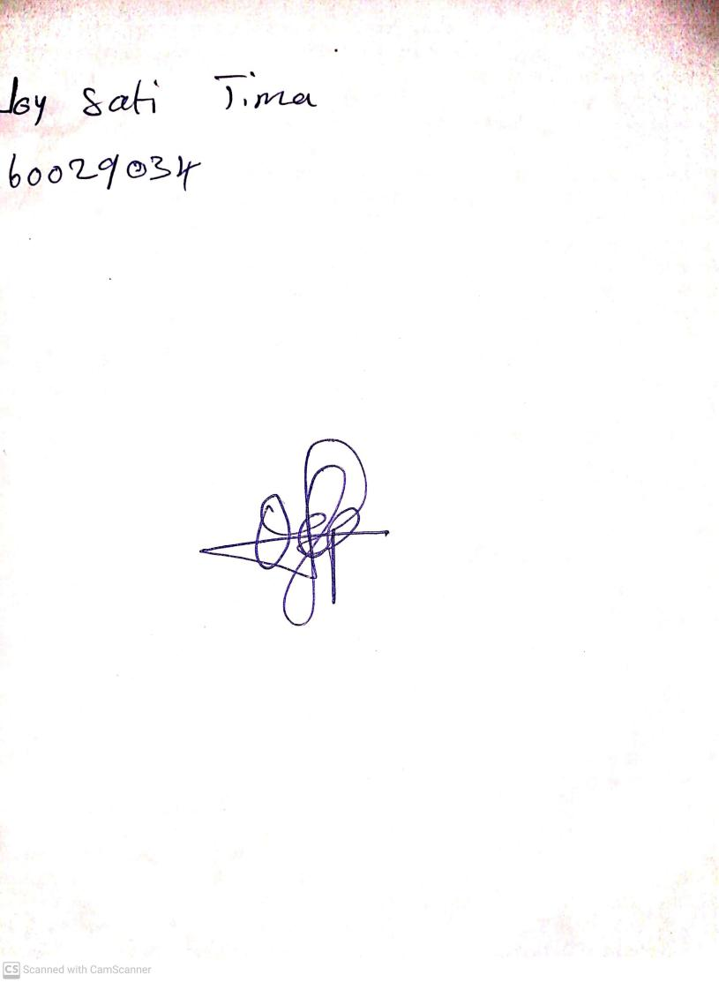

11TH OCTOBER, 2023

Perpetual Ojoma Ocheja

Stream Head Nursery