EMERALD ROYAL INTERNATIONAL SCHOOL

MPAPE, ABUJA.

LESSON PLAN AND NOTE FOR WEEK 9 ENDING 30TH JUNE, 2023

TERM: Third term.

WEEK: 9th

SUBJECT: Nature studies.

TOPIC: Animals and their movement

SUB-TOPIC: Reasons why some animals move and how the animals move.

DATE: 29/6/2023

DURATION: 40 minutes

TIME: 08:50-09:30

PERIOD: 3rd

CLASS: Pre-nursery

NUMBER OF PUPILS: 11

AVERAGE AGE: 2 years

SEX: Mixed

SPECIFIC OBJECTIVES: By the end of the lesson, the pupils should be able to:-

I State the reasons why animals move

2. Mention how animals move.

RATIONALE: For Pupils to know the movement of animals .

PREVIOUS KNOWLEDGE: Pupils have been seeing some of the animals in their environment.

INSTRUCTIONAL MATERIALS: chart of animals.

REFERENCE: Showers kiddies books Elementary science book nursery 1 by showers kiddies books.

LESSON DEVELOPMENT

|  |  |  |  |
| --- | --- | --- | --- |
| Stages/steps | Teacher's activities | Pupils' activities | Learning points |
| Introduction | Teacher introduces the lesson by reviewing the last lesson on Animals and their sounds. | Pupils listen to the teacher attentively | To arouse the interest of the pupils. |
| Presentation  Step 1 | Teacher states the reasons why animals move around.   1. Animals move to find food. 2. Animals move to avoid being eaten by bigger animals and human beings. 3. They move to find shelter from the sun, wind and rain. 4. They move to find each other and other animals.   Teacher asks the pupils to repeat after the teacher. | Pupils listen to the teacher and repeat after the teacher. | For better understanding of the lesson. |
| Step 2 | Teacher lists the animals and their movement.   |  |  | | --- | --- | | Animals | Movement | | Snake | Wiggle | | Frog | Hop | | Insect | Fly | | Hen | Walk | | Snail | Crawl | | Fish | Swim | | Birds | Fly | | Lion | Walk |   Teacher also asks the pupils to repeat after the teacher. | Pupils listen to the teacher and also repeat after the teacher. | For proper understanding of the lesson. |
| Summary | Teacher summarizes the lesson by going over the lesson again to State the reasons why animals move and how the animals move for more understanding. | Pupils listen attentively to the teacher as she is going over the lesson. | To ensure better understanding. |
| Evaluation | Teacher asks the Pupils to:-   1. State the reasons why animals move. 2. How do the snail move _____ 3. Insects---------   The cat______ | Pupils answer the teacher's questions correctly. | To ascertain the level of pupils understanding of the lesson. |
| Conclusion | Teacher concludes the lesson by singing a nursery rhyme for the pupils. | Pupils sing along with the teacher . | For onwards learning. |
| Assignment | Teacher asks the pupils to match the animals with their movement in their text books. Elementary science nursery 1 page 42 | Pupils do the assignment at home. | To encourage Learning at home. |

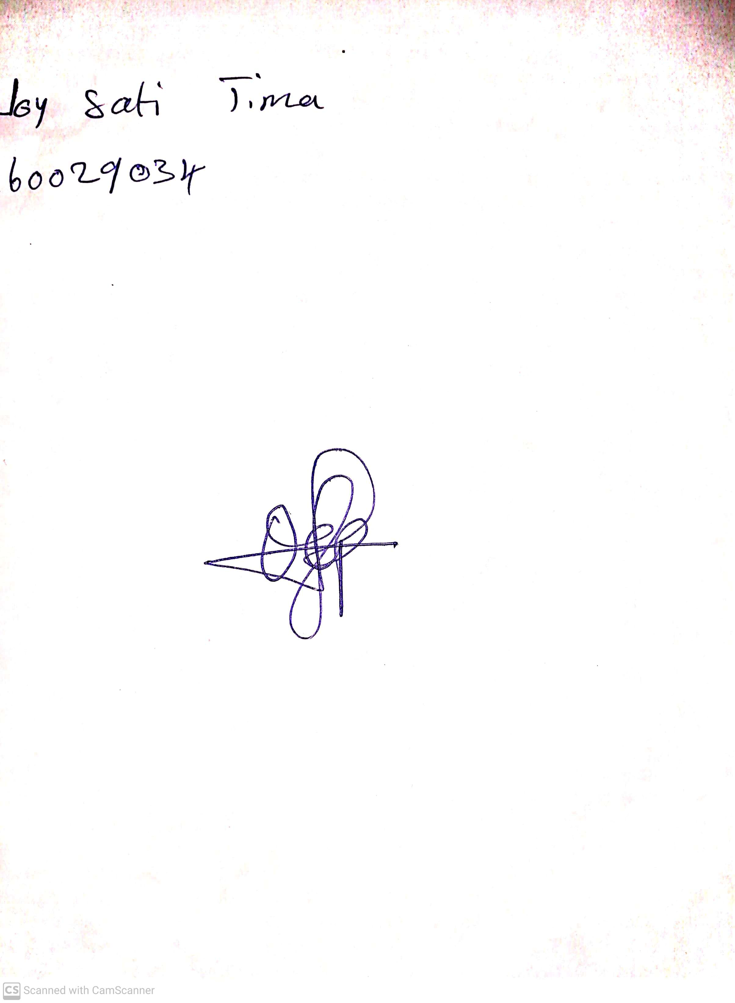

29th April, 2023

Perpetual Ojoma

Stream Head Nursery