**LESSON PLAN AND NOTE FOR WEEK 5 ENDING 11/10/2024**

**Term 1st term**

**Week 5th  week.**

**Date 9th October,2024**

**Class Nursery one**

**Subject Social Norms**

**Topic My environment.**

**Sub-topic Name objects in the environment**

**Period 4th period**

**Time 10:40 am**

**Duration 35 minutes**

**No in class 15**

**Average Age 3 years**

**Sex Mixed**

**Specific Objectives: By the end of the lesson the pupils should be able to:**

1. **Name the objects in our environment.**
2. **Colour the objects in our environment.**

**Rationale: To ensure the pupils colour &mention things in environment.**

**Previous Knowledge: The pupils can define environment.**

**Instructional Resources: Board,marker ,online research.**

**Reference Materials: Smart smart Civic Education by A.M Solu, T.Y Alabi, Nursery 2**

**LESSON PRESENTATION**

|  |  |  |  |
| --- | --- | --- | --- |
| **Steps** | **Teacher’s Activities** | **Pupils’ Activities** | **Learning Points** |
| **Introduction** | **The teacher introduces the lesson by taking the pupils round the school’s premises to observe the environment.** | **The pupils participates actively with the teacher in learning.** | **To arouse the pupils’ interest towards the lesson.** |
| **Step 1** | **The teacher assists the pupils to name the objects in their environment.** | **The pupils actively mentions the objects in their environment.** | **For proper understanding.** |
| **Step 2** | **The teacher guides the pupils in colouring below object in our environment**  **uncoloured car** | **The pupils activey participates in colouring the object.**  **coloured car** | **For better understanding.** |
| **Summary** | **The teacher summarizes the lesson by defining envrionment for the pupils..** | **The pupils actively participates with their teacher.** | **For onward study.** |
| **Evaluation** | **Colour the example of things found in our environment below?**  **uncoloured car**  **Mention 3 things you can find in your environment?**  **What is environment?** | **The pupils answer the questions accordingly.** | **To ascertain the pupils’ understanding.** |
| **Conclusion** | **The teacher summarizes,reacts,and corrects the pupils.** | **The teacher gives answers to the teacher’s question.** | **To consolidate the lesson.** |
| **Assignment** | **Mention 3 things you can find in your environment?**  **Identify and colour the below**  **uncoloured school bulding** | **The pupils copy and do their home-work at home.** | **To encourage learning while at home.** |

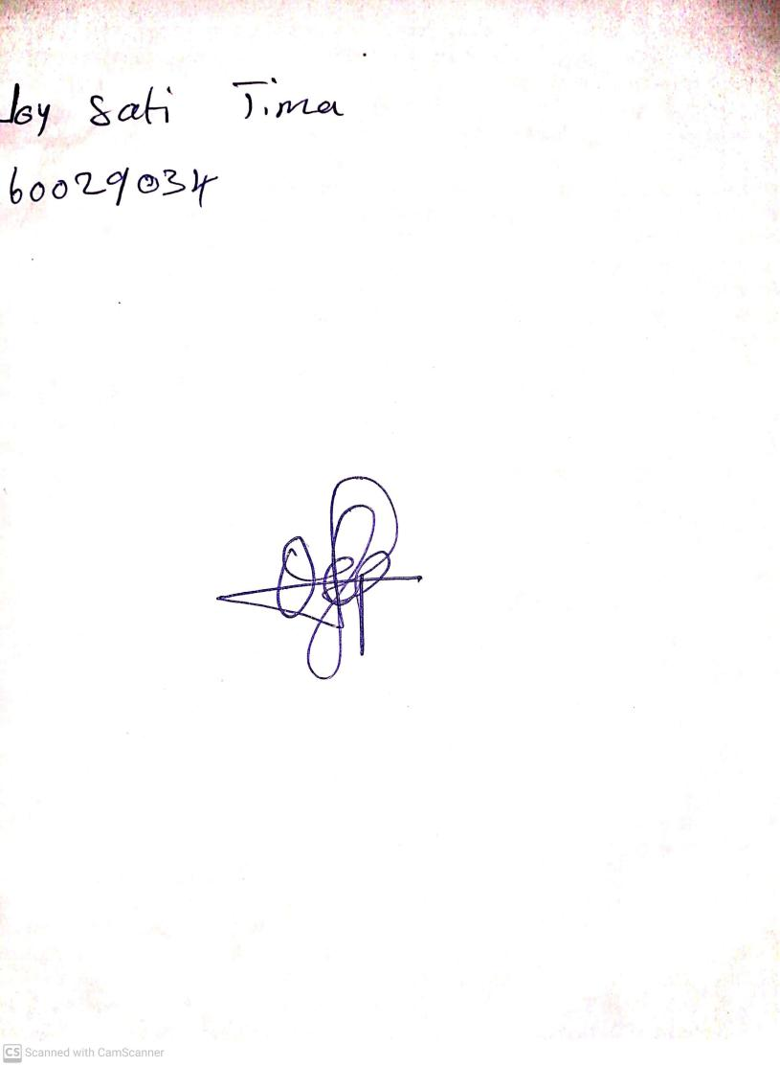

11th October, 2024

Perpetual Ojoma Ocheja

Stream Head Nursery