**EMERALD ROYAL INTERNATIONAL SCHOOL**

**MPAPE, ABUJA.**

**LESSON PLAN AND NOTE FOR WEEK 10 ENDING 28TH JUNE,2024**

TERM : Third term.

WEEK : 10th

SUBJECT: Social Norms

TOPIC: Conflict resolution.

SUB-TOPIC: Hurting some one is bad.

DATE: 24/6/2024

DURATION: 40 minutes

TIME: 10:40-11:20

PERIOD: 5th

CLASS: pre-nursery

NUMBER OF PUPILS: 19

AVERAGE AGE: 2

SEX: Mixed

SPECIFIC OBJECTIVES: By the end of the lesson, the pupils should be able to:-

1. Know the meaning of hurt.

2. State the types of hurting someone.

RATIONALE: For pupils to be able to know that Hurting or harming someone is not good.

PREVIOUS KNOWLEDGE: Pupils have been stepping on each others toes unknowingly.

INSTRUCTIONAL MATERIAL:- Rhyme.

REFERENCE: Smart start Civic education for nursery Schools book 1 by T.Y. Alabi and A. M. Solu.

LESSON DEVELOPMENT

|  |  |  |  |
| --- | --- | --- | --- |
| Stages/steps | Teacher's activities | Pupils' activities | Learning points |
| Introduction | Teacher introduces the lesson by singing a nursery rhyme for the pupils. | Pupils listen and sing the rhyme along with the teacher.  There are five magic words  There are five magic words. | To arouse the interest of the pupils for the new lesson. |
| Presentation  Step 1 | Teacher explains to the pupils the meaning of hurt as:-  " Hurt means doing things that is very bad to our friends." | Pupils listen and repeat after the teacher the meaning of hurt. | To improve pupils speaking skills . |
| Step 2 | Teacher explains to the pupils the types of hurt that is bad to someone as:-   1. bullying 2. Teasing 3. Slapping 4. Stepping on one's toes. | Pupils pay attention as the teacher is explaining the types of hurt to someone. | To ensure proper understanding. |
| Summary | Teacher summarizes the lesson by explaining to the pupils that, it is not good to hurt someone. | Pupils pay attention to the teacher and repeat after the her. | To ensure proper understanding of the lesson. |
| Evaluation | Teacher asks the pupils to:-   1. Mention the types of hurt. 2. Define hurt. | Pupils answer the questions correctly. | To assess the level of pupils understanding of the lesson. |

|  |  |  |  |
| --- | --- | --- | --- |
| Conclusion | Teacher ends the lesson by singing rhymes for the pupils. | Pupils sing along with the teacher. | To consolidate the lesson. |
| Assignment | Teacher asks pupils to:-  Define hurt. | Pupils do the assignment at home . | To encourage learning at home. |

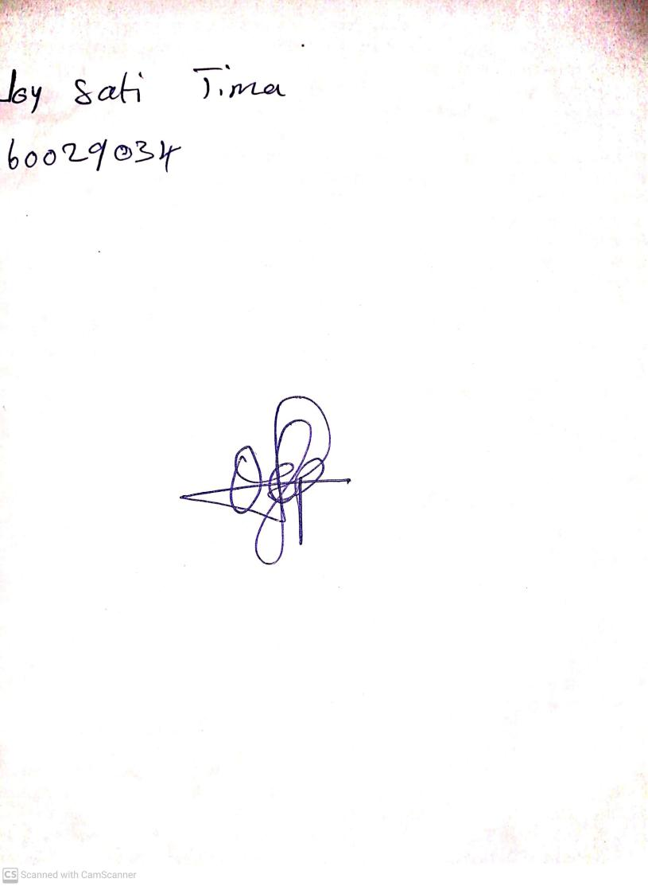

**21st June, 2024**

**Perpetual Ojoma Ocheja**

**Stream Head Nursery**