LESSON PLAN AND NOTE FOR WEEK 6 ENDING 09/06/2023

TERM: 3rd

WEEK: 6th

DATE: 05/06/2023

CLASS: Nursery 2

SUBJECT: Nature studies

TOPIC: Water storage

SUB—TOPIC: Reason for storing water.

PERIOD: 4th

TIME: 10:40—11:20am

DURATION: 40 minutes

NUMBER IN CLASS: 14

AVERAGE AGE: 5 years

SEX: Mixed

LEARNING OBJECTIVES: By the end of the lesson, the pupils should be able to:

1. Explain the reasons why we should store water.

2. Mention the container for storing water.

RATIONALE: For Pupils to know why it is good to store water.

PREVIOUS KNOWLEDGE:Pupils have learnt the how to purify water in previous lesson.

INSTRUCTIONAL MATERIALS: keg, bucket and bottle.

REFERENCE MATERIALS: Basic science and technology for Nursery schools book 3 by OPEMIPO DADA.

LESSON DEVELOPMENT

|  |  |  |  |
| --- | --- | --- | --- |
| Steps | Teacher's activities | Pupils' activities | Learning point |
| Introduction | Teacher introduces the lesson by reviewing the previous lesson. | Pupils pay attention to the teacher. | To prepare pupils minds for the lesson ahead. |
| Presentation step 1 | Teacher explains to pupils the reason why it's good to store water and then asks them to repeat after her. | Pupils listen to the teacher and repeat after her. | For better understanding. |
| Step 2 | Teacher mentions the containers for storing water and also asks Pupils to repeat after her. | Pupils pay attention to the teacher and repeat after the teacher. | For better understanding. |
| Board summary | Teacher writes the whole note of lesson on the board for pupils to copy. That is;  Why we store water  1. We store water to keep it clean and safe for use.  2. We store water to make it available to us all the time.  3. We store water to make it easy for us to get it when we need it.  4. We store water because it should not be wasted.  Water storage containers  Water storage containers are;  1. Tank    2. Bucket    3. Bottle    4. Keg | Pupils copy the note into their exercise books. | For onward study. |
| Evaluation | Teacher evaluates the lesson by asking the following questions;  1. What are the reasons why we store water?  2. Mention the containers for storing water. | Pupils answer the questions ask by the teacher. | To assess pupils level of understanding. |
| Conclusion | Teacher concludes the lesson by marking pupils books. | Pupils submit their books for marking. | For endorsement. |
| Assignment | Activity 20 page 66. Basic science textbook. | Pupils do their assignment at home. | To encourage learning at home. |

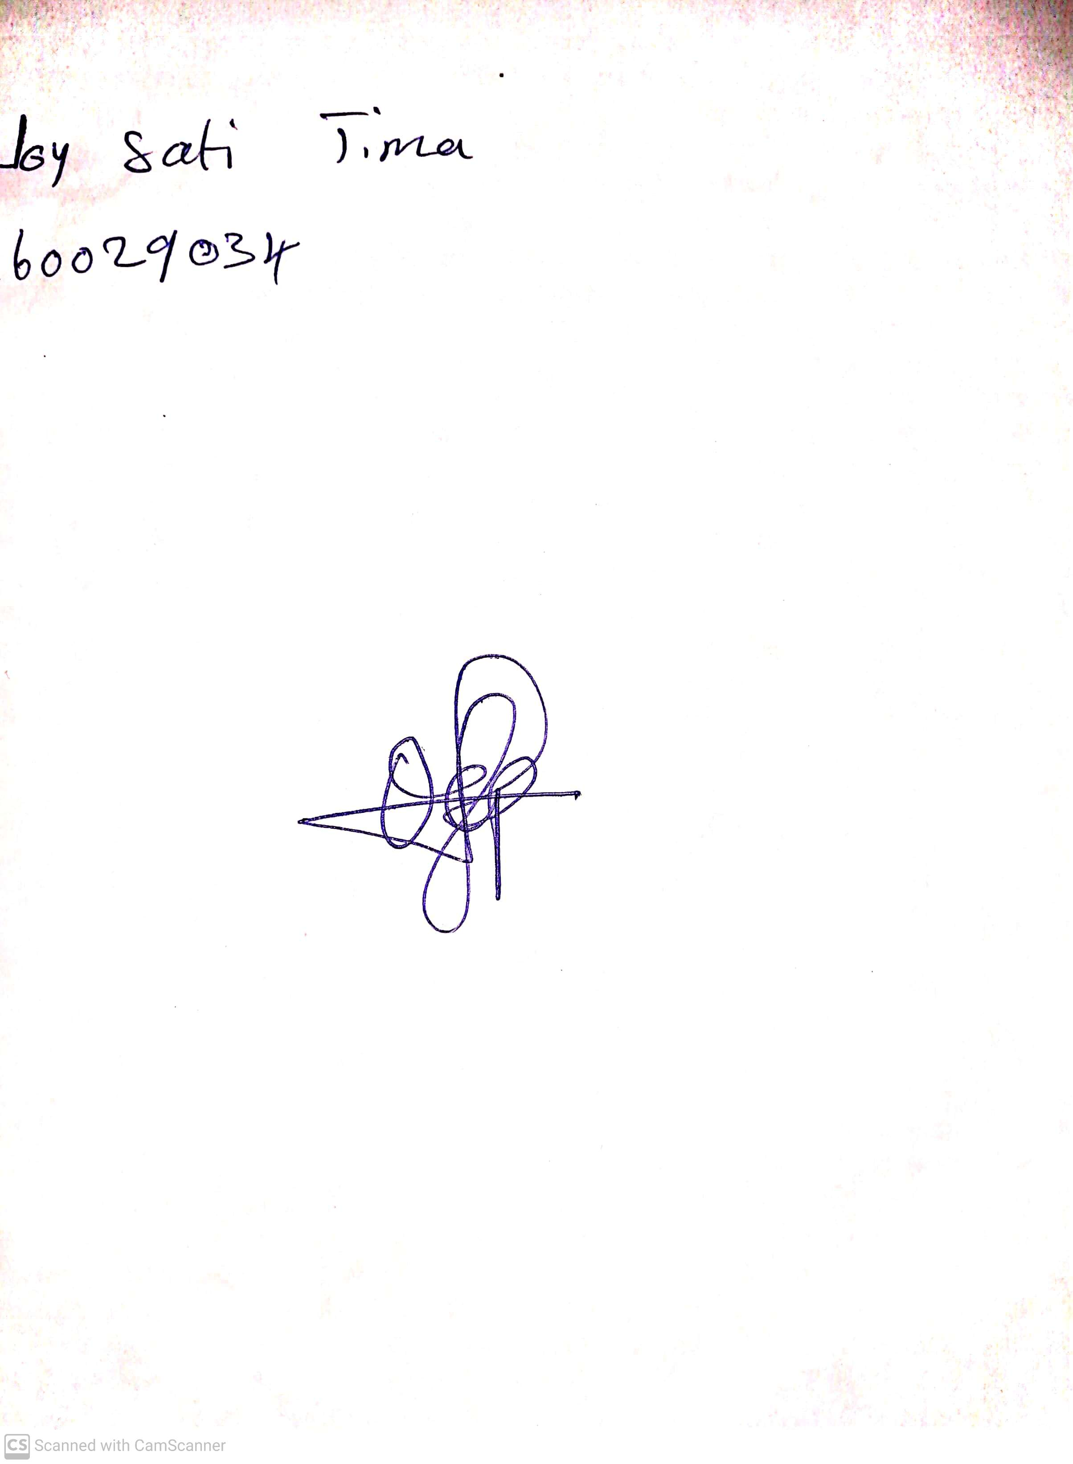

28th April, 2023

Perpetual Ojoma

Stream Head Nursery