**EMERALD ROYAL INTERNATIONAL SCHOOL**

**MPAPE, ABUJA.**

**LESSON PLAN AND NOTE FOR WEEK 5 PERIOD 1 ENDING 24/05/2024**

**TERM: THIRD**

**WEEK: 5TH**

**DATE: 20/05/2024**

**CLASS: NURSERY 2**

**SUBJECT: LETTER WORK**

**TOPIC: VOWEL DIGRAPHS 4**

**SUB-TOPIC: WORDS WITH VOWEL DIGRAPHS “OY” AND “AW”**

**PERIOD: 1ST PERIOD**

**TIME: 09: 30 - 10:10am**

**DURATION: 40 MINUTES.**

**NUMBER IN CLASS: 13**

**AVERAGE AGE: 5 YEARS.**

**SEX: MIXED.**

**SPECIFIC OBJECTIVES: BY THE END OF THE LESSON,THE PUPILS SHOULD BE**

**ABLE TO:**

**1. MENTION WORDS WITH VOWEL DIGRAPHS “OY”**

**AND "AW"**

**2. PRONOUNCE WORDS WITH VOWEL DIGRAPHS**

**"OY" AND "AW"**

**RATIONALE: FOR PUPILS TO KNOW WORDS WITH VOWEL DIGRAPHS “OY” AND “AW”**

**PREVIOU KNOWLEDGE: PUPILS HAVE LEARNT ABOUT WORDS ON VOWEL**

**DIGRAPHS“EA” “IE” “OA” AND “OI”**

**INSTRUCTIONAL MATERIALS: A CHART OF WORDS ON VOWEL DIGRAPHS "OY" AND**

**"AW"**

**REFERENCE MATERIALS: GOOGLE.COM .**

**LESSON DEVELOPMENT**

|  |  |  |  |
| --- | --- | --- | --- |
| **STAGES/STEPS** | **TEACHER’S ACTIVITIES** | **PUPILS’ ACTIVITIES** | **LEARNING POINTS** |
| **INTRODUCTION** | **Teacher reviews the previous lesson on vowel digraphs to pupils.** | **Pupil listen attentively to the teacher.** | **To prepare pupils minds for the lesson ahead.** |
| **PRESENTATION**  **STEP 1** | **Teacher mentions words with vowel digraphs “oy” “aw” to pupils and asks them to repeat after her.** | **Pupils listen attentively to the teacher and repeat after her.** | **For proper understanding .** |
| **STEP 2** | **Teacher writes the words with vowel digraph “oy” and “aw” on the board, spell and pronounce and also asks pupils to identify and repeat after her.** | **Pupils pay attention to the teacher and repeat after her.** | **For better understanding of the lesson.** |
| **BOARD SUMMARY** | **Teacher writes the whole not of lesson on the board for pupils to copy.ie,**  **VOWEL DIGRAPH “OY”**  **Examples of “oy” words are:**  **“oy” as in boy**  **“oy” as in soy**  **“oy” as in enjoy**  **“oy” as in oyster**  **“oy” as in toy**  **“oy” as in royal**  **“oy” as in joy**  **“oy” as in annoy**  **“oy” as in destroy**  **“oy” as in employ**  **“oy” as in deploy**  **“oy” as in voyage etc**  **VOWEL DIGRAPHS “AW” WORDS ARE:**  **“aw” as in raw**  **“aw” as in saw**  **“aw” as in jaw**  **“aw” as in law**  **“aw” as in claw**  **“aw” as in straw**  **“aw” as in crawl**  **“aw” as in lawn**  **“aw” as in caw**  **“aw” as in yawn etc.** | **Pupils copy the note into their exercise books.** | **For onward study.** |
| **EVALUATION** | **Teacher evaluates the lesson by asking pupils to go to the board one after the other and spell and pronounce the words.** | **Pupils listen to the teacher and read the note on the board one after another.** | **To assess pupils reading skills.** |
| **CONCLUTION** | **Teacher concludes the lesson by marking pupils books.** | **Pupils submit their books for marking.** | **For endorsement.** |
| **ASSIGNMENT** | **write 10 words with vowel digraphs “ow”** | **Pupils do their assignment at home.** | **To encourage learning at home.** |

**LESSON PLAN AND NOTE FOR WEEK 5 PERIOD 2 ENDING 24/05/2024**

**TERM: THIRD**

**WEEK: 5TH**

**DATE: 21/05/2024**

**CLASS: NURSERY 2**

**SUBJECT: LETTER WORK**

**TOPIC: VOWEL DIGRAPHS 4**

**SUB-TOPIC: WORDS WITH VOWEL DIGRAPHS “OW”**

**PERIOD: 2ND PERIOD**

**TIME: 08: 50 - 09:30am**

**DURATION: 40 MINUTES.**

**NUMBER IN CLASS: 13**

**AVERAGE AGE: 5 YEARS.**

**SEX: MIXED.**

**SPECIFIC OBJECTIVES: BY THE END OF THE LESSON,THE PUPILS SHOULD BE ABLE TO:**

**1. MENTION WORDS WITH VOWEL DIGRAPHS “OW”**

**2. PRONOUNCE WORDS WITH VOWEL DIGRAPHS**

**"OW"**

**RATIONALE: FOR PUPILS TO KNOW WORDS WITH VOWEL DIGRAPHS “OW”**

**PREVIOU KNOWLEDGE: PUPILS HAVE LEARNT ABOUT WORDS WITH VOWEL**

**DIGRAPHS“AW” AND “OY” IN PREVIOUS LESSON**

**INSTRUCTIONAL MATERIALS: CHART OF WORDS ON VOWEL DIGRAPHS "OW"**

**REFERENCE MATERIALS: GOOGLE.COM .**

**LESSON DEVELOPMENT**

|  |  |  |  |
| --- | --- | --- | --- |
| **STAGES/STEPS** | **TEACHER’S ACTIVITIES** | **PUPILS’ ACTIVITIES** | **LEARNING POINTS** |
| **INTRODUCTION** | **Teacher reviews the previous lesson on vowel digraphs to pupils.** | **Pupil listen attentively to the teacher.** | **To prepare pupils minds for the lesson ahead.** |
| **PRESENTATION**  **STEP 1** | **Teacher mentions words with vowel digraphs “ow” to pupils and asks them to repeat after her.** | **Pupils listen attentively to the teacher and repeat after her.** | **For proper understanding .** |
| **STEP 2** | **Teacher writes the words with vowel digraph “ow” on the board, spell and pronounce and also asks pupils to identify and repeat after her.** | **Pupils pay attention to the teacher and repeat after her.** | **For better understanding of the lesson.** |
| **BOARD SUMMARY** | **Teacher writes the whole not of lesson on the board for pupils to copy.ie,**  **VOWEL DIGRAPH “OW” WORDS ARE:**  **“ow” as in fowl**  **“ow” as in flow**  **“ow” as in growth**  **“ow” as in show**  **“ow” as in glow**  **“ow” as in slow**  **“ow” as in brown**  **“ow” as in crowd**  **“ow” as in down**  **“ow” as in owl etc.** | **Pupils copy the note into their exercise books.** | **For onward study.** |
| **EVALUATION** | **Teacher evaluates the lesson by asking pupils to all stand and then spell and pronounce the words on the board one after another.** | **Pupils listen to the teacher and read the note on the board one after another.** | **To assess pupils reading skills.** |
| **CONCLUTION** | **Teacher concludes the lesson by marking pupils books.** | **Pupils submit their books for marking.** | **For endorsement.** |
| **ASSIGNMENT** | **Write 10 words with vowel digraphs “ou”** | **Pupils do their assignment at home.** | **To encourage learning at home.** |

**LESSON PLAN AND NOTE FOR WEEK 5 PERIOD 3 ENDING 24/05/2024**

**TERM: THIRD**

**WEEK: 5TH**

**DATE: 24/05/2024**

**CLASS: NURSERY 2**

**SUBJECT: LETTER WORK**

**TOPIC: VOWEL DIGRAPHS 4**

**SUB-TOPIC: WORDS WITH VOWEL DIGRAPHS “OU”**

**PERIOD: 3RD PERIOD**

**TIME: 09: 30 - 10:10am**

**DURATION: 40 MINUTES.**

**NUMBER IN CLASS: 13**

**AVERAGE AGE: 5 YEARS.**

**SEX: MIXED.**

**SPECIFIC OBJECTIVES: BY THE END OF THE LESSON,THE PUPILS SHOULD BE ABLE TO:**

**1. MENTION WORDS WITH VOWEL DIGRAPHS “OU”**

**2. PRONOUNCE WORDS WITH VOWEL DIGRAPHS "OU"**

**RATIONALE: FOR PUPILS TO KNOW WORDS WITH VOWEL DIGRAPHS “OU”**

**PREVIOU KNOWLEDGE: PUPILS HAVE LEARNT ABOUT WORDS WITH VOWEL**

**DIGRAPHS “OW” IN PREVIOUS LESSON.**

**INSTRUCTIONAL MATERIALS: CHART OF WORDS ON VOWEL DIGRAPHS "OU"**

**REFERENCE MATERIALS: GOOGLE.COM .**

**LESSON DEVELOPMENT**

|  |  |  |  |
| --- | --- | --- | --- |
| **STAGES/STEPS** | **TEACHER’S ACTIVITIES** | **PUPILS’ ACTIVITIES** | **LEARNING POINTS** |
| **INTRODUCTION** | **Teacher reviews the previous lesson on vowel digraphs “ow” to pupils.** | **Pupil listen attentively to the teacher.** | **To prepare pupils minds for the lesson ahead.** |
| **PRESENTATION**  **STEP 1** | **Teacher mentions words with vowel digraphs “ou” to pupils and asks them to repeat after her.** | **Pupils listen attentively to the teacher and repeat after her.** | **For proper understanding .** |
| **STEP 2** | **Teacher writes the words with vowel digraph “ou” on the board, spell and pronounce and also asks pupils to identify and repeat after her.** | **Pupils pay attention to the teacher and repeat after her.** | **For better understanding of the lesson.** |
| **BOARD SUMMARY** | **Teacher writes the whole not of lesson on the board for pupils to copy.ie,**  **VOWEL DIGRAPH “OU” WORDS ARE:**  **“ou” as in house**  **“ou” as in loud**  **“ou” as in mouth**  **“ou” as in cloud**  **“ou” as in count**  **“ou” as in flour**  **“ou” as in sprout**  **“ou” as in boulder**  **“ou” as in mountain**  **“ou” as in shoulder**  **“ou” as in about**  **“ou”as in would**  **“ou” as in mould**  **“ou” as in group etc.** | **Pupils copy the note into their exercise books.** | **For onward study.** |
| **EVALUATION** | **Teacher evaluates the lesson by**   1. **spell the words.** 2. **pronounce the words on the board one after the other.** | **Pupils read the note on the board one after another.** | **To assess pupils reading skills.** |
| **CONCLUTION** | **Teacher concludes the lesson by marking pupils books.** | **Pupils submit their books for marking.** | **For endorsement.** |
| **ASSIGNMENT** | 1. **Make 10 words with vowel digraphs “oy”** 2. **Write 1o words with vowel “aw”** 3. **List 5 words with vowel digraphs “ow” and 5 words with vowel digraphs “ou”.** | **Pupils do their assignment at home.** | **To encourage learning at home.** |

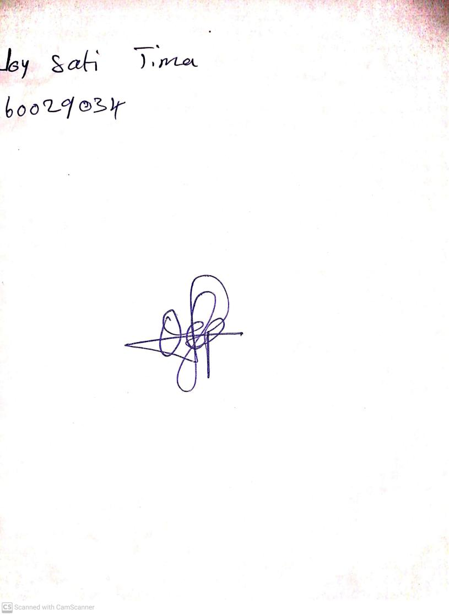

**17th May, 2024**

**Perpetual Ojoma Ocheja**

**Stream Head Nursery**