**EMERALD ROYAL INTERNATIONAL SCHOOL**

**MPAPE, ABUJA.**

**LESSON PLAN AND NOTE FOR WEEK 6 ENDING 9TH JUNE,2024**

TERM : Third term.

WEEK : 6th

SUBJECT: Social Norms

TOPIC: People and their profession.

SUB-TOPIC: Identifying people and their profession.

DATE: 9/6/2023

DURATION: 40 minutes

TIME: 10:40-11:20

PERIOD: 4th

CLASS: pre-nursery

NUMBER OF PUPILS: 11

AVERAGE AGE: 2

SEX: Mixed

SPECIFIC OBJECTIVES: By the end of the lesson, the pupils should be able to:-

1. Identify a teacher, banker and engineer.

2. Say what they do.

RATIONALE: For pupils to know people and what they do.

PREVIOUS KNOWLEDGE: Pupils have been seeing teachers and are familiar with them.

INSTRUCTIONAL MATERIALS: pictures of a banker, teacher and an engineer.

REFERENCE: Smart start Civic education for nursery Schools book 1 by T.Y. Alabi and A. M. Solu.

LESSON DEVELOPMENT

|  |  |  |  |
| --- | --- | --- | --- |
| Stages/steps | Teacher's activities | Pupils' activities | Learning points |
| Introduction | Teacher introduces the lesson by asking the pupils if they have seen a banker or engineer before. | Pupils answer the teacher's question by answering yes yes yes yes.... | To get pupils attention for the lesson. |
| Presentation  Step 1 | Teacher shows the pupils the pictures of a teacher, banker and an engineer. | The pupils take turns to point at them in the picture. | To improve pupils motor skills. |
| Step 2 | Teacher explains to the pupils who the teacher, banker and an engineer is and what they do.  ---- A teacher is a person who teaches people. A teacher teaches us how to read and write.  ---- A banker is a person who works in the bank.  ---- An engineer is a person who builds houses and construct roads. | Pupils pay attention to the teacher and repeat after the teacher. | To enhance pupils knowledge. |
| Summary | Teacher summarizes the lesson by emphasizing on the topic over again for more understanding.. | Pupils listen to the teacher. | To ensure better understanding of the lesson. |
| Evaluation | Teacher asks the pupils:-   1. Who is a teacher? 2. Point at a banker on the pictures? | Pupils answer the questions correctly. | To assess pupils level of understanding of the lesson. |
| Conclusion | Teacher ends the lesson by singing a nursery rhymes for the pupils. | Pupils sing the rhyme along with the teacher. | To consolidate the lesson. |

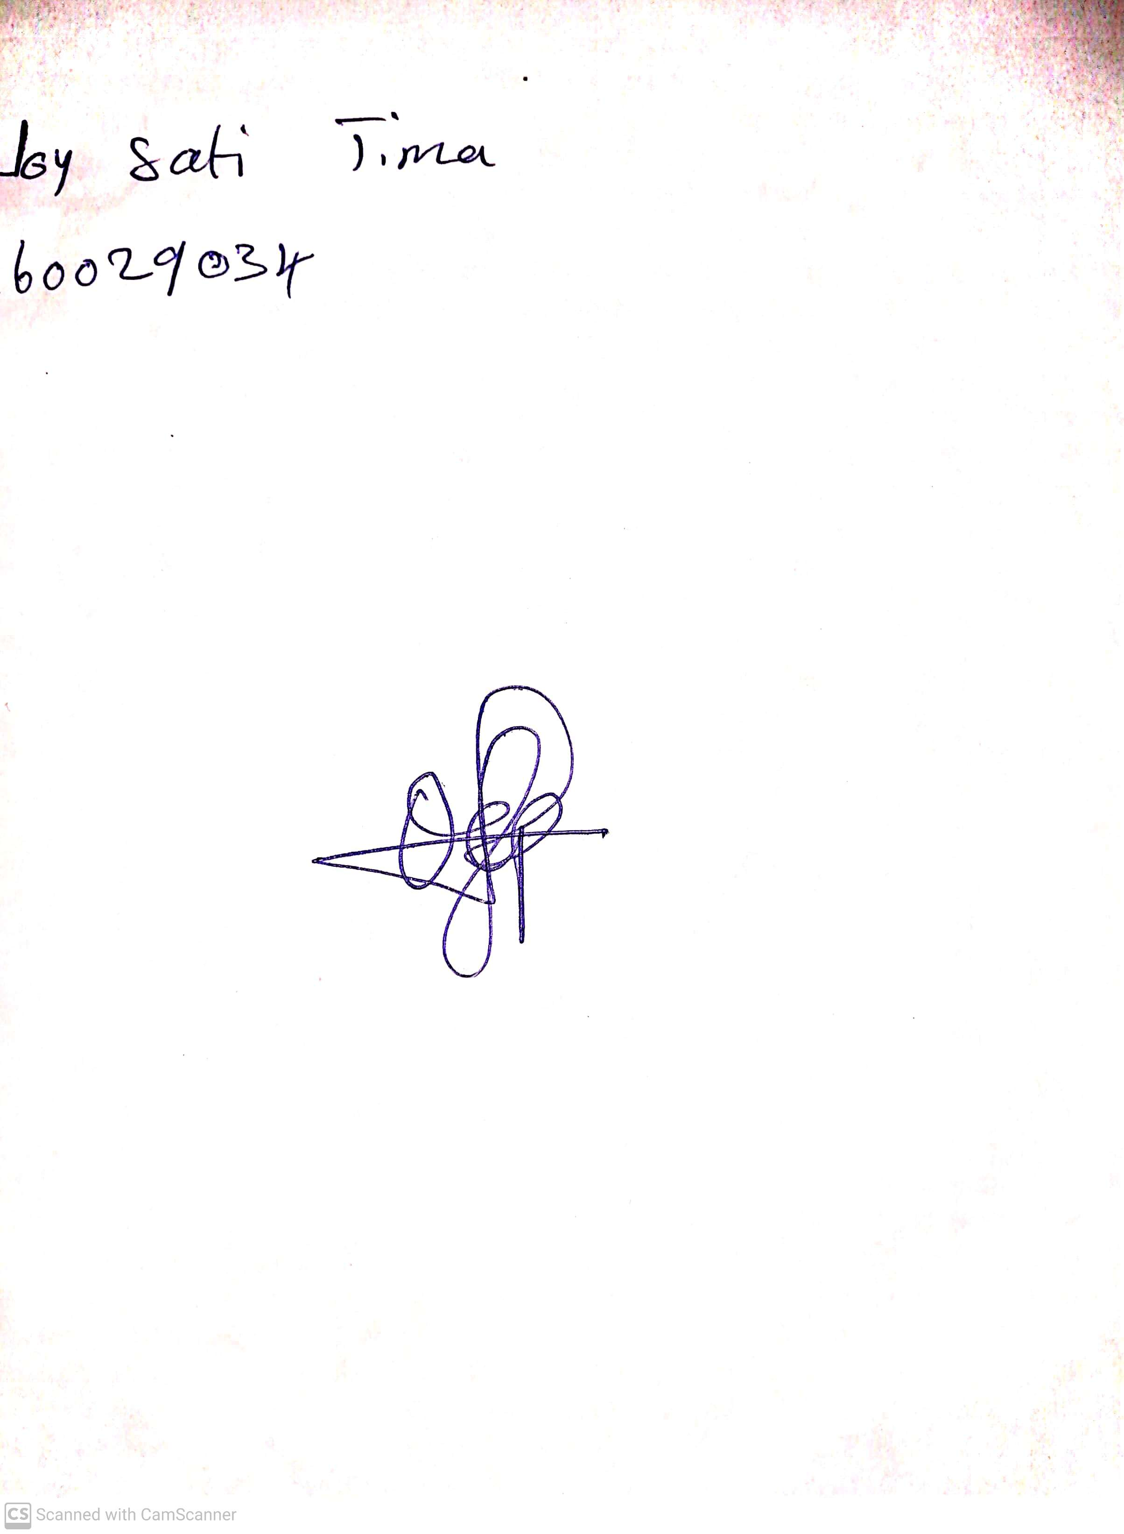

29th April, 2023

Perpetual Ojoma

Stream Head Nursery