**EMERALD ROYAL INTERNATIONAL SCHOOL**

**MPAPE, ABUJA.**

**LESSON PLAN AND NOTE 1 FOR WEEK 6 ENDING 9TH June,2023.**

TERM: 3RD TERM

WEEK: 6TH WEEK

SUBJECT: Number Work

TOPIC: Counting numbers 1 - 40.

SUB-TOPIC: Identification of numbers 1 - 40.

DATE: 5th June, 2023.

DURATION: 40 minutes.

TIME: 08:50--09:30.

PERIOD: 1st

CLASS: Pre-nursery

NUMBER OF PUPILS: 11

AVERAGE AGE: 2 years

SEX: Mixed.

SPECIFIC OBJECTIVES: By the end of the lesson, the pupils should be able to:-

1. Count Numbers 1- 40
2. Identify numbers 1 - 40

RATIONALE: For pupils to be able to count numbers.

PREVIOUS KNOWLEDGE: Pupils have been counting numbers.

INSTRUCTIONAL MATERIALS: Number chart, flash cards, building blocks etc

REFERENCE MATERIALS: Mastering mathematics for nursery schools book 1 by Henry Idogun.

**LESSON DEVELOPMENT**

|  |  |  |  |
| --- | --- | --- | --- |
| STAGES/STEPS | TEACHER’S ACTIVITIES | PUPILS’ ACTIVITIES | LEARNING POINTS |
| INTRODUCTION | Teacher asks pupils to count numbers 1- 35. | Pupils count numbers 1 - 35 | To encourage pupils to participate in the lesson. |
| PRESENTATION  STEP 1 | Teacher counts numbers 1 - 40 for the pupils to repeat after her. | Pupils count numbers 1 - 40 after the teacher. I.e 1 2 3 4 5 6 7 8 9 10 11 12 13 14 15 16 17 18 19 20 21 22 23 24 252627 28 29 30 31 32 33 34 35 36 37 38 39 40 | For better understanding of the lesson . |
| STEP 2 | Teacher guides pupils to identify numbers numbers 1 - 40 | Pupils point at numbers 1 - 40. ie  1 2 3 4 5 6 7 8 9 10 11 12 13 14 15 16 17 18 19 20 21 22 23 24 25 2627 28 29 30 31 32 33 34 35 36 37 38 39 40 | For proper understanding of the lesson. |
| SUMMARY | Teacher identifies each number 1 - 40 for the pupils. | Pupils point at the numbers. | For more understanding of the lesson. |
| EVALUATION | Teacher asks Pupils to count numbers 1 - 40 | Pupils count numbers 1 - 40. | To assess pupils understanding of the lesson. |
| CONCLUSION | Teacher sings a number rhyme for the pupils. | Pupils sing the rhyme along with the teacher. | To improve pupils speaking ability. |
| ASSIGNMENT (HOME WORK) | Count and circle numbers 1 - 40  1 2 3 4 5 6 7 8 9 10 11 12 13 14 15 16 19 20 21 22 23 24 25 26 27 28 29 30 31 32 33 34 35 36 37 38 39 40 . | Pupils do their assignment at home. | To encourage pupils to learn at home. |

**LESSON PLAN AND NOTE 2 FOR WEEK 6 ENDING 9TH JUNE, 2023.**

TERM: 3RD TERM

WEEK: 6TH WEEK

SUBJECT: Number Work

TOPIC: Counting numbers 1 - 40.

SUB-TOPIC: Copying number 5

DATE: 7th June, 2023.

DURATION: 40 minutes.

TIME: 10 : 40 - 11:20

PERIOD: 2nd

CLASS: Pre-nursery

NUMBER OF PUPILS: 11

AVERAGE AGE: 2 years

SEX: Mixed.

SPECIFIC OBJECTIVES: By the end of the lesson, the pupils should be able to:-

1.Count Numbers 1-40

2.Copy number 5

RATIONALE: For pupils to be able to count numbers.

PREVIOUS KNOWLEDGE: Pupils have been counting numbers.

INSTRUCTIONAL MATERIALS: Number chart, flash cards, building blocks pencils etc

REFERENCE MATERIALS: Mastering mathematics for nursery schools book 1 by Henry Idogun.

**LESSON DEVELOPMENT**

|  |  |  |  |
| --- | --- | --- | --- |
| STAGES/STEPS | TEACHER’S ACTIVITIES | PUPILS’ ACTIVITIES | LEARNING POINTS |
| INTRODUCTION | Teacher introduces the lesson by singing a number rhyme for the pupils. | Pupils sing the rhyme along with the teacher. | To arouse pupils interest in the lesson. |
| PRESENTATION  STEP 1 | Teacher counts numbers 1 - 40 for the pupils to repeat after her. | Pupils count numbers 1 - 40 after the teacher. I.e 1 2 3 4 5 6 7 8 9 10 11 12 13 14 15 16 17 18 19 20 21 22 23 24 252627 28 29 30 31 32 33 34 35 36 37 38 39 40. | For better understanding of the lesson . |
| STEP 2 | Teacher guides pupils to copy number 5 | Pupils copy number 5  numbers 1-   20numbers 1-   20numbers 1-   20numbers 1-   20numbers 1-   20numbers 1-   20numbers 1-   20numbers 1-   20numbers 1-   20 | For proper understanding of the lesson. |
| SUMMARY | Teacher writes number 5 boldly on the board for the pupils to see. | Pupils point at the number at number 5 on the board. | For more understanding of the lesson. |
| EVALUATION | Teacher asks Pupils to count numbers 1 - 40. | Pupils count numbers 1 - 40. | To assess pupils understanding of the lesson. |
| CONCLUSION | Teacher sings a number rhyme for the pupils. | Pupils sing the rhyme along with the teacher. | To improve pupils speaking ability. |
| ASSIGNMENT (HOME WORK) | Re-write number 5  numbers 1-   20numbers 1-   20numbers 1-   20numbers 1-   20numbers 1-   20numbers 1-   20 | Pupils do their assignment at home. | To encourage pupils to study at home. |

**LESSON PLAN AND NOTE 3 FOR WEEK 6 ENDING 9TH JUNE,2023.**

TERM: 3RD TERM

WEEK: 6TH WEEK

SUBJECT: Number Work

TOPIC: Counting numbers 1 - 40.

SUB-TOPIC: Copying number 6

DATE: 8th June, 2023.

DURATION: 40 minutes.

TIME: 08 : 10 - 08:50

PERIOD: 3rd

CLASS: Pre-nursery

NUMBER OF PUPILS: 11

AVERAGE AGE: 2 years

SEX: Mixed.

SPECIFIC OBJECTIVES: By the end of the lesson, the pupils should be able to:-

1.Count Numbers 1- 40

2.Copy number 6

RATIONALE: For pupils to be able to count numbers.

PREVIOUS KNOWLEDGE: Pupils have been counting numbers.

INSTRUCTIONAL MATERIALS: Number chart, flash cards, building blocks pencils etc.

REFERENCE MATERIALS: Mastering mathematics for nursery schools book 1 by Henry Idogun.

**LESSON DEVELOPMENT**

|  |  |  |  |
| --- | --- | --- | --- |
| STAGES/STEPS | TEACHER’S ACTIVITIES | PUPILS’ ACTIVITIES | LEARNING POINTS |
| INTRODUCTION | Teacher introduces the lesson by singing a number rhyme for the pupils. | Pupils sing the rhyme along with the teacher. | To arouse pupils interest in the lesson. |
| PRESENTATION  STEP 1 | Teacher counts numbers 1 - 40 for the pupils to repeat after her. | Pupils count numbers 1 - 40 after the teacher. I.e 1 2 3 4 5 6 7 8 9 10 11 12 13 14 15 16 17 18 19 20 21 22 23 24 25 26 27 28 29 30 31 32 33 34 35 36 37 38 39 40. | For better understanding of the lesson . |
| STEP 2 | Teacher guides pupils to copy number 6 | Pupils copy number 6  numbers 1-   20numbers 1-   20numbers 1-   20 | For proper understanding of the lesson. |
| SUMMARY | Teacher writes number 6 boldly on the board for the pupils to see. | Pupils point at the numbers.  numbers 1-   20numbers 1-   20numbers 1-   20numbers 1-   20numbers 1-   20numbers 1-   20 | For more understanding of the lesson. |
| EVALUATION | Teacher asks Pupils to count numbers 1 - 40 | Pupils count numbers 1 - 40. | To assess pupils understanding of the lesson. |
| CONCLUSION | Teacher writes number 6 on the board boldly for the pupils to see. | Pupils point the number on the board and say: number numbers 1-   20 | For proper under standing of the lesson. |
| ASSIGNMENT (HOME WORK) | Re-write number 6  numbers 1-   20numbers 1-   20numbers 1-   20numbers 1-   20numbers 1-   20numbers 1-   20 | Pupils do their assignment at home. | To encourage pupils to learn at home. |

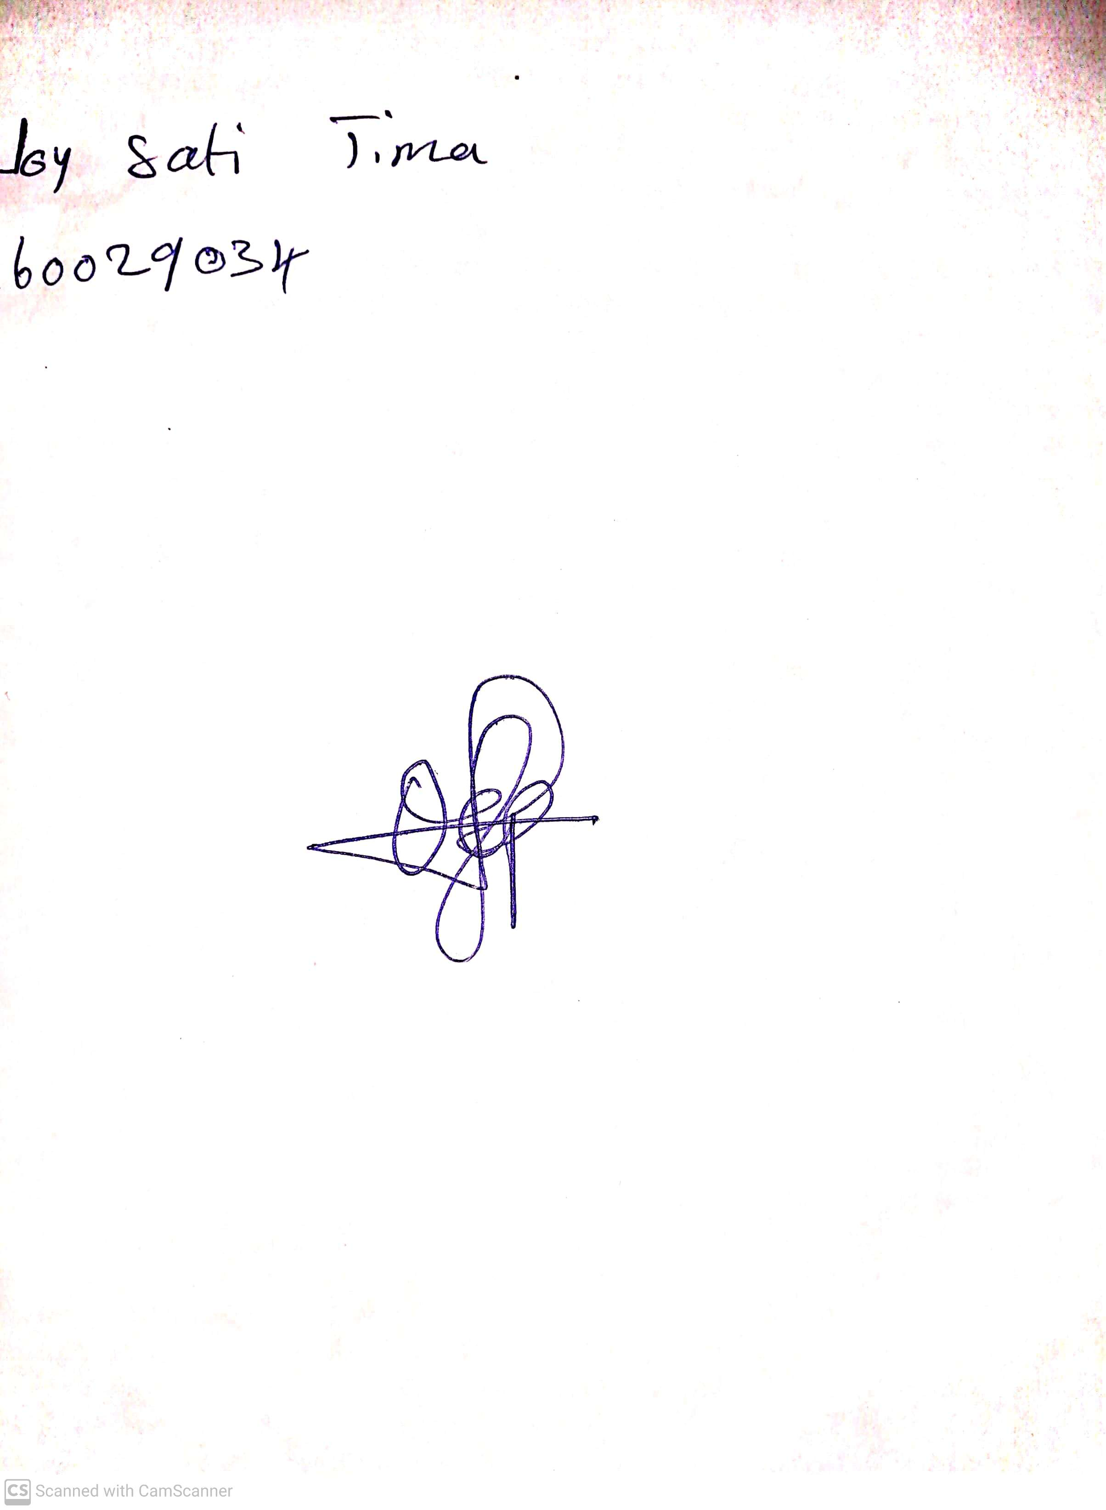

20th May, 2023

Perpetual Ojoma

Stream Head Nursery