EMERALD ROYAL INTERNATIONAL SCHOOL

MPAPE, ABUJA.

LESSON NOTE FOR WEEK 6ENDING 17TH FEBRUARY, 2023.

SUBJECT: Letter work

TOPIC: Reviewing letter g---I and their sounds.

SUB-TOPIC: Letter h and it’s sound.

DATE: 16/2/2023.

DURATION: 40 minutes.

TIME: 11:20--12:00.

PERIOD: 5th

CLASS: Pre-nursery

NUMBER OF PUPILS: 11

AVERAGE AGE: 2 YEARS

SEX: Mixed.

SPECIFIC OBJECTIVES: By the end of the lesson, the pupils should be able to:-

1. Identify letter h and it’s sound.
2. trace letter h

RATIONALE: For pupils to know letters and their sounds.

PREVIOUS KNOWLEDGE: Pupils have been practising sounds of the alphabets.

REFERENCE:Mastering English for nursery schools book 1 by J.M.Omogbai.

LESSON DEVELOPMENT

|  |  |  |  |
| --- | --- | --- | --- |
| STAGES/STEPS | TEACHER’S ACTIVITIES | PUPILS’ ACTIVITIES | LEARNING POINTS |
| INTRODUCTION | Teacher introduces the lesson by going over the previous lesson. | Pupils listen to the teacher and participate in the activities. | To arouse the interest of the pupils for the lesson. |
| PRESENTATION  STEP 1 | Teacher sing a phonics song for letter h for the pupils. | Pupils sing along with the teacher,that is  The h says /h/  The h says /h/  Every letter makes a sound  The h says /h/. | For better understanding of the lesson . |
| STEP2 | Teacher prepares the pupils book for them to trace letter h. | Pupils trace letter h and practice it's sound. | To improve pupils writing skills. |
| SUMMARY | Teacher summarizes the lesson by singing a jolly phonics song for letter h. | Pupils sing the rhyme along with the teacher. | For more understanding of the lesson. |
| EVALUATION | Teacher asks the pupils to:-   1. Say the sound for letter h 2. Point at letter h amongst other letters on the chart. | Pupils answer the teacher’s questions. | To assess the level of pupils understanding of the lesson. |
| CONCLUSION | Teacher marks the pupils books and make corrections where necessary. | Pupils submit their books for marking and corrections . | For onwards study. |
| ASSIGNMENT | Colour letter h and practice it’s sound.  **h** | Pupils do their Home work at home. | To ensure learning takes place at home. |

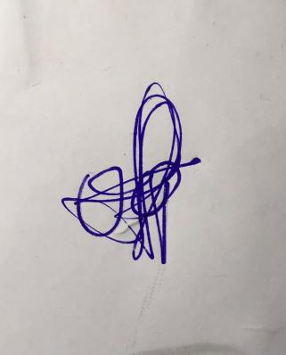

**24th March, 2023**

**Perpetual Ojoma**

**Head Nursery Stream Head**