**LESSON PLAN AND NOTE FOR WEEK 10 ENDING 15/11/2024**

**Term 1st term**

**Week 10th week.**

**Date 12th November,2024**

**Class Nursery one**

**Subject Social Norms**

**Topic Members of the family**

**Sub-topic Meaning of family**

**Period 7th period**

**Time 1:55 pm**

**Duration 35 minutes**

**No in class 15**

**Average Age 3 years**

**Sex Mixed**

**Specific Objectives: By the end of the lesson the pupils should be able to:**

1. **Define family.**
2. **Lists the members of the family.**

**Rationale: To ensure the pupils define & list the members of the family.**

**Previous Knowledge: The pupils can lists & identify tools to care for our surrounding.**

**Instructional Resources: Board,marker , members of the family chart, online research.**

**Reference Materials: Smart smart Civic Education by A.M Solu, T.Y Alabi, Nursery 2**

**LESSON PRESENTATION**

|  |  |  |  |
| --- | --- | --- | --- |
| **Steps** | **Teacher’s Activities** | **Pupils’ Activities** | **Learning Points** |
| **Introduction** | **The teacher introduces the lesson (Members to the family) to the pupils by showing the pupils members of the family chart.** | **The pupils participates with their teacher in the classroom.** | **To arouse the pupils’ interest towards the lesson.** |
| **Step 1** | **The teacher defines family as “the group of people who are related by blood”.** | **The pupils actively repeats after their teacher the meaning of family.** | **For proper understanding.** |
| **Step 2** | **The teacher mentions to the pupils the lists of people that makes up a family which include:**  **FATHER**  **MOTHER**  **BROTHER**  **SISTER**  **AUNTY**  **UNCLE**  **COUSIN ETC.** | **The pupils pays attention to the teacher and repeats after the teacher the people that makes a family.** | **For better understanding.** |
| **Summary** | **The teacher summarizes the lesson by defining family for the pupils.** | **The pupils actively repeats after their teacher.** | **For onward study.** |
| **Evaluation** | **The teacher asks the pupils to:**   1. **What is family?** 2. **Mention five members of the family?** | **The pupils answer the questions accordingly.** | **To ascertain the pupils’ understanding.** |
| **Conclusion** | **The teacher summarizes,reacts,and corrects the pupils.** | **The teacher gives answers to the teacher’s question.** | **To consolidate the lesson.** |
| **Assignment** | 1. **What is family?** 2. **Mention five members of the family?** | **The pupils copy and do their home-work at home.** | **To encourage learning while at home.** |

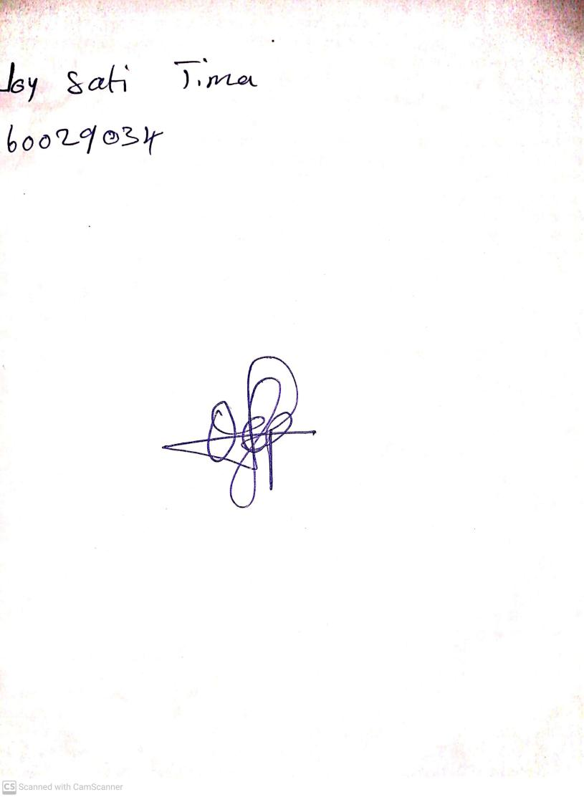

15th November, 2024

Perpetual Ojoma Ocheja

Stream Head Nursery