**LESSON PLAN AND NOTE 1 FOR WEEK 3 ENDING 26/01/2024**

**Term 2nd term**

**Week 3rd week**

**Date 22nd January,2024**

**Class Nursery One**

**Subject Number Work**

**Topic Counting numbers 1-80.**

**Sub-topic Count numbers 70-75**

**Period 4th period**

**Time 9:05 am**

**Duration 35 minutes**

**No in class 15**

**Average Age 3 years**

**Sex Mixed**

**Specific Objectives: By the end of the lesson ,the pupils should be able to:**

1. **Count numbers 70-75.**
2. **Identify numbers 70-75.**
3. **Write numbers 70-75**

**Rationale: To make sure the pupils count numbers 1-80.**

**Previous Knowledge: The pupils can match & fill in missing numbers 1-70.**

**Instructional Resources: Chart, board, marker, etc.**

**Reference Material: The new mastering mathematics.**

**LESSON PRESENTATION**

|  |  |  |  |  |
| --- | --- | --- | --- | --- |
| **Steps** | **Teacher’s Activities** | **Pupils’ Activities** | **Learning Points** | |
| **Introduction** | **The teacher introduces the topic (counting numbers 1-80) to the pupils by rhyming it.** | **The pupils with the teacher rhyme the numbers 1-80.** | **To arouse the pupils’ interest.** | |
| **Step 1** | **The teacher assists the pupils to count numbers 70-75**  **70 71 72**  **73 74 75** | **The pupils counts numbers 70-75 with their teacher.** | | **For proper understanding.** |
| **Step 2** | **The teacher leads the pupils to identify numbers 70-75**  **70 71 72**  **73** | **The pupils participate with the teacher in identifying numbers 70-75.**  **70 71 72**  **73** | | **For better understanding.** |
| **Step 3** | **The teacher guides the pupils to write numbers 70-75 inside their notebooks.**   |  |  | | --- | --- | | **70** | **71** | |  |  | | **72** | **73** | |  |  | | **74** | **75** | |  |  | | **The pupils write numbers 70-75 as the teacher guides them.**   |  |  | | --- | --- | | **70** | **71** | |  |  | | **72** | **73** | |  |  | | **74** | **75** | |  |  | | | **For further understanding** |
| **Summary** | **The teacher summarizes the lesson by counting numbers 70-75.** | **The pupils have master and count numbers 70-75**  **.** | | **For onward study.** |
| **Evaluation** | **Question:**  **Identify numbers 70-75.**  **70 71 72**  **73** | **The pupils answers the question correctly.** | | **To ascertain the pupils’ understanding.** |
| **Conclusion** | **The teacher summarizes, reacts and corrects the lesson.** | **The pupils gives answers to the teacher’s questions** | | **To consolidate the lesson** |
| **Assignment** | **Question:**  **Write the following numbers below**   |  |  | | --- | --- | | **70** | **71** | |  |  | | **72** | **73** | |  |  | | **74** | **75** | |  |  | | **The pupils copy and do their homework at home.** | | **To encourage learning while at home.** |

**LESSON PLAN AND NOTE 2 FOR WEEK 3 ENDING 26/01/2024**

**Term 2nd  term**

**Week 3rd week**

**Date 24th January,2024**

**Class Nursery One**

**Subject Number Work**

**Topic Counting numbers 1-80.**

**Sub-topic Count numbers 75-80**

**Period 4th period**

**Time 9:05 am**

**Duration 35 minutes**

**No in class 15**

**Average Age 3 years**

**Sex Mixed**

**Specific Objectives: By the end of the lesson ,the pupils should be able to:**

1. **Count numbers 75-80.**
2. **Identify numbers 75-80.**
3. **Write numbers 75-80.**

**Rationale: To make sure the pupils count numbers 1-80.**

**Previous Knowledge: The pupils knows how to count numbers 70-75.**

**Instructional Resources: Chart, board, marker, etc.**

**Reference Material: The new mastering mathematics.**

**LESSON PRESENTATION**

|  |  |  |  |
| --- | --- | --- | --- |
| **Steps** | **Teacher’s Activities** | **Pupils’ Activities** | **Learning Points** |
| **Introduction** | **The teacher introduces the topic (counting numbers 1-80) to the pupils by rhyming it.** | **The pupils with the teacher rhyme the numbers 1-80.** | **To arouse the pupils’ interest.** |
| **Step 1** | **The teacher assists the pupils to count numbers 75-80**  **75 76 77**  **78 79 80** | **The pupils counts numbers 75-80 with their teacher.** | **For proper understanding.** |
| **Step 2** | **The teacher leads the pupils to identify numbers 75-80**  **75 76 77**  **78** | **The pupils participate with the teacher in identifying numbers 75-80.**  **75 76 77**  **78** | **For better understanding.** |
| **Step 3** | **The teacher guides the pupils to write numbers 75-80 inside their notebooks.**   |  |  | | --- | --- | | **75** | **76** | |  |  | | **77** | **78** | |  |  | | **79** | **80** | |  |  | | **The pupils write numbers 75-80 as the teacher guides them.** | **For further understanding** |
| **Summary** | **The teacher summarizes the lesson by counting numbers 75-80** | **The pupils have master and count numbers 75-80.** | **For onward study.** |
| **Evaluation** | **Question:**  **Identify numbers 75-80.**  **75 76 77**  **78** | **The pupils answers the question correctly.** | **To ascertain the pupils’ understanding.** |
| **Conclusion** | **The teacher summarizes, reacts and corrects the lesson.** | **The pupils gives answers to the teacher’s questions** | **To consolidate the lesson** |
| **Assignment** | **Question:**  **Identify the following numbers**  **75 76 77**  **78**  **Write the following numbers below**   |  |  | | --- | --- | | **75** | **76** | |  |  | | **77** | **78** | |  |  | | **67** | **80** | |  |  | | **The pupils copy and do their homework at home.** | **To encourage learning while at home.** |

**LESSON PLAN AND NOTE 3 FOR WEEK 3 ENDING 26/01/2024**

**Term 2nd term**

**Week 3rd week**

**Date 26th January,2024**

**Class Nursery One**

**Subject Number Work**

**Topic Counting numbers 1-80.**

**Sub-topic Matching numbers 70-80**

**Period 4th period**

**Time 9:05 am**

**Duration 35 minutes**

**No in class 15**

**Average Age 3 years**

**Sex Mixed**

**Specific Objectives: By the end of the lesson ,the pupils should be able to:**

1. **Match numbers 70-75.**
2. **Fill in the numbers 75-80.**

**Rationale: To make sure the pupils match numbers 1-80.**

**Previous Knowledge: The pupils knows how to count numbers 75-80.**

**Instructional Resources: Chart, board, marker, etc.**

**Reference Material: The new mastering mathematics.**

**LESSON PRESENTATION**

|  |  |  |  |
| --- | --- | --- | --- |
| **Steps** | **Teacher’s Activities** | **Pupils’ Activities** | **Learning Points** |
| **Introduction** | **The teacher introduces the topic (counting numbers 1-80) to the pupils by rhyming it.** | **The pupils with the teacher rhyme the numbers 1-80.** | **To arouse the pupils’ interest.** |
| **Step 1** | **The teacher assists the pupils to match numbers 70-75**  **70 75**  **71 74**    **72 73**  **73 72**  **74 71**  **75 70** | **The pupils match numbers 70-75 with their teacher.**  7**0 75**  7**1 74**    7**2 73**  **73 72**  **74 71**  **75 70** | **For proper understanding.** |
| **Step 2** | **The teacher leads the pupils to fill in the numbers 75-80**  **75____ 77 ______ 79**  **____** | **The pupils participate with the teacher in filling in the missing numbers 75-80.**  **75 76 77**  **78 79 80** | **For better understanding.** |
| **Summary** | **The teacher summarizes the lesson by counting numbers**  **70-80** | **The pupils have master and count numbers 70-80.** | **For onward study.** |
| **Evaluation** | **Question:**  **Count numbers 70-80.** | **The pupils answers the question correctly.** | **To ascertain the pupils’ understanding.** |
| **Conclusion** | **The teacher summarizes, reacts and corrects the lesson.** | **The pupils gives answers to the teacher’s questions** | **To consolidate the lesson** |
| **Assignment** | **Question:**  **Fill in the missing numbers below**  **70____72____74____76**  **____ 78____ 80**  **Match the following numbers below**  **70 75**  **71 74**    **72 73**  **73 72**  **74 71**  **75 70**  **76 80**  **77 79**  **78 78**  **79 77**  **80 76** | **The pupils copy and do their homework at home.** | **To encourage learning while at home.** |

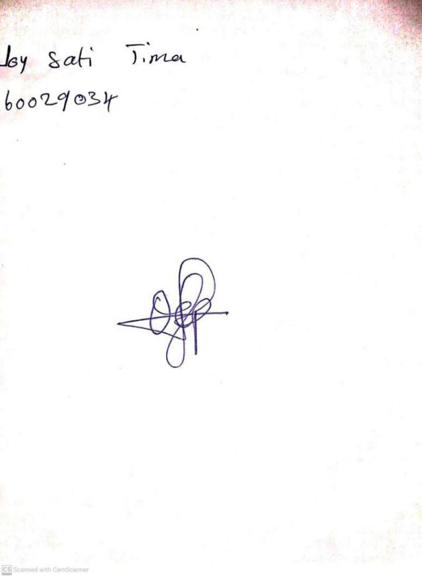

9TH January, 2024

Perpetual Ojoma Ocheja

Stream Head Nursery

**N.B THE EVALUATION SHOULD TALLY WITH THE LEARNING OBJECTIVES**

|  |  |
| --- | --- |
| **Evaluation** | **Question:**  **Count numbers 70-80.** |

**Specific Objectives: By the end of the lesson ,the pupils should be able to:**

1. **Count numbers 70-75.**
2. **Identify numbers 70-75.**
3. **Write numbers 70-75**

KINDLY DO SAME FOR THE OTHER NOTES