**EMERALD ROYAL INTERNATIONAL SCHOOL MPAPE, ABUJA**

**LESSON PLAN AND NOTE FOR WEEK 7 PERIOD 1 ENDING 25/10/2024**

**TERM: FIRST**

**WEEK: 7TH**

**DATE: 22/10/2024**

**CLASS: NURSERY 2**

**SUBJECT: LITERACY**

**TOPIC: THREE LETTER WORDS WENDING IN “od” “og” “op” “ot”**

**“oy” “ol” .**

**SUB-TOPIC: THREE LETTER WORDS ENDING IN “od” and “og”**

**PERIOD: 3RD**

**TIME: 09: 30-10: 10 am**

**DURATION: 40 MINUTES**

**NUMBER IN CLASS: 16**

**AVERAGE AGE: 4**

**SEX: MIXED**

**SPECIFIC OBJECTIVES: BY THE END OF THE LESSON, THE PUPILS SHOULD BE ABLE**

**TO:**

**1.STATE THREE LETTER WORDS ENDING IN “od”AND “og”**

**2.SPELL AND PRONOUNCE THREE LETTER WORDS ENDING IN**

**“od” AND “og”**

**RATIONALE: FOR PUPILS TO BE ABLE TO SPELL AND PRONOUNCE WORDS THAT ENDS WITH “od” AND “og”.**

**PREVIOUS KNOWLEDGE: PUPILS HAVE LEARNT SIMPLE SENTENCES ON THREE LETTER WORDS IN PREVIOUS LESSON.**

**INSTRUCTIONAL MATERIALS: A CHART OF THREE LETTER WORDS ENDING IN “od” AND “og”.**

**REFERENCE MATERIALS: TOP STAR MY CHOICE OF ENGLISH LANGUAGE STAGE 3 BY J.F OMOTAYO.**

**LESSON DEVELOPMENT**

|  |  |  |  |
| --- | --- | --- | --- |
| **STAGES/STEPS** | **TEACHER’S ACTIVITIES** | **PUPILS’ ACTIVITIES** | **LEARNING POINT** |
| **INTODUCTION** | **Teacher introduces the lesson by reviewing the previous lesson.** | **Pupils listen attentively to the teacher.** | **To arouse pupils interest for the lesson ahead.** |
| **PRESENTATION STEP 1** | **Teacher states the three letter words ending with “od” and “og” to pupils and then asks them to repeat after her.** | **Pupils pay attention to the teacher and repeat after her.** | **For proper understanding.** |
| **STEP 2** | **Teacher spells and pronounce the three letter words that ends with “od” and “og” to pupils and also asks them to repeat after her.** | **Pupils listen very attentively to the teacher and repeat after her.** | **For better understanding of the lesson.** |
| **BOARD SUMMARY** | **Teacher summarizes the lesson by writing the whole note of lesson on the board for pupils to copy into their books. That is;**  **Three letter words ending in “od” and “og” are:**  **“od” as in**   1. **God** 2. **Cod** 3. **Tod** 4. **Pod** 5. **Mod** 6. **Nod** 7. **Rod etc.**   **“og” as in**   1. **Jog** 2. **Cog** 3. **Dog** 4. **Mog** 5. **Log** 6. **Tog** 7. **Hog etc.** | **Pupils copy the note on the board into their exercise books.** | **For onward study.** |
| **EVALUATION** | **Teacher evaluates the lesson by asking the following questions:**   1. **State the three letter words that ends with “od” and “og”.** 2. **Spell and pronounce the three letter words that ends with “od”.** 3. **Spell and pronounce the three letter words that ends with “og”.** | **Pupils answer the questions asked by the teacher.** | **To asses pupils level of understanding of the lesson.** |
| **CONCLUSION** | **Teacher concludes the lesson by marking pupils books.** | **Pupils submit their books for marking.** | **For endorsement.** |
| **ASSIGNMENT** | **Identify, write and pronounce the following three letter words.**   1. **Top** 2. **Cop** 3. **Mop** 4. **Pop** 5. **Dop** 6. **Hop** 7. **Fop** 8. **Pot** 9. **Rot** 10. **Hot** 11. **Dot** 12. **Bot** 13. **Cot** 14. **Not** 15. **lot** | **Pupils do their assignment at home.** | **To encourage learning at home.** |

**LESSON PLAN AND NOTE FOR WEEK 7 PERIOD 2 ENDING 25/10/2024**

**TERM: FIRST**

**WEEK: 7TH**

**DATE: 22/10/2024**

**CLASS: NURSERY 2**

**SUBJECT: LITERACY**

**TOPIC: THREE LETTER WORDS WENDING IN “od” “og” “op” “ot”**

**“oy” .**

**SUB-TOPIC: THREE LETTER WORDS ENDING IN “op” AND “ot” .**

**PERIOD: 2ND**

**TIME: 08: 50-09: 30 am**

**DURATION: 40 MINUTES**

**NUMBER IN CLASS: 16**

**AVERAGE AGE: 4**

**SEX: MIXED**

**SPECIFIC OBJECTIVES: BY THE END OF THE LESSON, THE PUPILS SHOULD BE ABLE**

**TO:**

**1.STATE THREE LETTER WORDS ENDING IN “op” AND “ot”**

**2.SPELL AND PRONOUNCE THREE LETTER WORDS ENDING IN**

**“op” AND “ot”**

**RATIONALE: FOR PUPILS TO BE ABLE TO SPELL AND PRONOUNCE WORDS THAT ENDS WITH “op” AND “ot”.**

**PREVIOUS KNOWLEDGE: PUPILS HAVE LEARNT THREE LETTER WORDS ENDING IN “od” AND “og” IN PREVIOUS LESSON.**

**INSTRUCTIONAL MATERIALS: A CHART OF THREE LETTER WORDS ENDING IN “op” AND ot” .**

**REFERENCE MATERIALS: TOP STAR MY CHOICE OF ENGLISH LANGUAGE STAGE 3 BY J.F OMOTAYO.**

**LESSON DEVELOPMENT**

|  |  |  |  |
| --- | --- | --- | --- |
| **STAGES/STEPS** | **TEACHER’S ACTIVITIES** | **PUPILS’ ACTIVITIES** | **LEARNING POINT** |
| **INTODUCTION** | **Teacher introduces the lesson by reviewing the previous lesson.** | **Pupils listen attentively to the teacher.** | **To arouse pupils interest for the lesson ahead.** |
| **PRESENTATION STEP 1** | **Teacher states the three letter words ending with “op” and “ot” to pupils and then asks them to repeat after her.** | **Pupils pay attention to the teacher and repeat after her.** | **For proper understanding.** |
| **STEP 2** | **Teacher spells and pronounce the three letter words that ends with “op” and “ot” to pupils and also asks them to repeat after her.** | **Pupils listen very attentively to the teacher and repeat after her.** | **For better understanding of the lesson.** |
| **BOARD SUMMARY** | **Teacher summarizes the lesson by writing the whole note of lesson on the board for pupils to copy into their books. That is;**  **Three letter words ending in “op” and ot are:**  **“op” as in**   1. **Cop** 2. **Hop** 3. **Pop** 4. **Top** 5. **Mop** 6. **Dop** 7. **Fop** 8. **Lop** 9. **Nop** 10. **Oop** 11. **Rop** 12. **Gop** 13. **Bop** 14. **Sop etc**   **“0t” as in**   1. **Bot** 2. **Got** 3. **Oot** 4. **Tot** 5. **Mot** 6. **Pot** 7. **Rot** 8. **Hot** 9. **Dot** 10. **Cot** 11. **Not** 12. **Lot** 13. **Sot** 14. **Jot etc.** | **Pupils copy the note on the board into their exercise books.** | **For onward study.** |
| **EVALUATION** | **Teacher evaluates the lesson by asking the following questions:**   1. **State the three letter words that ends with “op” and “ot”.** 2. **Spell and pronounce the three letter words that ends with “op”.** 3. **Spell and pronounce the three letter words that ends with “ot”.** | **Pupils answer the questions asked by the teacher.** | **To asses pupils level of understanding of the lesson.** |
| **CONCLUSION** | **Teacher concludes the lesson by marking pupils books.** | **Pupils submit their books for marking.** | **For endorsement.** |
| **ASSIGNMENT** | **Identify, write and pronounce the following three letter words.**   1. **Bot** 2. **Got** 3. **Oot** 4. **Tot** 5. **Mot** 6. **Pot** 7. **Rot** 8. **Hot** 9. **Dot** 10. **Cot** 11. **Not** 12. **Lot** 13. **Sot** 14. **jot** | **Pupils do their assignment at home.** | **To encourage learning at home.** |

**LESSON PLAN AND NOTE FOR WEEK 7 PERIOD 3 ENDING 25/10/2024**

**TERM: FIRST**

**WEEK: 7TH**

**DATE: 25/10/2024**

**CLASS: NURSERY 2**

**SUBJECT: LITERACY**

**TOPIC: THREE LETTER WORDS WENDING IN “od” “og” “op” “ot”**

**“oy” “ol” .**

**SUB-TOPIC: THREE LETTER WORDS ENDING IN “oy” and “ol” .**

**PERIOD: 3RD**

**TIME: 09: 30-10: 10 am**

**DURATION: 40 MINUTES**

**NUMBER IN CLASS: 16**

**AVERAGE AGE: 4**

**SEX: MIXED**

**SPECIFIC OBJECTIVES: BY THE END OF THE LESSON, THE PUPILS SHOULD BE ABLE**

**TO:**

**1.STATE THREE LETTER WORDS ENDING IN “oy” AND “ol”**

**2.SPELL AND PRONOUNCE THREE LETTER WORDS ENDING IN**

**“oy” AND “ol”**

**RATIONALE: FOR PUPILS TO BE ABLE TO SPELL AND PRONOUNCE WORDS THAT ENDS WITH “oy” AND “ol”.**

**PREVIOUS KNOWLEDGE: PUPILS HAVE LEARNT THREE LETTER WORDS ENDING IN “op” AND “ot” IN PREVIOUS LESSON.**

**INSTRUCTIONAL MATERIALS: A CHART OF THREE LETTER WORDS ENDING IN “oy” AND “ol” .**

**REFERENCE MATERIALS: TOP STAR MY CHOICE OF ENGLISH LANGUAGE STAGE 3 BY J.F OMOTAYO.**

**LESSON DEVELOPMENT**

|  |  |  |  |
| --- | --- | --- | --- |
| **STAGES/STEPS** | **TEACHER’S ACTIVITIES** | **PUPILS’ ACTIVITIES** | **LEARNING POINT** |
| **INTODUCTION** | **Teacher introduces the lesson by reviewing the previous lesson.** | **Pupils listen attentively to the teacher.** | **To arouse pupils interest for the lesson ahead.** |
| **PRESENTATION STEP 1** | **Teacher states the three letter words ending with “oy” and “ol” to pupils and then asks them to repeat after her.** | **Pupils pay attention to the teacher and repeat after her.** | **For proper understanding.** |
| **STEP 2** | **Teacher spells and pronounce the three letter words that ends with “oy” and “ol” to pupils and also asks them to repeat after her.** | **Pupils listen very attentively to the teacher and repeat after her.** | **For better understanding of the lesson.** |
| **BOARD SUMMARY** | **Teacher summarizes the lesson by writing the whole note of lesson on the board for pupils to copy into their books. That is;**  **Three letter words ending in “oy” and “ol” are:**  **“oy” as in;**   1. **Boy** 2. **Coy** 3. **Joy** 4. **Toy** 5. **Roy** 6. **Moy** 7. **Soy** 8. **Doy** 9. **Goy** 10. **Foy** 11. **Hoy** 12. **Loy** 13. **Noy etc.**   **“ol” as in;**   1. **Pol** 2. **Col** 3. **Sol** 4. **Tol** 5. **Mol** 6. **Vol** 7. **Jol** 8. **Lol** 9. **Bol** 10. **Zol etc.** | **Pupils copy the note on the board into their exercise books.** | **For onward study.** |
| **EVALUATION** | **Teacher evaluates the lesson by asking the following questions:**   1. **State the three letter words that ends with “oy”.**   **2.Spell and pronounce the three letter words that ends with “ol”.** | **Pupils answer the questions asked by the teacher.** | **To asses pupils level of understanding of the lesson.** |
| **CONCLUSION** | **Teacher concludes the lesson by marking pupils books.** | **Pupils submit their books for marking.** | **For endorsement.** |
| **ASSIGNMENT** | **Read the following sentences:**   1. **Pat has a cat.** 2. **The cat is fat. Pat is sad.** 3. **Pat is sad at the cat.** 4. **Dan has a hat.** 5. **The hat is on the mat.** 6. **The cat sat on the mat.** | **Pupils do their assignment at home.** | **To encourage learning at home.** |

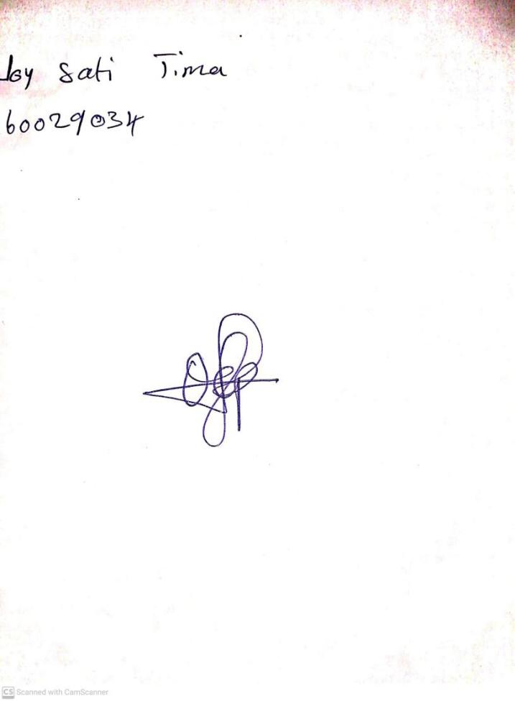

**18th October, 2024**

**Perpetual Ojoma Ocheja**

**Stream Head Nursery**