LESSON PLAN FOR WEEK 4 ENDING 3rd FEBRUARY, 2023

|  |  |
| --- | --- |
| TERM | 2ND |
| WEEK | 4 |
| DATE | 30th January- 3rd February, 2023. |
| CLASS | SS 2 |
| SUBJECT | Government |
| TOPIC | Indirect Rule in Southern Nigeria |
| SUB-TOPIC | Reasons the Educated Elites Opposed the Tradition of Indirect Rule in Southern Nigeria |
| PERIOD | 5th |
| TIME | 11:10-11:50AM |
| DURATION | 40 Minutes |
| NO IN CLASS | 2 |
| AVERAGE AGE | 16 Years |
| SEX | Mixed |
| SPECIFIC OBJECTIVES | By the end of the lesson, scholars should be able to:  i.List the reasons the educated elites opposed the tradition of Indirect Rule in Southern Nigeria.  ii.Explain the reasons the educated elites opposed the tradition of Indirect Rule in Southern Nigeria. |
| RATIONALE | To acquaint scholars with the reasons the educated elites opposed the tradition of Indirect Rule System in Southern Nigeria. |
| PREVIOUS KNOWLEDGE | The scholars can explain the roles played by traditional rulers in the British colonial system. |
| INSTRUCTIONAL RESOURCES | Charts from textbook explaining the topic. |
| REFERENCE MATERIAL | Essential Government for Senior Secondary Schools.  Debie Chris(2017) |

LESSON DEVELOPMENT

|  |  |  |  |
| --- | --- | --- | --- |
| STEPS | TEACHER’S ACTIVITIES | SCHOLARS’ ACTIVITIES | LEARNING POINTS |
| Introduction | The teacher introduces the lesson by asking the scholars to mention two roles played by the traditional rulers during the British colonial system. | The scholars mention the roles as:  i.Communal work  ii.Acted as link. | To arouse scholars interest towards the topic. |
| Step 1 | The teacher lists the reasons the educated elites opposed Indirect Rule in Southern Nigeria. | The scholars pay attention. | To ensure proper understanding of the topic. |
| Step 2 | The teacher explains the reasons the educated elites opposed Indirect Rule in Southern Nigeria. | The scholars ask relevant questions on the topic. | To make room for logical reasoning on the topic. |
| Board Summary | The teacher summerises the lesson thus:  **Reasons the Educated Elites Opposed The Tradition of Indirect Rule in Southern Nigeria:**  1.Uneducated traditional rulers.  2.Non-recognition of educated elites.  3.High handedness of warrant chiefs.  4.Taxation  5.Menial jobs, etc  Explanation:  i.The use of uneducated traditional rulers: The indirect rule system made use of local chiefs and traditional rulers who were mostly uneducated.  ii.Non-recognition of educated elites: British officials did not see the need to include the educated Nigerians in the colonial administration.  iii.The warrant chiefs: The creation of warrant chiefs in the eastern part of the country resulted in problems of different kinds. The warrant chiefs became high handed and ruthless in the discharge of their duties.  iv.Combination of judicial and executive functions in the hands of the colonial officers: Most of the British officials exercised both functions, even to the detriment of the people.  v.Introduction of taxation: The British imposed different methods of taxation on the people and it caused riots in different parts of the country. For example, the women riot of 1929.  vi.Menial jobs: The position of chieftaincy institution was disrespected by giving them menial jobs to perform.  vii.Appointment and Deposition: Traditional chiefs were appointed and deposed (sacked) by the colonial masters.  viii.Education: The level of education was high in the east. People could question the relevance of Indirect Rule system imposed on them. | The scholars copy notes into their notebooks. | For reference purposes. |
| Evaluation | The teacher evaluates the scholars thus:  i.List and explain three reasons the educated elites opposed Indirect Rule in Southern Nigeria. | The scholars attempt the questions. | To ascertain scholars understanding of the lesson. |
| Conclusion | The teacher check scholars notes and make corrections. | The scholars take corrections made by the teacher. | For consolidation of the lesson. |
| Assignment | The teacher gives the scholars assignment:  State four implications to the opposition of Indirect Rule by the educated elites in southern Nigeria. | The scholars copy their assignments to do at home. | To encourage continuity of learning. |

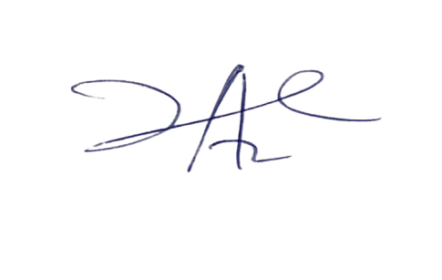

**20/3/2023**

**Principal Head Instructor**