**EMERALD ROYAL INTERNATIONAL SCHOOL, MPAPE ABUJA**

**LESSON PLAN AND NOTE 1 FOR WEEK 4 ENDING FRIDAY, 6TH OCTOBER, 2023**

**TERM:** FIRST TERM

**WEEK:** WEEK 4

**SUBJECT:** BASIC SCIENCE

**TOPIC:** ROAD

**SUB-TOPIC:** ROADS WITHIN AND OUTSIDE THE SCHOOL

**DATE:** TUESDAY, 3RD AND WEDNESDAY, 4TH OCTOBER, 2023

**TIME:** 08:45 – 09:25AM AND 09:25 – 09:55AM

**DURATION:** 40 MINUTES

**PERIOD:** 2ND AND 3RD

**CLASS:** NURSERY 3

**NUMBER IN CLASS:** ELEVEN

**AVERAGE AGE:** FIVE

**SEX:** MIXED

**LEARNING OBJECTIVES:** By the end of the lesson, the pupils should be able to:

1. Identify roads within the school.
2. Identify and mention roads outside the school.

**RATIONALE:** for pupils to learn roads within and outside the school.

**PREVIOUS KNOWLEGDE:** pupils have learnt the meaning and types of roads

**INSTRUCTIONAL MATERIALS:**

1. Flash cards.
2. Road chart.

**REFERENCE MATERIALS:**

Smart Basic Science and Technology book 1 by D. I. Bika, Cambridge University Press

**LESSON DEVELOPMENT**

|  |  |  |  |
| --- | --- | --- | --- |
| **STAGES/STEPS** | **TEACHER’S ACTIVITIES** | **PUPILS’ ACTIVITIES** | **LEARNING POINTS** |
| **INTRODUCTION** | Review previous knowledge | Identify numbers 1-10 | To arouse the pupils’ interest. |
| **PRESENTATION**  **STEP 1** | Leads pupils to identify roads within the school.   1. Parkway 2. Track 3. Lane | Roads within the school | Roads within the school. |
| **STEP 2** | Leads pupils to roads outside the school.   1. Route 2. Highway 3. Dead-end 4. Short cut 5. Express way | Roads outside the school | Roads outside the school. |
| **SUMMARY** | Summarises the lesson by emphasising on the main concept and writes note on the board | Listen and copy their notes | For onward study |
| **EVALUATION** | Asks pupils to:   1. List the roads within the school. 2. List the roads outside the school | Respond to the teacher’s question. | To test the pupils understanding on the lesson. |
| **CONCLUSION** | Summarizes, corrects and mark pupils’ notebooks | Submit their notebooks for marking. | Clarifying the concept. |
| **HOME WORK** | 1. Write out three roads each within and outside the school | Cope and return with task. | Extending lesson home. |

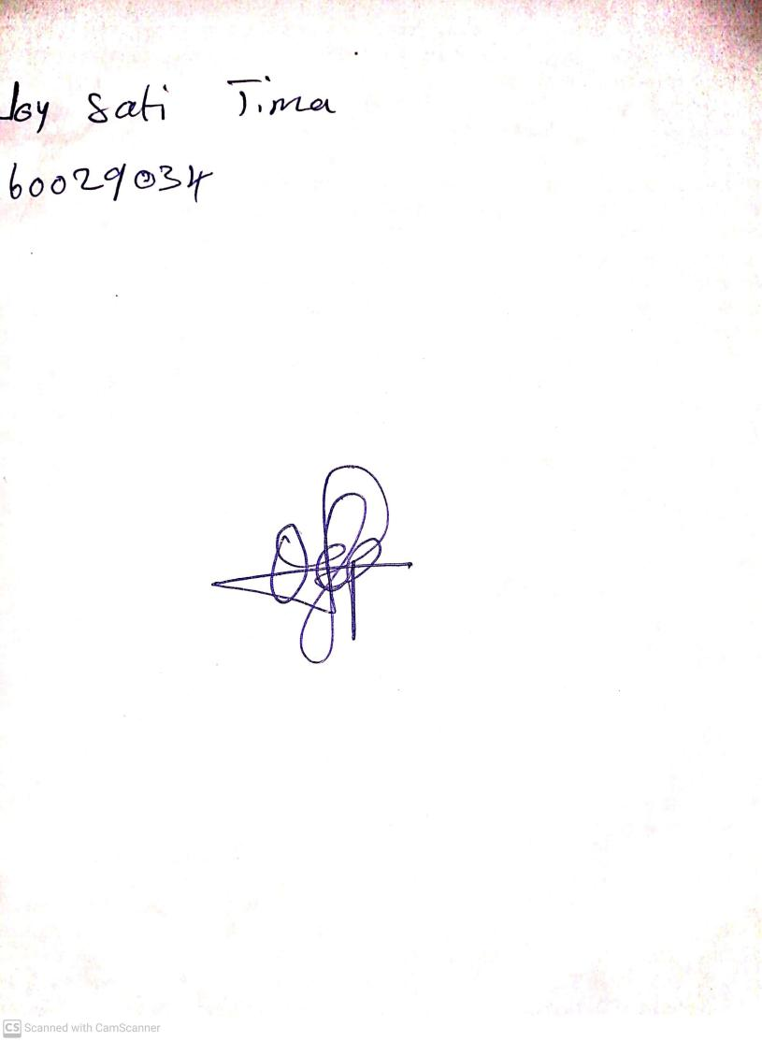

29TH September, 2023

Perpetual Ojoma Ocheja

Stream Head Nursery