**LESSON PLAN FOR WEEK 11 ENDING 22/11/2024**

**Term 1st term**

**Week 11th  week**

**Date 20th November,2024**

**Class Nursery One**

**Subject Nature studies**

**Topic Floating Objects.**

**Sub-topic Meaning of floating objects**

**Period 4th period**

**Time 10:40 am**

**Duration 35 minutes**

**No in class 15**

**Average Age 3 years**

**Sex Mixed**

**Specific Objectives: By the end of the lesson, the pupils should be able to:**

1. **Define floating objects.**
2. **Mention examples of floating objects..**

**Rationale: To ensure the pupils define and lists examples of floating objects.**

**Previous Knowledge: The pupils can mention the uses of soil.**

**Instructional Resources: Online Research.**

**Reference Material: Elementary science by Showers kiddies nursery 1**

**LESSON PRESENTATION**

|  |  |  |  |
| --- | --- | --- | --- |
| **Steps** | **Teacher’s Activities** | **Pupils’ Activities** | **Learning Points** |
| **Introduction** | **The teacher introduces the lesson (Floating objects) to the pupils.** | **The pupils listens attentively to their teacher.** | **To arose the pupils’ interest.** |
| **Step 1** | **The teacher defines floating objects to the pupils:**  **Floating objects are those objects that floats or stays on top of water.** | **The pupils repeats after the teacher the uses of soil.** | **For proper understanding.** |
| **Step 2** | **The teacher mentions the examples of floating objects which includes:**  **Pencil**  **Pen**  **Plastic spoon**  **Plastic ball, etc.** | **The pupils participates in mentioning the examples of floating objects.** | **For better understanding.** |
| **Summary** | **The teacher summarizes the lesson by defining floating objects.** | **The pupils can define floating objects.** | **For onward study.** |
| **Evaluation** | **Define floating objects?**  **Mention the examples of floating objects?** | **The pupils answer the question correctly.** | **To ascertain the pupils’ understanding.** |
| **Conclusion** | **The teacher summarizes, reacts, and corrects the pupils.** | **The pupils gives answer to the teacher’s questions** | **To consolidate the lesson.** |
| **Assignment** | **Define floating objects?**  **Mention 5 examples of floating objects?** | **The pupils copy and do their homework at home.** | **To encourage learning while at home.** |

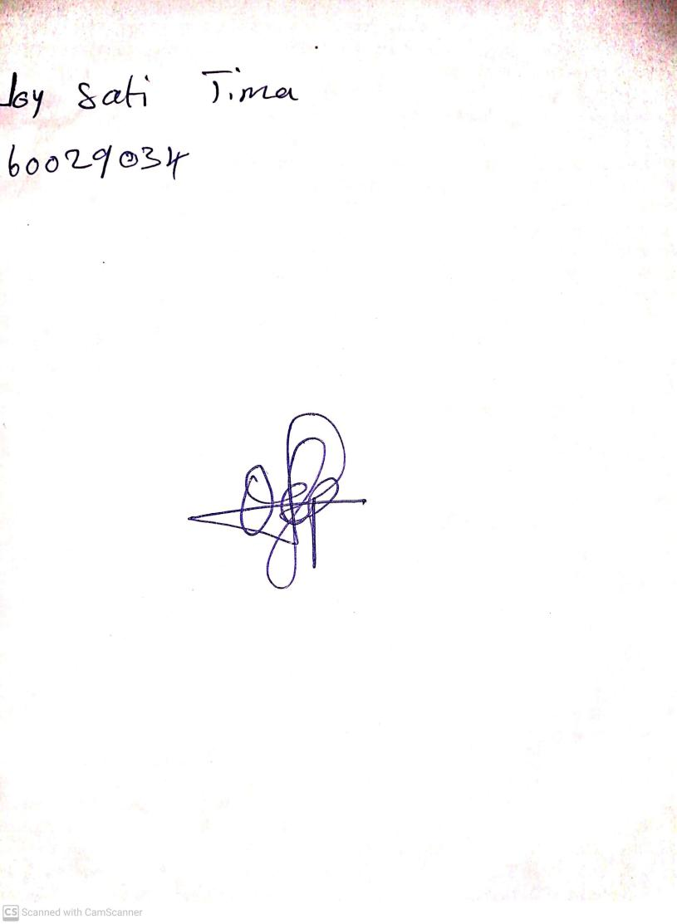

22nd November, 2024

Perpetual Ojoma Ocheja

Stream Head Nursery