**LESSON PLAN AND NOTE FOR WEEK 2 ENDING 19/01/2024**

**Term 2nd term**

**Week 2nd week.**

**Date 17th January ,2024**

**Class Nursery one**

**Subject Social Norms**

**Topic My School**

**Sub-topic Places and activities found in a school**

**Period 4th period**

**Time 10:40**

**Duration 35 minutes**

**No in class 15**

**Average Age 3 years**

**Sex Mixed**

**Specific Objectives: By the end of the lesson the pupils should be able to:**

1. **Mention places around their school**
2. **Mention activities carried out in their school**

**Rationale: To ensure the pupils have vital knowledge about their school.**

**Previous Knowledge: The pupils know the meaning of school & the name of their school**

**Instructional Resources: School premises,online research.**

**Reference Materials: Smart smart Civic Education by A.M Solu, T.Y Alabi, Nursery 2**

**LESSON PRESENTATION**

|  |  |  |  |
| --- | --- | --- | --- |
| **Steps** | **Teacher’s Activities** | **Pupils’ Activities** | **Learning Points** |
| **Introduction** | **The teacher introduces the topic (My School) by singing the school’s anthem with the pupils.** | **The pupils participate actively in singing the school’s anthem with the teacher.** | **To arouse the pupils’ interest towards the lesson.** |
| **Step 1** | **The teacher leads the pupils in mentioning places around the school such as : library,refetree,classrooms ,computer labs, playground etc.** | **The pupils mention by repeating after the teacher places found in school** | **For proper understanding.** |
| **Step 2** | **The teacher leads the pupils to mention the activities done in the school such as :sports,exercise on the playground.** | **The pupils mention the activities that takes place in school.** | **For better understanding.** |
| **Summary** | **The teacher summarizes the lesson by mentioning places around the school, and activities that occur in school** | **The pupils listen and understand the teachers teaching.** | **For onward study.** |
| **Evaluation** | **Question:**   1. **Mention 2 activities found in your school?** 2. **Mention 2 places around the school?.** | **The pupils answer the questions accordingly.** | **To ascertain the pupils’ understanding.** |
| **Conclusion** | **The teacher summarizes,reacts,and corrects the pupils.** | **The teacher gives answers to the teacher’s question.** | **To consolidate the lesson.** |
| **Assignment** | **Question:**   1. **Mention the activities carried out school.** 2. **Mention 2 places around the school?.** | **The pupils copy and do their homework at home.** | **To ensure learning while at home.** |

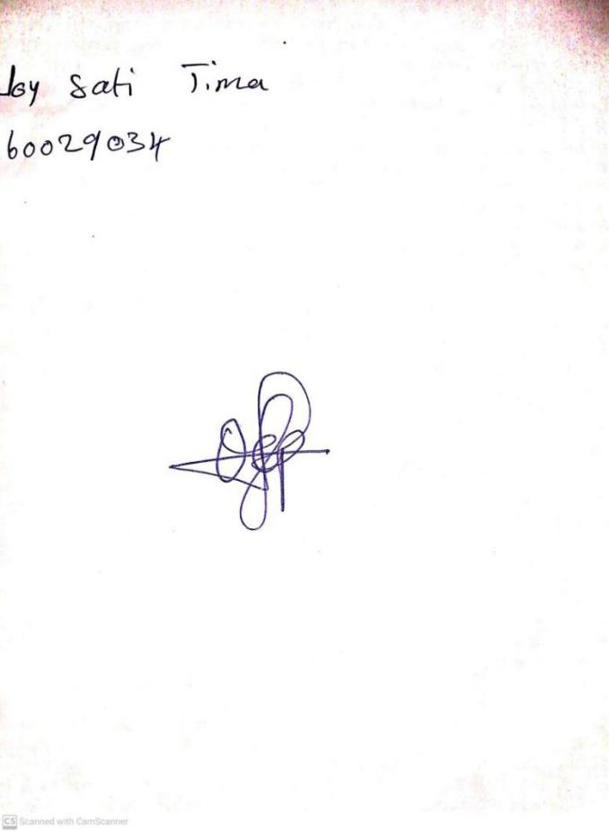

12TH January, 2024

Perpetual Ojoma Ocheja

Stream Head Nursery