**LESSON PLAN AND NOTE FOR WEEK 1 ENDING 15/09/2023**

**Term 1st term**

**Week 1st week.**

**Date 11th September,2023**

**Class Nursery one**

**Subject Social Norms**

**Topic My self**

**Sub-topic What is your name?**

**Period 4th period**

**Time 10:40 am**

**Duration 35 minutes**

**No in class 15**

**Average Age 3 years**

**Sex Mixed**

**Specific Objectives: By the end of the lesson the pupils should be able to:**

1. **Identify their full names.**
2. **Know their hobbies.**

**Rationale: To ensure the pupils know & list everything about theirselves.**

**Previous Knowledge: The pupils can mention who they must love and respect.**

**Instructional Resources: Board,marker ,online research.**

**Reference Materials: Smart smart Civic Education by A.M Solu, T.Y Alabi, Nursery 2**

**LESSON PRESENTATION**

|  |  |  |  |
| --- | --- | --- | --- |
| **Steps** | **Teacher’s Activities** | **Pupils’ Activities** | **Learning Points** |
| **Introduction** | **The teacher introduces the lesson by first telling the pupils her names before asking the pupils one after the other to mention their different names.** | **The pupils participate actively in addressing themselves with their names.** | **To arouse the pupils’ interest towards the lesson.** |
| **Step 1** | **The teacher leads the pupils by using herself as example to mention their full names which includes ,**  **Their father’s surname and their names.**  **E.g**  **My name is Chine Onyinyechi Favour.** | **The pupils actively participates in addressing themselves.** | **For proper understanding.** |
| **Step 2** | **The teacher leads the pupils to mention what they love doing by using herself as example**  **E.g**  **My name is Miss Favour, I love dancing, singing and cooking.**  **My favourite food are Yam an egg sauce.** | **The pupils actively participates in addressing themselves about many things.** | **For better understanding.** |
| **Summary** | **The teacher summarizes the lesson by asking the pupils each their favourite food and snacks.** | **The pupils actively mention all their favourite snacks and food.** | **For onward study.** |
| **Evaluation** | **What is your name?**  **What do you hate?** | **The pupils answer the questions accordingly.** | **To ascertain the pupils’ understanding.** |
| **Conclusion** | **The teacher summarizes,reacts,and corrects the pupils.** | **The teacher gives answers to the teacher’s question.** | **To consolidate the lesson.** |
| **Assignment** | **What is your favourite food?**  **What is your favourite snacks?** | **The pupils copy and do their home-work at home.** | **To encourage learning while at home.** |

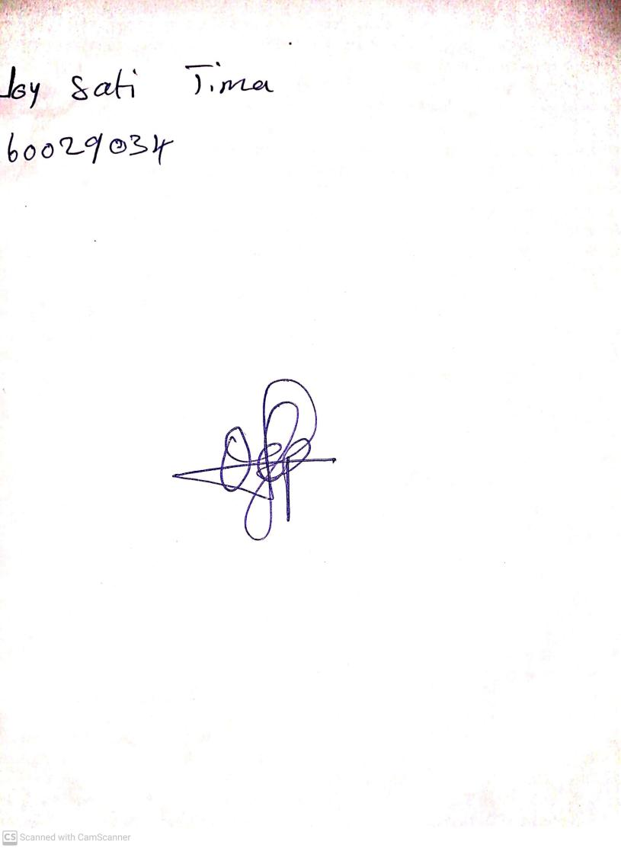

15th August, 2023

Perpetual Ojoma Ocheja

Stream Head Nursery