**Lesson Plan/Note for week One Ending 13/1/2023.**

**Term:** 2nd

**Week:** One

**Date:** 10/1/2023.

**Class:** SS 2

**Subject:** Economics

**Topic:** Labour market

**Sub-Topic:** Meaning of self- employment, Needs and Concept of Dignity of Labour

**Period:** 6th

**Time:** 11:50-12:30

**Duration:** 40 Minutes

**Number in class:** 5 Students

**Average Age:** 14 Years

**Sex**: Mixed

**Specific objectives:** By the end of the lesson, the students should be able to:

1 Explain self- employment

11 State the Needs for self- employment

111 Describe the concept of Dignity of Labour

**Rationale:** To be able to develop the spirit of creativity and self-reliance.

**Previous knowledge:** The students have learned one skill or the other.

**Instructional Material:** A chart showing people working in shop's and their private business

**Reference material:** Gbenga Babalola (2017), Metropolitan Economics for senior Secondary schools.

**LESSON DEVELOPMENT**

|  |  |  |  |
| --- | --- | --- | --- |
| **Stages/steps** | **Teacher's Activities** | **Students' Activities** | **Learning points.** |
| **Introduction** | Review the previous lesson | Participate actively in the class discussion | To arouse the students’- interest to learn. |
| **Step 1** | Explains Self- employment as: self- employment is the act of an individual working for his/ herself without being employed by any organization or government. | Listen carefully to the teacher | For better understanding of the lesson |
| **Step 11** | Guides the students to State the needs of self -employment | State the Needs of Self Employment as: (1) creativity (2) growth and development etc. | To encourage critical thinking. |
| **Step 111** | Leads the students to describe the concept of Dignity of Labour. | Respond to the class activity positively. | To enhance their logical reasoning |
| **Board Summary** | Summarizes the lesson as:  **Self- employment**  Self- employment is the act of an individual working for his/herself without being employed by any organization or government. Self- employed people generally find their own work rather than being provided with work by an employer, earning income from a trade or business that they operate. A highly skilled person in a trade or vocation can easily be self- employed.  However, government alone can not bear the burden of employment for all her citizens or be able to employ everyone in the state. Therefore, there is need for people to be self-employed.  **Needs for self- Employment.**  (1) Creativity: This increase people vocational skills thereby leaving them to be highly creative in whatever they do.  (2) Growth and development  (3) It creates employment.  (4) Reduces crimes: self -employment does not Foster high crime rate in a country. They are always busy.  (5) High standard of living: This help to improve people standard of living.  **Dignity of Labour**  Dignity of Labour is the theory that all variety of jobs have equal respect and that no occupation is considered higher than the other. There is no shame in doing a job, no matter what it entails, but it should be done with dignity and respect. No profession is higher or lower, dignified or undignified. It is the way we pursue it that makes it sacred or otherwise. We must learn that honest work of all types is dignified and worthy of respect. Even the humble sweeter, who engaged in an unpleasant task, is Worthy of respect from the society. The only thing we should be ashamed of is idleness and to live without labour. | Copy and submit the note book for marking. | For future reference. |
| **Evaluation** | Evaluates the students as:  (1) what is self- employment?  (2) State 4 needs for self- Employment.  (3) Describe dignity of labour. | Respond to the questions | Ascertaining the attainment of the stated objectives |
| **Conclusion** | Rounds up the lesson by marking and correcting students work | Check and do their correction | Consolidation of the lesson |
| **Assignment** | Gives home as:  (1) Explain 4 Needs for self- Employment | Respond by doing the home work at home. | To ensure continuity of learning. |

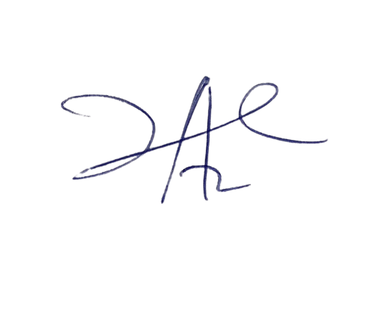

6/3/2023

Principal Head Instructor