**EMERALD ROYAL INTERNATIONAL SCHOOL**

**MPAPE, ABUJA.**

**LESSON PLAN AND NOTE FOR WEEK 8 PERIOD 1 ENDING 23/06/2023**

TERM: THIRD

WEEK: 8TH

DATE: 19/06/2023

CLASS: NURSERY 2

SUBJECT: LETTER WORK

TOPIC: COMMON THINGS IN THE CLASSROOM

SUB-TOPIC: IDENTIFICATION OF THINGS IN THE CLASSROOM

PERIOD: 1ST PERIOD

TIME: 09: 30 - 10:10am

DURATION: 40 MINUTES.

NUMBER IN CLASS: 17

AVERAGE AGE: 5 YEARS.

SEX: MIXED.

SPECIFIC OBJECTIVES: BY THE END OF THE LESSON,THE PUPILS SHOULD BE

ABLE TO:

1. MENTION THINGS IN THE CLASSROOM

2. SPELL AND PRONOUNCE THINGS IN THE

CLASSROOM

RATIONALE: FOR PUPILS TO KNOW HOW TO SPELL THINGS IN

CLASSROOM

PREVIOU KNOWLEDGE: PUPILS HAVE BEEN MAKING USE OF THINGS IN THE

CLASSROOM

INSTRUCTIONAL MATERIALS: PENCILS,BOOKS, CHAIRS AND DESK

REFERENCE MATERIALS: THE NEW MASTERING ENGLISH FOR NURSERY

SCHOOLS BOOK 3 BY J .M OMOGBAI .

**LESSON DEVELOPMENT**

|  |  |  |  |
| --- | --- | --- | --- |
| STAGES/STEPS | TEACHER’S ACTIVITIES | PUPILS’ ACTIVITIES | LEARNING POINTS |
| INTRODUCTION | Teacher reviews the previous lesson on vowel digraphs to pupils. | Pupil listen attentively to the teacher. | To prepare pupils minds for the lesson ahead. |
| PRESENTATION  STEP 1 | Teacher mentions the things in the classroom to pupils and asks them to repeat after her. | Pupils listen attentively to the teacher and repeat after her. | For proper understanding . |
| STEP 2 | Teacher writes the words on things in the classroom on the board, spell and pronounce and also asks pupils to repeat after her. | Pupils pay attention to the teacher and repeat after her. | For better understanding of the lesson. |
| BOARD SUMMARY | Teacher writes the whole not of lesson on the board for pupils to copy.ie,  COMMON THINGS IN THE CLASSROOM  The following are things we can find the classroom:  1. Eraser  2. Ruler  3. Desk  4. Calculator  5. Chair  6. Books  7. Pencils  8. Scissors  9. Backpack  10. Pen  11. Crayon  12. Board  13. Sharpener  14. Clock  15. Paint  16. Paper  17. Waste bin  18. Paint brush  19. Pencil case  20. Calendar etc. | Pupils copy the note into their exercise books. | For onward study. |
| EVALUATION | Teacher evaluates the lesson by asking asking the following questions:  1. MENTION the things in the classroom.  2. Spell and pronounce the things in the classroom on the board one after another | Pupils listen to the teacher and answer the questions asked by her.. | To assess pupils reading skills. |
| CONCLUTION | Teacher concludes the lesson by marking pupils books. | Pupils submit their books for marking. | For endorsement. |
| ASSIGNMENT | Answer the following questions: | Pupils do their assignment at home. | To encourage learning at home. |

**LESSON PLAN AND NOTE FOR WEEK 8 PERIOD 2 ENDING 23/06/2023**

TERM: THIRD

WEEK: 8TH

DATE: 22/06/2023

CLASS: NURSERY 2

SUBJECT: LETTER WORK

TOPIC: COMMON THINGS IN THE CLASSROOM

SUB-TOPIC: THINGS IN THE SCHOOL ENVIRONMENT

PERIOD: 2ND PERIOD

TIME: 08: 50 - 09:30am

DURATION: 40 MINUTES.

NUMBER IN CLASS: 17

AVERAGE AGE: 5 YEARS.

SEX: MIXED.

SPECIFIC OBJECTIVES: BY THE END OF THE LESSON,THE PUPILS SHOULD BE

ABLE TO:

1. MENTION THINGS IN SCHOOL ENVIRONMENT

2. SPELL AND PRONOUNCE THINGS IN SCHOOL

ENVIRONMENT

RATIONALE: FOR PUPILS TO KNOW THINGS IN SCHOOL

ENVIRONMENT

PREVIOU KNOWLEDGE: PUPILS HAVE LEARNT THINGS IN THE CLASSROOM

IN PREVIOUS LESSON

INSTRUCTIONAL MATERIALS: STAPLER, COMPUTER, AND TELEVISION

REFERENCE MATERIALS: GOOGLE.COM .

**LESSON DEVELOPMENT**

|  |  |  |  |
| --- | --- | --- | --- |
| STAGES/STEPS | TEACHER’S ACTIVITIES | PUPILS’ ACTIVITIES | LEARNING POINTS |
| INTRODUCTION | Teacher introduces the lesson by taking pupils round the school environment. | Pupil walk together with the teacher round the school environment. | To prepare pupils minds for the lesson ahead. |
| PRESENTATION  STEP 1 | Teacher mentions the things in the school environment to pupils and asks them to repeat after her. | Pupils listen attentively to the teacher and repeat after her. | For proper understanding . |
| STEP 2 | Teacher writes the things in the school environment on the board, spell and pronounce and also asks pupils to repeat after her. | Pupils pay attention to the teacher and repeat after her. | For better understanding of the lesson. |
| BOARD SUMMARY | Teacher writes the whole not of lesson on the board for pupils to copy.ie,  Things in the school environment are:  1. School bus  2. Television  3. Waste bin  4. C C T V camera  5. Power bike  6. Slide  7. Swing  8. Computer  9. Stapler  10. Pins etc. | Pupils copy the note into their exercise books. | For onward study. |
| EVALUATION | Teacher evaluates the lesson by asking pupils the following questions:  1. Mention the things in the school environment.  2. Spell and PRONOUNCE the words on the board one after the other. | Pupils listen to the teacher and answer the questions asked by her. | To assess pupils reading skills. |
| CONCLUTION | Teacher concludes the lesson by marking pupils books. | Pupils submit their books for marking. | For endorsement. |
| ASSIGNMENT | Match the pictures below to the given words. | Pupils do their assignment at home. | To encourage learning at home. |

**LESSON PLAN AND NOTE FOR WEEK 8 PERIOD 3 ENDING 23/06/2023**

TERM: THIRD

WEEK: 8TH

DATE: 23/06/2023

CLASS: NURSERY 2

SUBJECT: LETTER WORK

TOPIC: COMMON THINGS IN THE CLASSROOM

SUB-TOPIC: MATCHING WORDS WITH IN THE CLASSROOM

PERIOD: 3RD PERIOD

TIME: 09: 30 - 10:10am

DURATION: 40 MINUTES.

NUMBER IN CLASS: 17

AVERAGE AGE: 5 YEARS.

SEX: MIXED.

SPECIFIC OBJECTIVES: BY THE END OF THE LESSON,THE PUPILS SHOULD BE ABLE TO:

1. MENTION THINGS IN THE CLASSROOM

AND IN THE SCHOOL ENVIRONMENT

2. MATCH THE THINGS IN THE CLASSROOM TO WORDS

RATIONALE: TO IMPROVE PUPILS EYE AND HAND COORDINATION

PREVIOU KNOWLEDGE: PUPILS HAVE LEARNT ABOUT THINGS IN THE SCHOOL

ENVIROMENT.

INSTRUCTIONAL MATERIALS: CHAIRS, PENCILS, AND RULER

REFERENCE MATERIALS: NEW MASTERING ENGLISH FOR NURSERY

SCHOOLS BOOK 3 BY J. M OMOGBAI

**LESSON DEVELOPMENT**

|  |  |  |  |
| --- | --- | --- | --- |
| STAGES/STEPS | TEACHER’S ACTIVITIES | PUPILS’ ACTIVITIES | LEARNING POINTS |
| INTRODUCTION | Teacher reviews the previous lesson on to pupils. | Pupil listen attentively to the teacher. | To prepare pupils minds for the lesson ahead. |
| PRESENTATION  STEP 1 | Teacher mentions the things in the classroom and things in the school environment and then asks Pupils to repeat after her. | Pupils listen attentively to the teacher and repeat after her. | For proper understanding |
| STEP 2 | Teacher guides pupils to read and match the things in the classroom. | Pupils rea and match the things in the classroom | For better understanding of the lesson. |
| BOARD SUMMARY | Teacher writes the whole not of lesson on the board for pupils to copy and match. As;  Things in the class and school environment are:  1. Books  2. Chairs  3. Desk  4. Pencils  5. Crayon  6. School bus  7. Swing  8. Slide  9. Television  10. Computer etc  Matching of words to objects in the classroom | Pupils copy the note into their exercise books. | For onward study. |
| EVALUATION | Teacher evaluates the lesson by asking pupils the following questions:  1. Mention the things in the classroom.  2. List the things in the school environment. | Pupils read the note on the board one after another. | To assess pupils reading skills. |
| CONCLUTION | Teacher concludes the lesson by marking pupils books. | Pupils submit their books for marking. | For endorsement. |
| ASSIGNMENT | Match the following sentences to the correct objects. | Pupils do their assignment at home. | To encourage learning at home. |

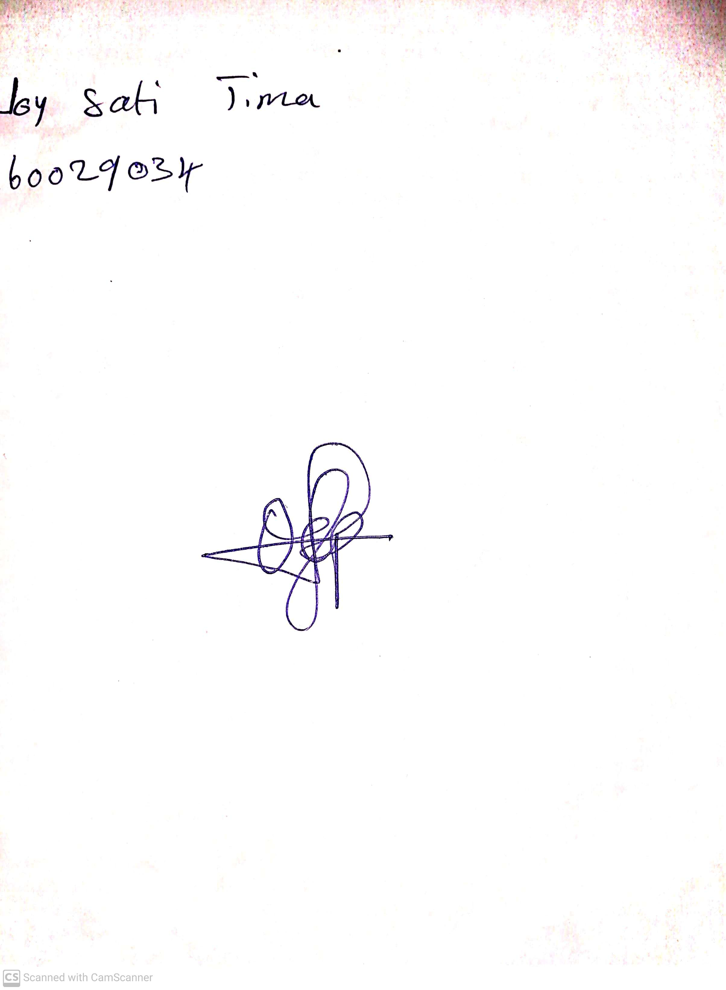

28th May, 2023

Perpetual Ojoma

Stream Head Nursery