LESSON PLAN FOR WEEK 4 ENDING 3rd FEBRUARY,2023

|  |  |
| --- | --- |
| TERM | 2ND |
| WEEK | 5 |
| DATE | 27TH January- 3rd February,2023 |
| CLASS | SS1 |
| SUBJECT | History |
| TOPIC | Non-centralized States |
| SUB-TOPIC | The Efik,Ijaw and Itshekiri |
| PERIOD | 4th |
| TIME | 10:30-11:10 |
| DURATION | 40 Minutes |
| NO IN CLASS | 11 |
| AVERAGE AGE | 15 years |
| SEX | Mixed |
| SPECIFIC OBJECTIVES | By the end of the lesson, scholars should be able to:  i.State the socio-political organization of the Ijaw and Efik.  ii.Explain the socio-political structure of the Itsekiri |
| RATIONALE | To acquaint the scholars with the socio-political organization of Efik, Ijaw and Itsekiri. |
| PREVIOUS KNOWLEDGE | The scholars can mention the non-centralized states. |
| INSTRUCTIONAL RESOURCES | Charts from textbook explaining the topic. |
| REFERENCE MATERIAL | Online Information(2017) |

LESSON DEVELOPMENT

|  |  |  |  |
| --- | --- | --- | --- |
| STEPS | TEACHER’S ACTIVITIES | SCHOLARS’ ACTIVITIES | LEARNING POINTS |
| Introduction | The teacher introduces the topic by asking the scholars to mention two features of non-centralized states. | The scholars mention them as:  i.No central government.  ii.Basic social unit was the village. | To arouse scholars’ interest towards the topic. |
| Step 1 | The teacher explains the socio-political structure of Ijaw and Efik. | The scholars pay attention. | To enhance proper understanding of the topic. |
| Step 2 | The teacher states and explains the socio-political structure of Itshekiri. | The scholars listen and ask questions. | To encourage logical reasoning on the topic. |
| Board summary | **Socio-political organization of Ijaw and Efik:**  1.They are divided into clans known as Ibe. They had no central control.  2.Only the high priest had authority over the village.  3.Villages enjoyed a high degree of independence.  4.Village assembly was known as Amagula and was the main political authority.  They also had secret societies which played important roles in the society which include: maintenance of law and order and trained youths. Women cannot join them. They held meetings and had a system of grades.  **The Socio-Political Structure of Itshekiri**  They have a compact system with the Ode Itshekiri as the capital.  1.Olu was the head of administration and also the head of chiefs (Ojoye).  2.Oigbosere: He was the prime minister and Chief Adviser.  3.Iyasere: War leader  4.Uwangue: Custodian of the Olu’s regalia.  Political Organization  1.The monarch acquired more power.  2.The political competition was fierce.  3.The economy was majorly fishing production of salt and textile, etc. | The scholars copy notes into their notebooks. | For reference purposes. |
| Evaluation | The teacher evaluates the scholars thus:  i.State the political organization of the Ijaw and Efik.  ii.Explain the socio structural organization of the Itshekiri.  iii.Mention the political organizations. | The scholars attempt the questions. | To ascertain scholars understanding of the topic. |
| Conclusion | The teacher checks scholars notes and make corrections. | The scholars take corrections made by the teacher. | For consolidation of the topic. |
| assignment | The teacher gives the scholars assignment:  Explain the Ijaw and the Itshekiris. | The scholars copy their assignment to do it at home. | To encourage scholars to study and learn at home. |

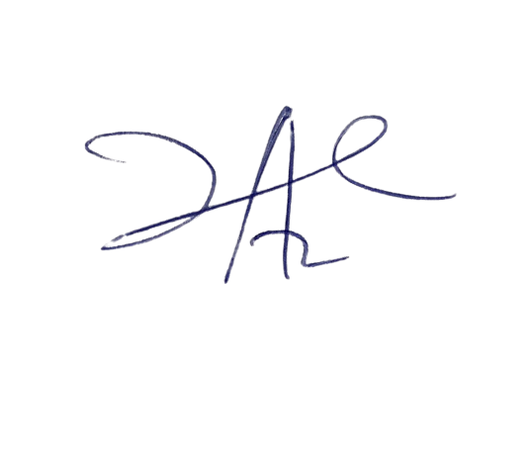

3/3/2023

Head Instructor