**EMERALD ROYAL INTERNATIONAL SCHOOL MPAPE, ABUJA**

**NURSERY 2 (TWO) SCHEME OF WORK**

**1ST TERM**

**HANDWRITING**

|  |  |  |
| --- | --- | --- |
| **WEEKS** | **TOPICS** | **CONTENT/ACTIVITIES** |
| **1-2** | **Two letters in words** | **Copying two letter words accurately and with good spacing.** |
| **3-4** | **Sentences with two letters words** | **Copying sentences with two letter words accurately and with good spacing.** |
| **5** | **Three letter words .** | **Copying three letter words accurately and with good spacing.** |
| **6** | **sentences with three letter words.** | **Copying sentences with three letter words accurately and with good spacing.** |
| **7-8** | **Four letter words.** | **Copying four letter words accurately and with good spacing.** |
| **9** | **Sentences with four letter words.** | **Copying sentences with four letter words accurately and with good spacing.** |
| **10-11** | **Five letter words** | **Copying five letter words accurately and with good spacing.** |
| **12** | **Sentences with five letter words.** | **Copying sentences with five letter words accurately and with good spacing.** |
| **13-14** | **Revision / examination .** |  |

**EMERALD ROYAL INTERNATIONAL SCHOOL MPAPE, ABUJA**

**NURSERY 2 (TWO) SCHEME OF WORK**

**2ND TERM**

**HANDWRITING**

|  |  |  |
| --- | --- | --- |
| **WEEKS** | **TOPICS** | **CONTENT/ACTIVITIES** |
| **1-2** | **Names of parts of the body.** | **Copying with good spacing.** |
| **3-4** | **Numbers in words.** | **Copying with good spacing.** |
| **5-6** | **Names of colours.names of domestic animals.** | **Copying with good spacing.** |
| **7-8** | **Names of domestic animals.** | **Copying with good spacing.** |
| **9-10** | **Clothing vocabulary.** | **Copying with good spacing.** |
| **11-12** | **Days of the week.** | **Copying with good spacing.** |
| **13** | **Revision** |  |
| **14** | **Examination** |  |

**EMERALD ROYAL INTERNATIONAL SCHOOL MPAPE, ABUJA**

**NURSERY 2 (TWO) SCHEME OF WORK**

**3RD TERM**

**HANDWRITING**

|  |  |  |
| --- | --- | --- |
| **WEEKS** | **TOPICS** | **CONTENT/ACTIVITIES** |
| **1** | **Names of foods.** | **Copying with good spacing.** |
| **2** | **Science vocabulary.** | **Copying with good spacing.** |
| **3** | **Mathematics vocabulary.** | **Copying with good spacing.** |
| **4** | **Social studies vocabulary.** | **Copying with good spacing.** |
| **5** | **Health education vocabulary.** | **Copying with good spacing.** |
| **6** | **Games and sports vocabulary.** | **Copying with good spacing.** |
| **7-8** | **Towns and cities in my country.** | **Copying with good spacing.** |
| **9-10** | **Clothing vocabulary.** | **Copying with good spacing.** |
| **11-12** | **Days of the week** | **Copying with good spacing.** |
| **13** | **Revision** |  |
| **14** | **Examination** |  |

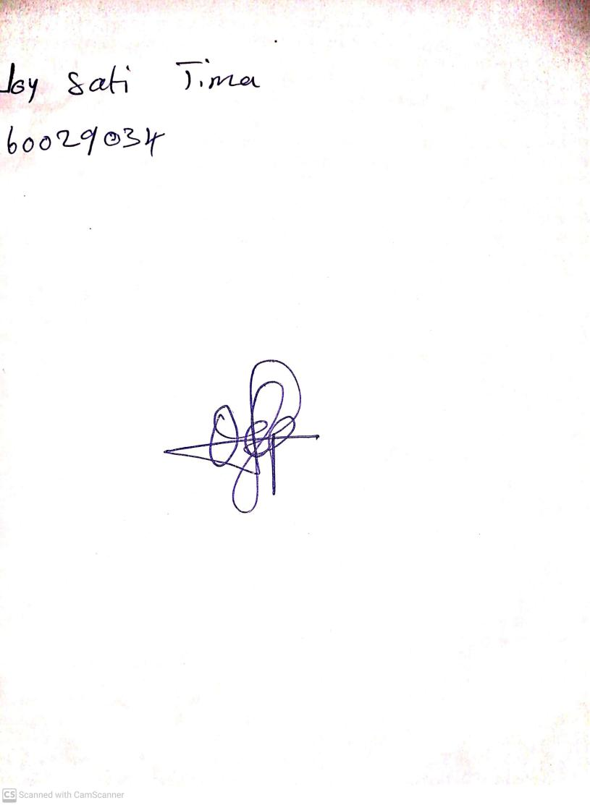

11TH OCTOBER, 2023

Perpetual Ojoma Ocheja

Stream Head Nursery