**Lesson Plan/Note for week 3 Ending 27/1/2023.**

**Term:** 2nd.

**Week**: 3 .

**Date:** 23/1/2023.

**Class**: SS 1.

**Subject:** Civic Education.

**Topic**: Rule of Law.

**Sub-Topic:** Meaning of the majority and Steps to safe guide the minority.

**Period:** 3rd

**Time:** 9:30-10:10.

**Duration:** 40 Minutes.

**Number in class:** 7 Students.

**Average Age:** 14 Years.

**Sex:** Mixed.

**Specific objectives:** By the end of the lesson, the students should be able to:

(1) Define Rule of Law.

(11) Explain rule of the majority.

(111) state the steps on how to protect the minority.

**Rationale:** For the students to be able to identify the ways on how the minority and majority can live peaceful.

**Previous knowledge:** The students have been living with their senior and elders or sisters peacefully.

**Instructional Material:** A chart showing ballot boxes and people voting in an election.

**Reference material**: Gbenga Babalola (2017) Essential Civic Education for senior Secondary schools.

**LESSON DEVELOPMENT**

|  |  |  |  |
| --- | --- | --- | --- |
| **Stages/steps** | **Teacher's Activities** | **Students' Activities** | **Learning points.** |
| **Introduction** | Review the previous lesson | Participate actively in the class discussion | To arouse the students interest to learn. |
| **Step 1** | Defines Rule of law as: Rule of law is the supremacy of the constitution over every citizen in a political system. | Listen carefully to the teacher | For better understanding of the lesson. |
| **Step 11** | Guides the students to explain the rule of the majority | Respond to the class activity | To encourage critical thinking |
| **Step 111** | Asks the students to state the steps on how to protect the minority. | State the steps on how to protect the minority as: (1) No discrimination.(2) They should be allowed to Contest election. (3) equality. | To enhance their logical reasoning. |
| **Board Summary** | Summarises the lesson as:  **Rule of the majority**  In any representatives democracy, it is difficult if not impossible for the entire people or their representatives to agree on issue. Rule of majority is the principle which involves making decisions on issues that affect people in the society by the majority. The concept of majority rule means that after an election, which ever political party wins the election, there should be no discrimination against the people that voted against the winning party. Those in minority groups still have the right to express their view on issues. The minority should be protected.  **Steps to protect the minority**  (1) They should be no discrimination against the minority. (2) They should be allowed to Contest election and win. (3) They should be given equal right. (4) Their opinion and expression should be counted. (5) Right to freedom of thought, conscience or religion. (6) Right to own property any where in Nigeria. | Copy and submit the note book for marking | For future reference. |
| **Evaluation** | Evaluates the students as:  (1) Explain the rule of the majority.  (2) State 5 Steps in safe guiding the minority. | Respond to the questions | Ascertaining the attainment of the stated objectives |
| **Conclusion** | Rounds up the lesson by marking and correcting students work | Check and do their correction | Consolidation of the lesson. |
| **Assignment** | Gives home work as:  (1) State five steps to safe guide the minority. | Respond by doing the home work at home. | To ensure continuity of learning. |

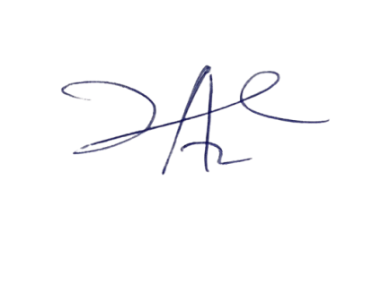

14/3/2023

Principal Head Instructor