**EMERALD ROYAL INTERNATIONAL SCHOOL, MPAPE ABUJA**

**LESSON PLAN AND NOTE 1 FOR WEEK 5 ENDING FRIDAY, 9TH FEBRUARY, 2024**

**TERM:** FIRST TERM

**WEEK:** WEEK 5

**SUBJECT:** BASIC SCIENCE

**TOPIC:** IDENTIFICATION OFCOLOURS

**SUB-TOPIC:** COLOURS OF TRAFFIC SIGNS

**DATE:** TUESDAY, 6TH AND WEDNESDAY, 7TH FEBRUARY,2024

**TIME:** 08:45 – 09:25AM AND 09:25 – 09:55AM

**DURATION:** 40 MINUTES

**PERIOD:** 2ND AND 3RD

**CLASS:** NURSERY 3

**NUMBER IN CLASS:** TWELVE

**AVERAGE AGE:** FIVE

**SEX:** MIXED

**LEARNING OBJECTIVES:** By the end of the lesson, the pupils should be able to:

1. Identify road traffic signs.
2. Identify the colours of the road traffic signs.

**RATIONALE:** for pupils to learn about road traffic signs and their colours.

**PREVIOUS KNOWLEGDE:** pupils have learnt about some of the road traffic signs and their colours.

**INSTRUCTIONAL MATERIALS:**

1. Flash cards.
2. Road chart.

**REFERENCE MATERIALS:**

Smart Basic Science and Technology book 1 by D. I. Bika, Cambridge University Press

**LESSON DEVELOPMENT**

|  |  |  |  |
| --- | --- | --- | --- |
| **STAGES/STEPS** | **TEACHER’S ACTIVITIES** | **PUPILS’ ACTIVITIES** | **LEARNING POINTS** |
| **INTRODUCTION** | Review previous knowledge | Respond to the teacher | To arouse the pupils’ interest. |
| **PRESENTATION**  **STEP 1** | Teaches and guides the pupils to identify road traffic signs.   1. Traffic light   Screenshot_20240105-082139   1. Stop   Screenshot_20240319-141818   1. U- turn   Screenshot_20240319-142029 | Identify road signs. | For better understanding. |
| **STEP 2** | Teaches and guides the pupils to identify road traffic signs.   1. Traffic light   Screenshot_20240105-082139  The traffic light is a road sign that has three colours. The colours ar:   1. Red which means **Stop** 2. Yellow which means **Get ready** 3. Green which means **Go**   2. Stop  Screenshot_20240319-141818  The stop is a road sign that indicate that vehicles should stop, that there maybe danger ahead. The colours of the stop sign are red, white and black.  3. U- turn  Screenshot_20240319-142029  The u-turn is a road sign that indicates there is a u-turn ahead at the left or right side of the road.  The colours of the u-turn are red, white and black. | Listen attentively and learn. | Roads signs and their colours. |
| **SUMMARY** | Summarises the lesson by emphasising on the main concept and writes note on the board | Listen and copy their notes | For onward study |
| **EVALUATION** | Asks pupils to:   1. Mention the road signs. 2. Identify the different road signs and their colours. | Respond to the teacher’s question. | To test the pupils understanding on the lesson. |
| **CONCLUSION** | Summarizes, corrects and mark pupils’ notebooks | Submit their notebooks for marking. | Clarifying the concept. |
| **HOME WORK** | 1. Draw any two of the road signs and colour. | Cope and return with task. | Extending lesson home. |

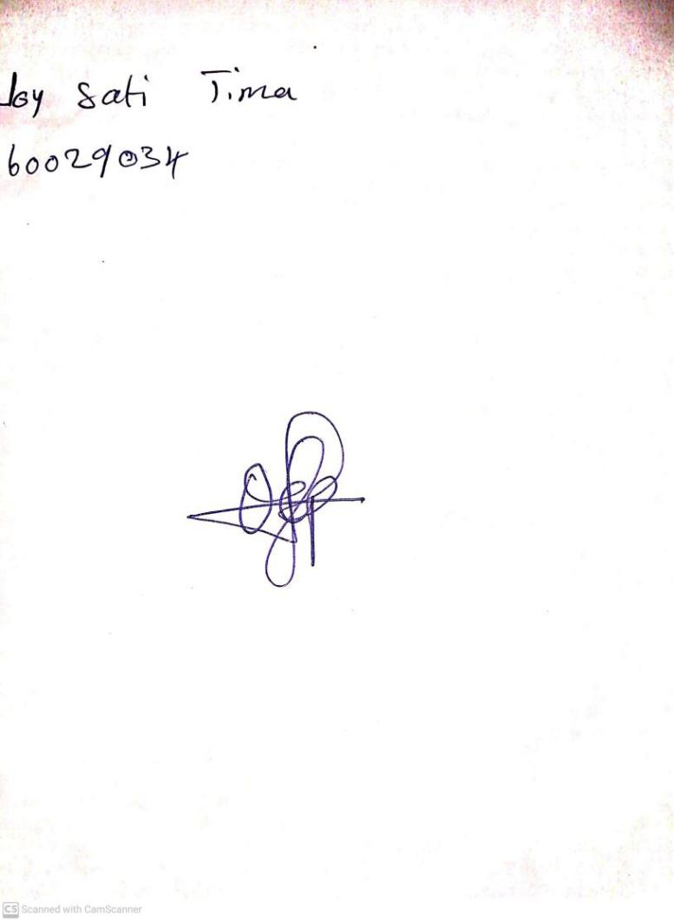

2ND FEBRUARY, 2024

Perpetual Ojoma Ocheja

Stream Head Nursery