**LESSON PLAN AND NOTE 1 FOR WEEK 2 ENDING 19/01/2024**

**Term 2nd term**

**Week 2nd week**

**Date 15th January,2024**

**Class Nursery one**

**Subject Letter work**

**Topic Coping words with letter Bb**

**Sub-topic Naming three letter words with letter Bb**

**Period 5th period**

**Time 11:20 am**

**Duration 35 minutes**

**No in class 14**

**Average Age 3 years**

**Sex Mixed.**

**Specific Objectives: By the end of the lesson, the pupils should be able to:**

1. **Name three letters words that start with Bb**
2. **Trace three letters words that start with Bb.**

**Rationale: To make the pupils mention & trace three letter words with Bb.**

**Previous Knowledge: The pupils can match & write three letter words starting with letter Bb**

**Instructional Resources: Chart, board, marker.**

**Reference Material: Online research, board, marker, chart.**

**LESSON PRESENTATION**

|  |  |  |  |
| --- | --- | --- | --- |
| **Steps** | **Teacher’s Activities** | **Pupils’ Activities** | **Learning Points** |
| **Introduction** | **The teacher introduces the topic (coping words with letter Bb) to the pupils.** | **The pupils listen to the teacher attentively.** | **To arouse the interest of the pupils.** |
| **Step 1** | **The teacher starts by naming three letter words with Bb for the pupils to repeat after**  **‘’boy’’, ‘’bed’’, “bag”,**  **“big”, “bad”, “bit”** | **The pupils repeat after the teacher three letter words with Bb**  **‘’boy’’, ‘’bed’’, “bag”,**  **“big”, “bad”, “bit”** | **For proper understanding.** |
| **Step 2** | **The teacher guides the pupils in writing three letter words with sound Bb inside their notebook.**  **b o y**  **_________**  **b i t**  **_________** | **The pupils write the three letter words with Bb as the teacher guides them inside their notebook.** | **For better understanding.** |
| **Summary** | **The teacher summarizes the lesson by sounding three letter words with Bb**  **‘’boy’’, ‘’bed’’, “bag”,**  **“big”, “bad”, “bit”** | **The pupils mention three letter words with Bb**  **‘’boy’’, ‘’bed’’, “bag”,**  **“big”, “bad”, “bit”** | **For onward study.** |
| **Evaluation** | **Question:**  **Mention (2) three letter words with Bb below**  **____________**  **____________**  **Write below the words that starts with sound ‘b’ below**  **b i t**  **_________**  **b a d**  **_________** | **The pupils answer the question correctly.** | **To ascertain the pupils’ understanding of the lesson.** |
| **Conclusion** | **The teacher summarizes, reacts and corrects the pupils.** | **The pupils gives answers to the teacher's question.** | **To consolidate the lesson.** |
| **Assignment** | **Question:**  **Mention (2) three letter words with Bb below**  **____________**  **____________**  **Write below the words that starts with sound ‘b’ below**  **b i t**  **_________**  **b a d**  **_________** | **The pupils copy and do their homework at home.** | **To encourage learning while at home.** |

**LESSON PLAN AND NOTE 2 FOR WEEK 2 ENDING 19/01/2024**

**Term** **2nd term**

**Week** **2nd week**

**Date** **17th January,2024**

**Class** **Nursery one**

**Subject**  **Letter work**

**Topic** **Coping words with letter Bb**

**Sub-topic** **Colouring objects & animals with letter Bb**

**Period** **5th period**

**Time** **11:35am**

**Duration** **35 minutes**

**No in class** **14**

**Average Age** **3 years**

**Sex** **Mixed.**

**Specific Objectives:**  **By the end of the lesson, the pupils should be able to:**

1. **Identify three letters words & objects that start with Bb**

**2.**  **Colour three letters words & objects that start with Bb.**

**Rationale:** **To make the pupils identify & colour three letter words & objects with Bb.**

**Previous Knowledge:**  **The pupils have name & trace three letter words starting with letter Bb**

**Instructional Resources:**  **Crayons, pencils, exercise books, board, marker.**

**Reference Material:**  **Online research, board, marker.**

**LESSON PRESENTATION**

|  |  |  |  |
| --- | --- | --- | --- |
| **Steps** | **Teacher’s Activities** | **Pupils’ Activities** | **Learning Points** |
| **Introduction** | **The teacher introduces the topic (coping words with letter Bb) to the pupils.** | **The pupils listen to the teacher attentively.** | **To arouse the interest of the pupils.** |
| **Step 1** | **The teacher draws objects that start with three letter word Bb for the pupils to identify**  **plain brother and sister**  **_________** | **The pupils participate to identify objects that starts with Bb.**  **plain brother and sister**  **boy** | **For proper understanding.** |
| **Step 2** | **The teacher draws & guides the pupils to colour objects starting with letter Bb inside their notebooks.**  **plain brother and sister** | **The pupils colour the objects that start with letter Bb inside their notebooks.** | **For better understanding.** |
| **Summary** | **The teacher summarizes the lesson by identifying other objects with letter Bb.** | **The pupils have knowledge of identifying & colouring objects with letter Bb.** | **For onward study.** |
| **Evaluation** | **Question:**  **Identify and colour the object below with letter Bb**  **plain brother and sister**  **Identify the object with sound ‘b’**  **plain brother and sister**  **_________** | **The pupils answer the question correctly.** | **To ascertain the pupils’ understanding of the lesson.** |
| **Conclusion** | **The teacher summarizes,reacts and corrects the pupils.** | **The pupils give answer to the teacher.** | **To consolidate the lesson.** |
| **Assignment** | **Question:**  **Identify and colour the object below with letter Bb**  **plain brother and sister**  **Identify the object with sound ‘b’**  **plain brother and sister**  **_________** | **The pupils copy and do their homework at home.** | **To encourage learning while at home.** |

**LESSON PLAN AND NOTE 3 FOR WEEK 2 ENDING 19/01/2024**

**Term** **2nd term**

**Week** **2nd week**

**Date** **18th January,2024**

**Class** **Nursery one**

**Subject** **Letter work**

**Topic** **Coping words with letter Bb**

**Sub-topic** **Matching objects & animals with letter Bb on**

**Cardboard (practical)**

**Period** **5th period**

**Time** **11:40 am**

**Duration** **35 minutes**

**No in class** **14**

**Average Age** **3 years**

**Sex** **Mixed.**

**Specific Objectives: By the end of the lesson, the pupils should be able to:**

**1.**  **Pick from a box a picture words with letter Bb & paste it on the cardboard**

**2.**    **Write three letters words with Bb.**

**Rationale:** **To make the pupils match & write three letter words with Bb**

**Previous Knowledge: The pupils have identify & colour three letter words with letter ‘b’**

**Instructional Resources:**  **Cardboard, pencils, exercise books.**

**Reference Material:**  **Online research ,cardboard.**

**LESSON PRESENTATION**

|  |  |  |  |
| --- | --- | --- | --- |
| **Steps** | **Teacher’s Activities** | **Pupils’ Activities** | **Learning Points** |
| **Introduction** | **The teacher introduces the topic (coping words with letter Bb) to the pupils.** | **The pupils listen to the teacher attentively.** | **To arouse the interest of the pupils.** |
| **Step 1** | **The teacher present a box with picture words and assists the pupils using gum to paste on the cardboard the pictures starting with Bb.** | **The pupils participate actively in picking and pasting on the cardboard the word picture with letter Bb.** | **For proper understanding.** |
| **Step 2** | **The teacher guides the pupils to write three letter words with Bb inside their notebooks.**  **b o y**  **b e d** | **The pupils write three letter words with Bb as the teacher guides them.** | **For better understanding.** |
| **Summary** | **The teacher summarizes the lesson by sounding random three letter words with Bb.** | **The pupils have knowledge of three letter words with Bb.** | **For onward study.** |
| **Evaluation** | **Question:**  **With a box of picture word, pick up picture with sound ‘b’ and paste it on the cardboard?**  **Write the three letter words with Bb**   |  | | --- | | **b e d** | |  | | **b o y** | |  | | **The pupils answer the question correctly.** | **To ascertain the pupils’ understanding of the lesson.** |
| **Conclusion** | **The teacher summarizes, reacts and corrects the pupils** | **The pupils gives answers to the teacher's question.** | **To consolidate the lesson.** |
| **Assignment** | **Write the three letter word ‘’ b a g ‘’**  **Circle the word with sound ‘b’ below**  **bag cat bed leg** | **The pupils copy and do their homework at home.** | **To ensure learning while at home.** |

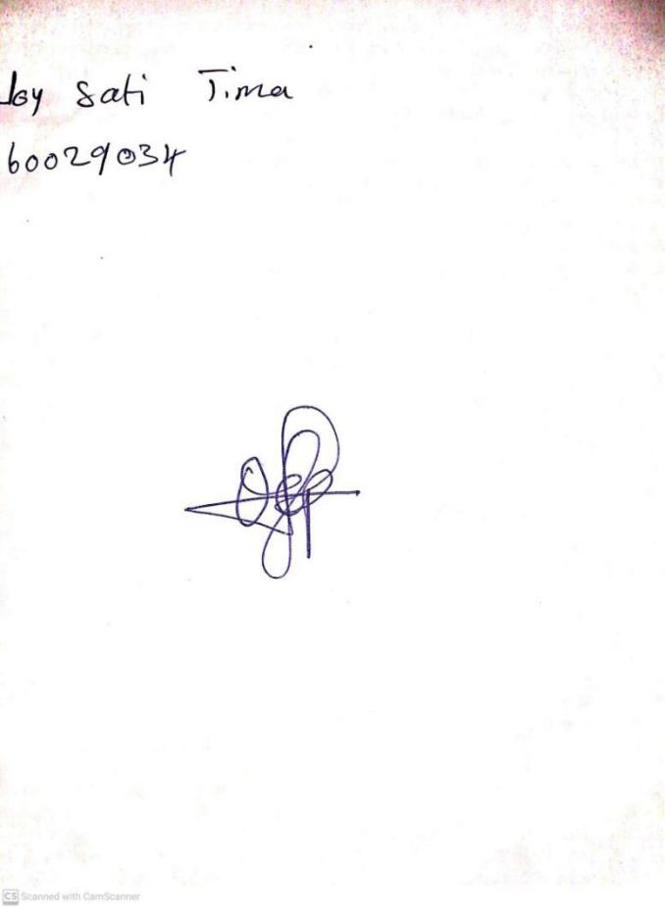

**12th January, 2024**

**Perpetual Ojoma Ocheja**

**Stream Head Nursery**